**Compressive behavior of epoxy resin filled with silica nanoparticles at high strain rate**

Mauro Zarrelli1, Ahmed Elmahdy2, Aldobenedetto Zotti1, Simona Zuppolini1, Anna Borriello1 and Patricia Verleysen2

1CNR - National Research Council, IPCB - Institute of Polymers, Composites and Biomaterials, ,P.le E. Fermi, Granatello, Portici, 80055, Italy

Email: mauro.zarrelli@cnr.it

2MST - DyMaLab Research Group, Department EEMMeCS, Ghent University, Technologiepark 903b, 9052 Zwijnaarde, Belgium

Email: ahmed.elmahdy@ugent.be

**Keywords:** high strain rate, split Hopkinson bar, epoxy resin, silica nanoparticles

**Abstract**

The aim of this paper is to study the compressive behavior of a typical aeronautical epoxy composite matrix filled with silica nanoparticles at high strain rates. The weight percentage of the silica nanoparticles was 1% of the epoxy resin and the average size of the nanoparticles was approx. 800 nm, as measured by SEM image analysis. Reference quasi-static experiments (at strain rates 0.0008, 0.008, and 0.08 s-1) and high strain rate experiments (up to 1050 s-1) were carried out using both neat and silica nanoparticle filled epoxy resins. Results showed that the addition of silica nanoparticles improved the compressive yield strength and reduced the maximum strain of the epoxy resin at quasi-static and high strain rates. In addition, results revealed that strain rate sensitivity at higher strain rates was also negatively affected.. The effect of strain rate on the compressive yield strength of silica nanoparticles filled epoxy reasonably followed a power law, which is characterised by a strain rate exponent value of approx. 0.0227.

1. Introduction

Epoxy resins are widely used as matrix material for high performance composites in aeronautical applications. On the one hand, epoxy resins can have a highly cross linked microstructures upon curing, which gives the resin its favourable characteristics such as high modulus and strength and good performance at elevated temperatures [1]. On the other hand, epoxy resins are generally very brittle materials (can break even when handled), and have low resistance to cracks and low fracture toughness [2]. As a result, efforts were made to improve the mechanical performance of the epoxy resins by the addition of small, more rigid particles such as silica (SiO2) nanoparticles to the neat resin [3-5]. The addition of silica nanoparticles (up to 170 nm in size) to the neat epoxy resin can improve its elastic modulus and fracture toughness [6]. In addition, well dispersed nanoparticles can also improve the tensile strength significantly without affecting the failure strain [7]. However, the behavior of these epoxy nanocomposites at high strain rates was only recently studied in very few papers and up to particle size of 30 nm [8-10].

The aim of this paper is to study the high strain rate compressive behavior of epoxy resin reinforced with silica nanoparticles, having an average size of 800 nm. High strain rate experiments using neat and silica nanoparticle filled epoxy resins were carried out using the split Hopkinson pressure bar facility available at DyMaLab of Ghent University. Reference quasi-static experiments were also carried out to establish a comparison of the behavior at different strain rates. The effect of the addition of silica nanoparticles on the compressive yield strength at diffierent strain rates is presented and discussed.

2. Materials and Methods

2.1. Specimen matrial and geomerty

The material used in this study was the RTM-6 epoxy resin in the form of neat and silica nanoparticles filled resins. Long cylindrical rods of both resins were manufactured at IPCB, by degassing the resin at 90°C for 30 minutes in a vaccum oven, followed by casting the unreacted liquid resin into a cylindrical alumiunium mold. The systems were cured according the RTM6 standard cure profile, i.e. 90 mins at 160°C followed by 120 mins at 180°C. Nanoparticles filled epoxy resin was prepeared by the addition of silica nanoparticles to the neat epoxy matrix with 1% weight content, and having no surface functionalization. A sol-gel procedure was employed to synthesize the silica nanoparticles, along with an optimized dispersion procedure to ensure well dispersion of the nanoparticles into the host matrix. SEM imaging analysis was used to determine the average size of the synthesized silica nanoparticles, which was found to be approx. 800 nm in diameter. Figure 1 reports an SEM image with the measured diameters of the silica nanoparticles. The fully cured cylindrical rods of both neat and filled resins were finally cut into small cylinders, having the dimensions shown in figure 2. To eliminate any descripancies related to the sample geometry, the same shape of tested specimens along with their nominal dimension and testing boundary conditions were used for both reference quasi-static and high strain rate tests.

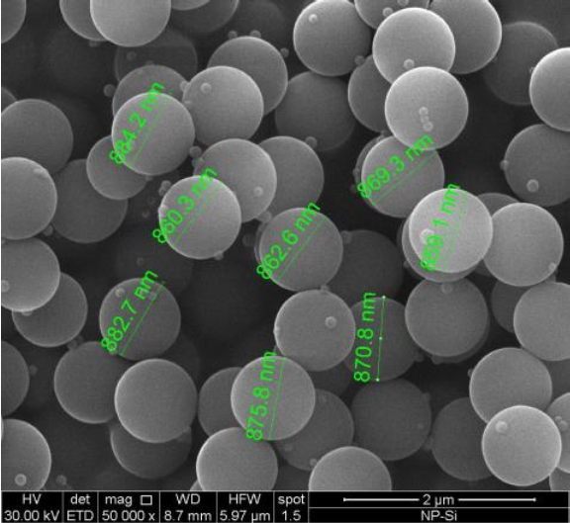

Figure . SEM imaging analysis of silica nanopaticles

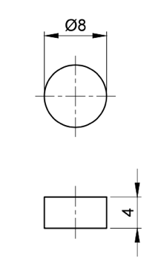

Figure . Dimensions of the compression specimen

2.2. Quasi-static setup

Reference quasi-static tests were carried out using an Instron 5569 universal testing machine at a testing speed of 0.2, 2 and 20 mm/min, corresponding to strain rates of 8x10-4 and 8x10-3, and 8x10-2 s-1. The load was measured using a 50 kN load cell. Samples were placed between 2 two long bars, where two hardened steel platens were attached to the bars at the loading interfaces. Dispalcements were measured using 3 LVDTs which were fixed on the bars. Figure 3 shows the full quasi-static setup used. The loading interfaces of the samples were lubricated with PTFE based lubricant to reduce friction.

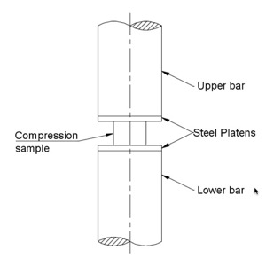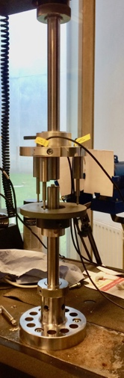

Figure . Quasi-static setup

2.3. Dynamic setup

Dynamic experiments were carried out using a split Hopkison pressure bar (SHPB) facility. In a SHPB setup, the sample is placed between two long bars –the input and output bar- and loaded by a mechanical compressive wave, denoted as incident wave. Interacting with the sample, the incident wave is partly reflected and partly transmitted. The input and output bars were made of high strength aluminium with diameters of 25mm and lengths of 6m and 3m, respectively. The dynamic compressive stress waves were generated by accelerating a cylindrical impactor towards the end of the input bar, at speeds of 8, 11 and 14m/s. As for the static tests, to obtain uniform, uniaxial deformation conditions, hardened steel plates were attached to the bar ends in contact with the sample. A special alignment device was used to ensure good alignment along the center of the sample and the bars. The incident (*ɛi*), reflected (*ɛr*), and transmitted (*ɛt*) strain waves were measured using foil type strain gauges attached on both bars. When dynamic stress equilibrium is achieved at the input and output bar interfaces, the average stress (*σ*), strain (*ɛ*) and strain rate (*ɛ̇*) in the sample gauge section can be calculated from the classical Hopkinson bar equations as follows [11]:

$\dot{ε}=2(C_{o}/L_{s})∙ε_{r}(t)$ (1)

$ε=2(C_{o}/L_{s})∙\int_{0}^{t}{ε_{r}(t)dt}$ (2)

$σ=E_{b}∙(A_{b}/A_{s})∙ε_{t}$ (3)

where *Ab* and *As* are the cross section area of the bars and the sample respectively, *Co* is the elastic wave speed in the bar material, *Ls* is the gauge length of the sample. Similar to quasi-static tests, the loading interfaces of the sample were lubricated with PTFE based lubricant to reduce friction.

3. Results and discussion

Figure 4 reports the engineering stress strain behavior of neat epoxy resin at low and high strain rates. For the purpose of figure clarity, only the quasi-static strain rate 0.0008 s-1 is shown. The material can be clearly seen as highly strain rate sensitive, due to its viscoelastic nature. The engineering stress strain response of neat epoxy resin in compression can be divided into 3 regions: (1) an initial elastic linear region followed by a nonlinear region, (2) a stress plateau region, where the stress in constant or nearly constant with the increase of strain, and finally (3) a strain hardening region up to failure. Compressive yield strength is here defined as the stress at the first point at the plateau region, corresponding to the arrow position shown on the curves. Neat epoxy resin shows an increase in stiffness and yield strength with the increase of strain rate. It should be noted that at the strain rates of 250 and 650 s-1, the tested samples did not fail, and therefore, a drop in stress with a recovery of strain can be seen upon unloading.

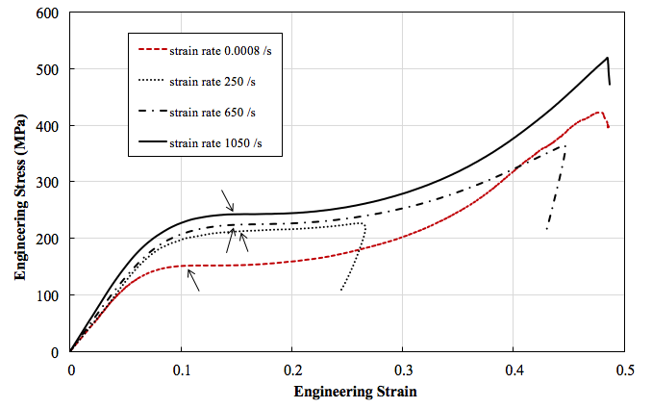

Figure . Engineering stress strain response of neat epoxy resin at different strain rates

Figure 5 reports the engineering stress strain behavior of silica nanoparticle filled epoxy resin. The arrows on the curve represent the position of the yield strength. The behavior of the silica nanoparticle filled epoxy follows the same trend and distinct regions as in the neat epoxy resin. It can be seen that the stiffness and yield strength increase with the increase of strain rate. However, the variation of the yield strength at high strain rates is less pronounced for the silica nanoparticle filled epoxy compared to the neat epoxy at high strain rates. It should also be noted that at strain rates of 340 and 670 s-1, the tested samples did not fail, and therefore, a drop in stress with a recovery of strain can be seen upon unloading. For samples which were loaded until failure at 0.0008 and 1000s-1, the failure strain decreases with the addition of silica nanoparticles.

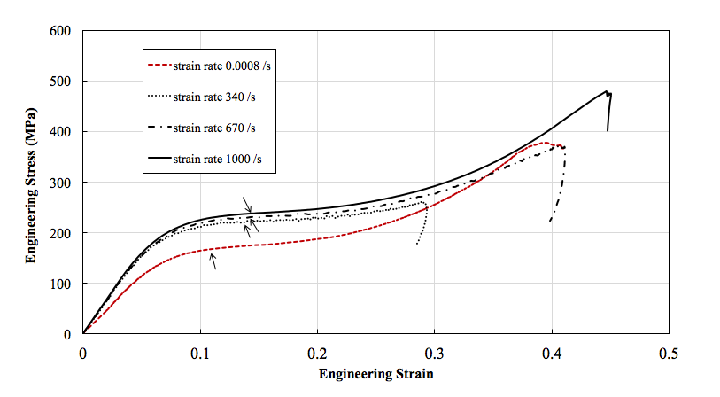

Figure . Engineering stress strain response of silica nanoparticles filled epoxy resin at different strain rates

Figure 6 shows the effect of the strain rate on the compressive yield strength for both neat and silica nanoparticles filled epoxy. The silica nanoparticle filled epoxy shows significant improvement of the yield strength at quasi-static strain rates compared to the neat epoxy. At higher strain rates, only a slight improvement can be seen for the silica nanoparticle filled epoxy compared to the neat resin. The strain rate effect on the compressive yield strength of both neat and filled epoxy resins can be described in a power law fitted curve having an equation as follows:

$σ_{y}^{comp}=K{\dot{ε}}^{n}$ (4)

where K and n are material constants. n is defined as the strain rate exponent. For both neat and silica nanoparticle filled epoxy resins, the K values were 181.04 and 195.2MPa, respectively, while the n values were 0.034 and 0.0227, respectively. A similar finding was reported by Ying-Gang Miao et al. [9], with lower K values and comparable n values. The difference in K values could be attributed to the size of the nanoparticles used. The average diameter of the silica nanoparticles used in Ying-Gang Miao’s study was approx. 20nm, while the average diameter of the silica nanoparticles used in this study is approx. 800nm.

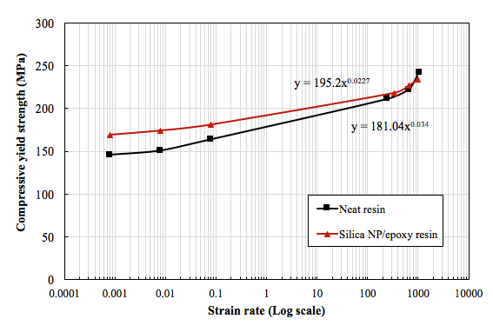

Figure . Effect of strain rate on the compressive yield strength for both neat and silica nanoparticles filled epoxy resins

4. Conclusions

The behavior of both neat and silica nanoparticle filled epoxy resins was studied at high strain rate compressive loading. The weight percentage of the silica nanoparticles was 1% of the epoxy resin, and the average size of the nanoparticles was approx. 800 nm. Reference quasi-static compression tests were also carried out for both materials to establish a comparison of the behaviour of both materials at high strain rates. The effect of adding the silica nanoparticles to the epoxy resin at high strain rates was presented and discussed. Considering the materials, nanoparticle size and setups used, the following can be concluded:

1. The addition of silica nanoparticles to the neat epoxy resin improves the compressive yield strength, while reducing the maximum strain at quasi-static and high strain rates.
2. The strain rate sensitivity at high strain rates is reduced with the addition of silica nanoparticles to the epoxy resin.
3. The effect of the strain rate on the compressive yield strength of silica nanoparticles filled epoxy follows a power law trend with a strain rate exponent of 0.022.

Acknowledgments

The project “EXTEME” leading to this paper has received funding from the European Union’s Horizon 2020 research and innovation program under agreement No. 636549.

References

[1] T. H. Hsieh, A. J. Kinloch, K. Masania, A. C. Taylor, and S. Sprenger. The mechanisms and mechanics of the toughening of epoxy polymers modified with silica nanoparticles. *Polymer*, 51:6284–6294, 2010.

[2] N. Domun, H. Hadavinia, T. Zhang, G. Liaghat, S. Vahid, C. Spacie, K. R. Paton, and T. Sainsbury. Improving the fracture toughness properties of epoxy using graphene nanoplatelets at low filler content. *Nanocomposites*, 3:85–96, 2017.

[3] N. R. Paluvai, S. Mohanty, and S. K. Nayak. Synthesis and Modifications of Epoxy Resins and Their Composites: A Review. *Polymer-Plastics Technology and Engineering*, 53:1723–1758, 2014.

[4] Yohanes and Y. Sekiguchi, “Effects of mixed micro and nano silica particles on the dynamic compressive performances of epoxy adhesive. *Applied Adhesion Science*, 5:1-12, 2017.

[5] M. Zamanian, M. Mortezaei, B. Salehnia, and J. E. Jam. Fracture toughness of epoxy polymer modified with nanosilica particles: Particle size effect. *Engineering Fracture Mechanics*, 97:193–206, 2013.

[6] P. Dittanet and R. A. Pearson.Effect of silica nanoparticle size on toughening mechanisms of filled epoxy. *Polymer*, 53:1890–1905, 2012.

[7] A. Jumahat, C. Soutis, S. A. Abdullah, and S. Kasolang. Tensile Properties of Nanosilica/Epoxy Nanocomposites. *Procedia Engineering*, 41:1634–1640, 2012.

[8] Y. Tian, H. Zhang, J. Zhao, T. Li, B.-X. Bie, S.-N. Luo, and Z. Zhang. High strain rate compression of epoxy based nanocomposites. *Composites Part A*, 90:62–70, 2016.

[9] Y.-G. Miao, H.-Y. Liu, T. Suo, Y.-W. Mai, F.-Q. Xie, and Y.-L. Li. Effects of strain rate on mechanical properties of nanosilica/epoxy. *Composites Part B*, 96:119–124, 2016.

[10] Y. Guo and Y. Li, “Quasi-static/dynamic response of SiO2–epoxy nanocomposites,” *Materials Science & Engineering A*, 458:330–335, 2007.

[11] H. Kolsky. An Investigation of the Mechanical Properties of Materials at very High Rates of Loading. *Proceedings of the. Physical Soiety B*, 62:676–700,1949.