SYNTHESIS OF ADVANCED PANI BASED CONDUCTIVE COMPOSITES USING METHACRYLATE GROUPS BASED MATERIALS

S.Pati^{1*}, T.Yokozeki², V.Kumar³ , T.Goto⁴ and T. Takahashi⁵

¹Department of Aeronautics and Astronautics, The University of Tokyo, 7-3- 1 Hongo, Bunkyo-ku, Tokyo, 113-8656 Japan, *santwana@aastr.t.u-tokyo.ac.jp

²Department of Aeronautics and Astronautics, The University of Tokyo, 7-3- 1 Hongo, Bunkyo-ku, Tokyo, 113-8656 Japan, yokozeki@aastr.t.u-tokyo.ac.jp

³Department of Aeronautics and Astronautics, The University of Tokyo, 7-3- 1 Hongo, Bunkyo-ku, Tokyo, 113-8656 Japan, vipin.kr27@gmail.com

⁴ Department of Organic Device Engineering, Yamagata University, 4-3- 16 Jonan, Yonezawa,
Yamagata, 992-5810 Japan t-goto@yz.yamagata-u.ac.jp

⁵ Department of Organic Device Engineering, Yamagata University, 4-3- 16 Jonan, Yonezawa,
Yamagata, 992-5810 Japan effort@yz.yamagata-u.ac.jp

Keywords: Polyaniline, conductive aerospace composites, Thermal doping, methacrylate based toughening materials

Abstract:
A methacrylate-based material, called P-2M, has been introduced to the widely studied conductive polymer polyaniline to develop a thermosetting conductive composite. P-2M has both acidic group for doping of PANI and acrylate group for curing of PANI and hence act as a bifunctional material. The study includes in depth analysis of P-2M using thermal microscope, UV-Vis spectroscopy, FTIR analysis and DSC. And then a simple method to synthesize composite of PANI and P-2M is presented, and its electrical as well as mechanical properties are measured for various structural applications. This new bifunctional material leads to a simple thermosetting composite with PANI that has enhanced both mechanical and conductivity.

1.Introduction:
Polyaniline with its rich chemistry owing to the alternating single and double bonds is an immensely studied conductive composite. It has been researched widely and applied in numerous fields of science like energy storage, electrochemistry, composites [1-3]. The team of Yokozeki et al. [4] has worked on the synthesis of conducting PANI using dodecylbenzene sulfonic acid (DBSA) and divinylbenzene (DVB) to make carbon fiber-reinforced plastics (CFRP) composites that can provide polymeric composites with superior lightning strike resistance and EMI shielding properties. But the mechanical properties of the PANI-DBSA based composites was not as high as the commonly used epoxy systems. Hence the major scope for further research is to design PANI based composite that can have higher mechanical properties. This work involves the introduction of a new PMMA like material called P-2M into PANI and hence essays the analysis of P-2M. Then, synthesis of PANI-P-2M composites and the detailed characterization for electrical and mechanical properties are presented. Earlier PMMA has been used with PANI to prepare composites but that was in a complex in-situ polymerization technique and the obtained material could enhance the conductivity but not so good mechanical properties [5]. However, this research is mainly intended for composites application and hence enhanced mechanical properties is a priority. Therefore the novel bifunctional material has been utilized to make conductive structural composites with PANI with improved mechanical properties.

2.Experimental procedure:
P-2M is a material that encompasses both acidic group as well as methacrylate groups hence contributing in both doping and curing of PANI. To characterize the doping behavior we ran a few experiments by mixing only PANI and P-2M . and further we tested the mechanical properties by giving thermal treatment to the mixture and curing the composite. The methodology of the experiments is as follows:
PANI (supplied by Regulus Co. Ltd., Tokyo, Japan) was kept in an oven for 24 h at 60℃ to eliminate moisture content. Dried PANI was then mixed with P-2M (supplied by Kyoeisha chemicals ) in the desired weight ratio and then mixed using a centrifugal mixture at 2000 rpm for 2minutes to prepare a homogenous mixture. This sample was used for DSC, UV-Vis, Thermal microscopy analysis and electrical properties characterization after hardening. This sample was then added with the crosslinking catalyst perbutyl-E(supplied by NOF corporation )(10wt%) and then mixed again to get a homogenous mixture . This mixture was poured into a flexible mold (dimensions: 50mm × 15mm × 2mm) and pressed using a hot press at 120$°$C for 2hours to obtain a cured sample. This sample was used for final electrical and mechanical properties characterization.

3.Results and discussion:
3.1. Thermal microscopy:
Doping is the phenomena in which PANI forms a polar covalent bond with P-2M to change from insulating base form to conducting salt form. This process requires the dopant to have a functional –OH group and elevated temperature for the reaction [6]. This process is the beginning step for the manufacturing of conductive structural composite using PANI. Thermal microscope analyses the material when the temperature changes from 25°C (Room temperature) to 120°C and the onset of doping was seen when PANI changes colour to green around 70°C. The figure 1 shows the morphology at room temperature and at 50°C and 100°C. The sample used for this analysis is the simple mixture of PANI(15wt%) and P-2M(85%) , the details of preparation of which have already been explained in the section 2. The change in the colour at around 70°C confirms the functionality of P-2M as a dopant for PANI.
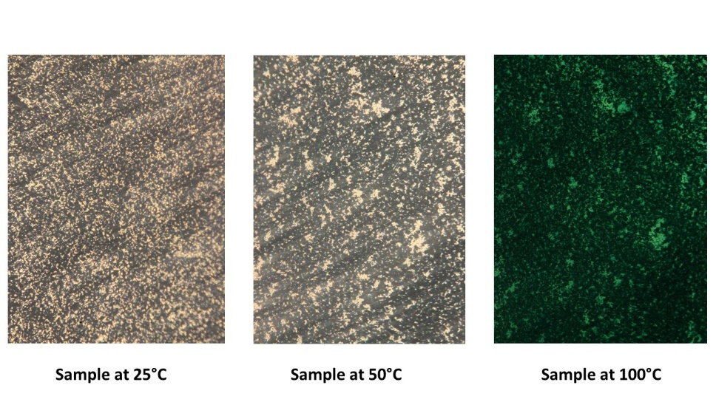
Figure 1: Thermal microscopy analysis of PANI-P-2M mixture to confirm the doping procedure

3.2 UV-Vis spectroscopy:
Figure 1 shows the UV-Vis spectroscopy of the PANI (15wt%)-P-2M(85wt%) sample prepared by the procedure as explained in the section above. The plot shows the change in the absorbance level when the sample is heated for 15mins at 120°C. UV-Vis is a strong tool to determine the doping levels [4, 7]. The thermal energy leads to the doping of the PANI in the presence of P-2M and PANI changes state from base form to the conducting salt form. The absorbance level change is seen in the longer wavelength range (1000cm⁻¹-2500cm⁻¹). Hence this plot helps us confirm the doping of PANI with P-2M and hence confirms dopant property of the bifunctional P-2M.

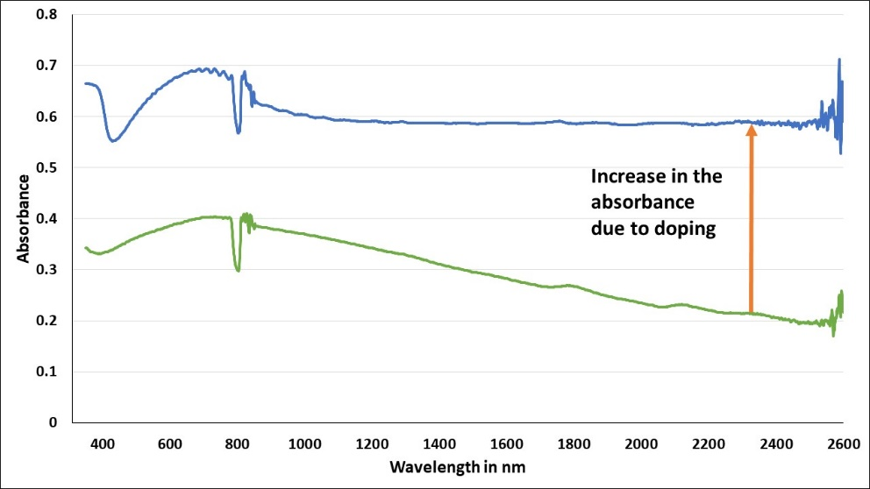
Figure-2: UV-Vis plot of PANI-P-2M sample. The lower plot is of the sample at room temperature and the blue plot is after thermal treatment for 15mins at 120°C

3.3. Differential scanning calorimetry(DSC):
DSC is a very strong tool to determine the thermal properties of a material and the analysis of what kind of exothermic reactions happen at what temperature when PANI and P-2M are mixed. We could estimate the exact doping and curing reactions qualitatively and quantitatively. The PANI (20wt%)-P-2M(80wt%) sample was prepared as explained in section 2. The doping peak was confirmed using periodic thermal treatment of the sample at 80°C. and analysing the DSC peaks after each period of thermal treatment. DSC from Shimadzu corporation Japan was used and 18mg of the sample was heated from room temperature till 300°C and the heat of the reaction was plotted against temperature. The figure below shows 4 different plots of the sample being treated for 0h, 1h, 2h and 2.5h respectively and the peak of doping gradually diminishes with the heat treatment. From the plot and the heat of reaction obtained we have calculated the exact amount of time for doping for the constitution of the sample and the further experiments were conducted according to that.

Figure 3: DSC analysis of PANI-P-2M samples in periodic thermal treatment for doping estimation

3.4. Electrical conductivity measurement:
The electrical conductivity is an important property of the composite material. Conductive composites with high mechanical strength can be suitable for many structural applications with multifunctional properties. The conductivity was measured for the PANI-P-2M system with the electrical conductivity (DC measurement) of the samples was measured using LCR meter (3522-50 LCR HiTESTER, Hioki E.E. Corporation, Ueda, Japan) by four-probe method. DOTITE conductive adhesive paste (supplied by Fujikura Kasei Co. Ltd. Tokyo, Japan) was applied and then aluminium conducting tape was attached on both sides for the measurement of conductivity. In order to dry the paste, the samples were kept overnight at room temperature.

In order to determine the variation of conductivity with the constitution of PANI and P-2M in the composite, uncured samples were prepared in the process as explained in the section 2. This time the weight percentage of the constituents was converted into the corresponding molar ratios. Molar ratios are calculated from weight ratios by using the molecular weight of the materials using the following formula:
$$\left({PANI}/{P-2M }\right)weight= \left({PANI}/{P-2M }\right) molar X \left({Mol. wt. of PANI}/{Mol. wt. of P-2M}\right)$$

Uncured PANI-P-2M samples were prepared in the following molar ratios: 1:1, 0.9,0.8,0.7 and the electrical conductivity were measured . The maximum feasible conductivity was obtained in the sample with the ratio 1:0.7 of 30S/m. However when the final cured composites were prepared by adding the curing catalyst in the composition: PANI (20wt %), P-2M (70wt %) and perbutyl (10wt%) the conductivity reduced after curing to 0.5S/m. This can be explained as P-2M is the single bifunctional material that is used for both conductivity and strength. Hence, when the sample is cured to impart strength, the conductivity is reduced.

Figure 4 : Electrical conductivity of uncured PANI-P-2M samples mixed in various molar ratios

3.5. Mechanical properties measurement:

The flexural properties of the samples were measured using the Universal Testing machine (Instron -5582) by three point bending method, using a load cell of the range of 5kN and the crosshead speed of 1mm/min. The sample dimensions are 50mm in length, 10 mm in width, and 1.5mm in thickness, and the span distance is taken as 16times the thickness as described in the standard. The samples were prepared by mixing PANI(20wt%) and P-2M(70wt%) with perbutyl(10wt%) as explained in section-2. The samples were thermally treated for 1hour post curing to obtain the mechanical strength properties as follows: flexural modulus of 2.6±0.13GPa and flexural strength of 14.92±2 MPa. Figure 5 below shows the typical load deflection curve for the sample obtained during the three point bending test.

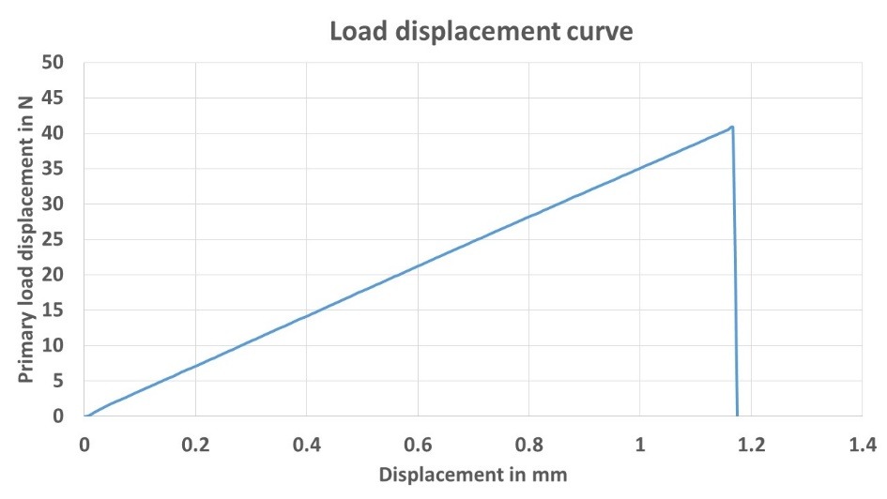
Figure 5 : Load displacement curve of a cured sample with PANI (20wt%) constitution

4. Conclusions

In the research reported here, polyaniline based conductive composite has been synthesized using a bifunctional methacrylate group material named P-2M. The synthesis route is quite simple as a single material works both way to impart electrical conductivity as well as mechanical properties to the system. The doping was characterized using Thermal microscopy, UV-Vis and DSC analysis. In conclusion, the cured composites obtained showed a conductivity of 0.5S/m, flexural modulus of 2.6±0.13GPa and flexural strength of 14.92±2 MPa. Although the conductivity is lower than the conventional PANI -DBSA system already reported by our research group, but the current system has many advantages over the previously reported systems in respect to the mechanical properties, stability of uncured complex with temperature and time, ease of fabrication, and viscosity. Further this polymer system can be used along with carbon fibers to make conducting PANI based CFRP composites.

References

[1] Shirshova, N, Qian, H, Shaffer, MSP. Structural composite supercapacitors. Compos Part A 2013; 46: 96–107
[2] Kondawar, SB, Acharya, SA, Dhakate, SR. Microwave assisted hydrothermally synthesized nanostructure zinc oxide reinforced polyaniline nanocomposites. Adv Mat Lett 2011; 2: 362–367.
[3] Ran F, Tan Y, Dong W, Liu Z, Kong L, Kang L. In situ polymerization and reduction to fabricate gold nanoparticle‐incorporated polyaniline as supercapacitor electrode materials. Polym Adv Technol. 2018;1–9.
[4] V Kumar , T Yokozeki, T Goto, T Takahashi , Mechanical and electrical properties of PANI-based conductive thermosetting composites, Journal of Reinforced Plastics and Composites, Vol. 34(16) 1298–1305, 2015
[5] Yang, Shiyong, Processable conductive composites of polyaniline/poly(alkyl methacrylate) prepared via an emulsion method, Synthetic Metals, 59, 1-12, 1993

[6] Li, C. , Chiu, W. and Don, T. (2007), Polyurethane/polyaniline and polyurethane‐poly(methyl methacrylate)/polyaniline conductive core‐shell particles: Preparation, morphology, and conductivity. J. Polym. Sci. A Polym. Chem., 45: 3902-3911
[7] Wusheng Yin, Eli Ruckenstein, Soluble polyaniline co-doped with dodecyl benzene sulfonic acid and hydrochloric acid, Synthetic Metals, 108,39-46, 2000

