STATISTICAL OPTIMIZATION OF COMPOSITE MATERIALS LASER ASSISTED ABLATION PROCESS FOR BONDED REPAIR PURPOSES
T.H. Loutas, D. Bonas, G. Sotiriadis, S. Psarras and V. Kostopoulos

Department of Mechanical & Aeronautical Engineering, University of Patras, Patras, Greece

Abstract
The repair philosophy in modern aircraft composite structures is steadily moving from bolted to bonded repairs. The conventional way to material removal is via manual mechanical machining. Very few attempts the last decade, have utilized pulsed lasers to a more automatic, more precise, less labor intensive process. In this paper, such a process is systematically investigated to the direction of identifying the influential parameters as well as optimize their values in a multi-objective optimization task that entails the maximization of the mechanical properties of the repair as well as the material removal rate simultaneously with the minimization of the Heat Affected Zone (HAZ). Quadratic response surface methodologies and Box-Behnken design are utilized to achieve this goal. The candidate influential parameters of the process are: the power of the laser (through pulse frequency control), laser head velocity and hatching distance. The measured responses/objectives of the process are the material removal rate (RR), the HAZ (in 3 different areas) and the shear strength (SS) of in-house manufactured CFRP single-lap bonded joints. The design of the experiments was done with the use of a Box-Behnken Design and the obtained results were analyzed using the Analysis of Variance (ANOVA) approach.

Introduction

Carbon-fibre reinforced polymers (CFRP) constitute at present the prevalent material in the aeronautics industry due to its superior specific mechanical properties. Large passenger aircrafts nowadays reach 50% or more of CFRPs and other composites. This extended usage raised rapidly new challenges in the maintenance of such structures during service. One of the most important aspects of maintenance concerns structural repairs after damage induced due to foreign objects impacts, bird/lightning strikes, hail impact, ground accidents etc. Being totally different in nature as compared to metals, composites require a quite different approach for their repair. The present and future trend in structural repairs is towards the bonded repair technique for a number of reasons analyzed by Katnam et al. [1]. Among others, bonded repairs provide enhanced stress transfer mechanisms and joint efficiency as well as aerodynamic performance.
Laser-based repair techniques have the last decade emerged as an innovative approach that removes the human factor out of the material removal process and promises top precision, automation of the process, better mechanical properties of the joint and more flexibility in the repair design. This draw the attention and focus of some researchers and at the same time laser technology has made advancements that allowed the manufacturing of cost-effective sophisticated pulsed lasers in various wavelengths as well as pulse durations (ns, ps or even fs). Ellert et al. [2] in a recent study on the CFRP repair, examined many influencing factors that control the process. Factors such as the material removal technique, the geometry of material removal, the surface pre-treatment and different repair techniques and found their effect by testing repaired samples for their residual tensile strength and stiffness. They concluded that laser pre-treatment of CFRP achieves similar or marginally superior mechanical properties as compared to manual abrasion or conventional milling. Similar results were reported by Fischer et al. [3] and Kreling et al. [4], after utilizing an excimer laser for the surface pre-treatment and found out that the laser (LPX ProTM 305, λ=308nm, τ=28ns, f_{p}=50Hz, P_{av}=30W) pre-treated specimens achieve comparable shear strength, in a single-lap tensile test, as references prepared by manual abrasion. Fischer et al. [5] suggest that the prevalent material removal mechanisms during composites laser processing involve the thermal and the photo-chemical ablation of matrix and fibers respectively. The percentage that each mechanism contributes to the material removal depends highly on the wavelength. Low wavelengths, in the UV range and below allow for a photo-chemical ablation of the fibers whereas in higher wavelengths thermal ablation dominates. In the latter case, there is a risk of a Heat Affected Zone (HAZ) formation. The pulse duration as well as the energy density of the pulse control the HAZ size for a specific wavelength. The higher the pulse duration and the energy density, the larger the HAZ. Single-lap shear tests were also performed by Yokozeki et al. [6], who used a pulsed CO₂ laser (ML105E, wavelength: 10.6 μm, maximum energy: 6.5 J/pulse, pulse frequency: 50 Hz, maximum power: 250 W) for the surface pre-treatment of the CFRP specimens. They found that the treated with laser specimens had similar shear strength as the manually gridded and much higher than the untreated specimens. They investigated via XPS the chemical characteristics of the treated surfaces and concluded that fluorine and silicone contamination were removed from the laser-treated surfaces.
Another great advantage of laser-assisted repair as Fischer et al. [7] proposed, is the precise ply by ply removal. Moreover, they tested different process parameters like hatch distance and number of cycles and their effect on the ablation depth as well as the subsequent bond shear strength. They demonstrated a comparable shear strength versus reference ones for two scarf ratios combined with a significant decrease in total process time. Leone et al. [8] were among the first to use systematically in their study statistical tools such as Analysis Of Variance (ANOVA) in a two-level factorial design (linear design) for CFRPs ablation by laser. Their objective is to detect which process parameters affect to a larger extent the laser beam–material interaction, and to explain the effect of the process parameters on the removal mechanisms and HAZ formation. The laser they utilized was a Q-switched Yb:YAG fiber laser (λ=1064 nm, τ≈50 ns, f_{p}=30⁓80 kHz, P_{m}=30W) and the process parameters they examined were: the laser beam scan speed, the pulse frequency, the number of repetitions of the geometric pattern, the distance between two consecutive scan lines and the scanning strategy. They concluded that the statistical significance of the various process parameters could be indicated from the ANOVA tables and the effect of the process parameters in the removal and HAZ formation (removal rate and HAZ are the objective functions) could be easily explained from ANOVA along with the analysis of the plots.

2. Experimental setup and design of experiments

Laser equipment and control

The composite material ablation trials were performed with a pulsed Ytterbium green fiber laser from IPG Photonics company (type GLPM-20-Y13), with a fundamental wavelength at 532 nm, nominal power at 20 W and a pulse repetition rate in the range of 10-600 kHz. The specific laser was selected after a large review of commercially available lasers due to its relatively low weight (~1.5 kg) and compact dimensions which make it ideal candidate for utilization in automated robotic manipulators for aircraft repairs. The laser beam was guided by a CNC router machine from CNC-Cat company (gantry robot of x,y,z axis movement capability), for the purposes of the lab scale tests. Such a system was selected for its large physical dimensions that could facilitate a large composite panel as a workpiece, its 3-axis movement capability and the additional spindle control with two extra degrees of freedom as an option for future upgrade. Both laser and CNC router were controlled by special software. Photos from the hardware and a snapshot from the laser ablation process are depicted in Fig. 1. The detailed characteristics of the laser and the CNC router are presented in Table 1. The beam was focused by a flat field lens with a focal length of 14.8 mm.

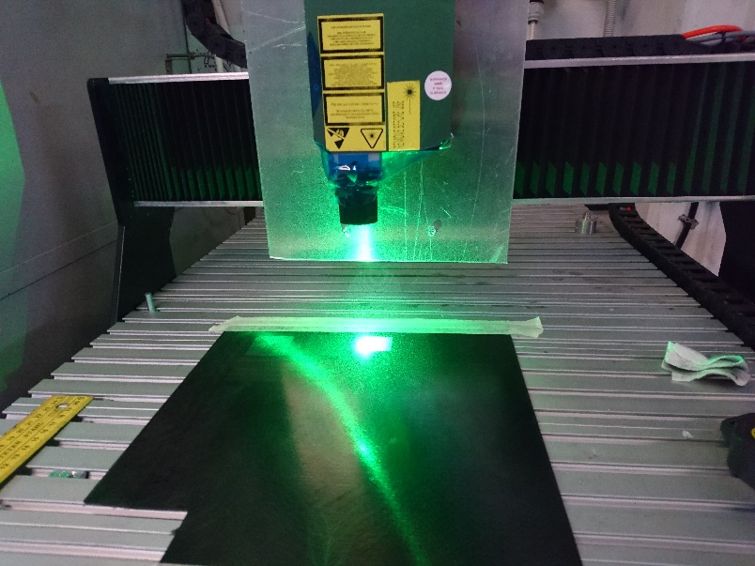

Figure 1. The Ytterbium fiber green laser on the CNC router table of the experimental setup

Table 1. Laser characteristics

Characteristics | Values
Wavelength, nm | 532± 10
Type | Pulsed
Max Average Power, W | 20
Pulse Energy, μJ | 20
Pulse Duration, ns | 1.0 - 2.0
Power Range, % | 20 – 100
Peak Power, kW | > 150
Repetition Rate, kHz | 10 – 600
Laser Beam Quality, M² | < 1.3

In a laser process, a fundamental quantity is the energy density (ED) or fluence per pulse. Especially in composite materials ablation applications, the ED determines the material removal rate as well as the size of the Heat Affected Zone (HAZ) as shown for example in [4]. ED is defined as:

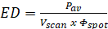 (1)

In the present study, the aim is to assess the influence of the various involved process parameters on the MRR, the HAZ and the mechanical strength as assessed by stepped-lap shear tests. The average power is the product of energy per pulse multiplied with the pulse repetition frequency and by changing the latter we manage to control its nominal value. Another candidate influential process parameter is the scanning speed whilst the is kept constant at approximately 50 μm. Finally, the hatching pattern has been proved to play a role in the final ablation outcome [15] and in this study is selected to be parallel i.e. parallel burning lines with a feed equal to the pre-defined hatching distance every time.

Experimental design and Response Surface Methodology

As previously mentioned, the objective of the present study is double. First, to assess which of the parameters/factors involved in a laser ablation process are statistically significant and second, to determine the optimal parameter values of a multi-variable process such as the laser ablation of composites for repair purposes, in a multi-objective optimization scheme. The statistical tools that are employed to this direction are the classical Analysis Of Variance (ANOVA) for the first objective and the Response Surface Methodology (RSM) through the Box-Behnken Design (BBD) for the second.
The classic ANOVA method is a tool to assess the variations observed in a population and explain the variances. ANOVA answers the question whether or not the means of several groups are equal. The RSM approach is a tool frequently used in the optimization of industrial processes when a number of independent variables is involved and a reduction in the number of experiments need to be executed is pursued. RSM deals with statistical and mathematical techniques for designing experiments, evaluating the effects of variables, developing new processes, building models, optimizing performance and reaching optimum conditions for the variables with the purpose of predicting the anticipated responses. The BBD is considered as a nearly rotatable second-order design based on three-level incomplete factorial designs. BBD does not entail runs in which all the components of the including factors are at their highest or lowest levels simultaneously, an extreme case which often generates non-representative results. BBD is often employed when optimization is required since it models the response surfaces with quadratic functions and this is why it requires three levels of parameter values. The three-level, three-factorial BBD is employed to optimize the following objective functions/ measured responses: 1) CFRP material removal rate, 2) the Heat Affected Zones at three locations on the laser-treated surface and 3) the shear strength obtained after the material removal through the tensile test of a stepped-lap joint.
Three experimental factors were selected as the major process variables i.e. the pulse repetition frequency (A) which in turn controls the average power, the scanning speed (B), and the hatching distance (C) which represents the distance between two consecutive laser scans. After some preliminary tests and taking into account the capabilities and limitations of the available CNC router, the range of interest of the process variables was determined as in Table 2 below.

Table 2. The selected levels of the investigated factors

Parameters | Units | Labels | Values Levels
 |  |  | Low (-1) | Medium (0) | High (1)
Pulse Frequency | kHz | A | 300 | 450 | 600
V_{scan} | mm/min | B | 1500 | 3500 | 5500
Hatching Distance | μm | C | 100 | 175 | 250

ANOVA was utilized in order to obtain the interaction between the response, the process variables as well as their interactions based on p-value statistics. Furthermore, for the optimization task using RSM, the quadratic fitting of the experimental data was performed using the following second order polynomial equation:

(2)

Y_{predicted} | = | is the predicted response,
β₀ | = | a constant coefficient,
β_{i} | = | the linear coefficient of the factor X_{i},
β_{ii} | = | the quadratic coefficient of the factor X_{i},
β_{ij} | = | the coefficient determining the interaction between factors X_{i} and X_{j},
X_{i} & X_{j} | = | the process variables, and
ε_{i} | = | the error of the model.
Where:

BBD for a three-factor case proposes the execution of 15 runs/experiments in random order instead of the 3³=27. The experiments that were extracted from the BBD and the responses of them are presented in Table 3 below.
Additionally, in order to check the quality of the fit of the model, the coefficient of determination R² was used:

(3)

With the sum of squares of the residuals and the sum of squares of the proposed model. The required runs and the selected factor levels are presented analytically on Table 3.

Table 3. The selected levels and randomized runs

Run | A:Frequency | B:Velocity | C: Hatching Distance
 | kHz | mm/min | μm
1 | 450 | 5500 | 100
2 | 300 | 5500 | 175
3 | 450 | 3500 | 175
4 | 600 | 5500 | 175
5 | 450 | 1500 | 100
6 | 450 | 5500 | 250
7 | 300 | 3500 | 100
8 | 600 | 3500 | 250
9 | 600 | 3500 | 100
10 | 300 | 3500 | 250
11 | 300 | 1500 | 175
12 | 600 | 1500 | 175
13 | 450 | 1500 | 250
14 | 450 | 3500 | 175
15 | 450 | 3500 | 175

Results and analysis

3.1 Obtained experimental responses

The final stepped lap joint coupons were subjected to tensile testing at a rate of 13 mm/min in an INSTRON-8872 universal testing machine (Fig. 2a) in order to obtain the shear strength of the joint.
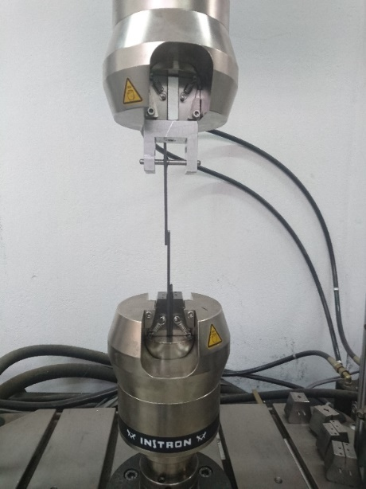
Figure 2. a) coupon during a representative test b) resulted stress-extension curves

Regarding the HAZ measurements, we attempted to assess the HAZ effect in the plane of the ablated surface. Several authors investigate the HAZ out-of-the-plane of the laser processing with very interesting findings and insights. The images necessary for the HAZ estimation were captured in a SINOWON IMS300 inverted metallurgical microscope and measurements were focused in three areas of the stepped joint, the 1st step at A, the 2nd step at C and the side at B as it is schematically shown in Fig. 3. For the measurements, the Material Plus software was utilized.

A
B
C
Figure 3. Schematic depiction of the three locations on the adherent were HAZ was measured: A – HAZ 1st Step, B – HAZ Side, C – HAZ 2nd Step

3.2 ANOVA results

The ANOVA analysis was implemented with the free statistical software JASP [9]. In the present work its utility is to assess which of the three process parameters under study (frequency, velocity and hatching distance) as well as their dual interactions are statistically significant regarding the five targeted responses (removal rate, HAZx3, shear strength of lap joints). ANOVA’s results are summarized in Tables 4-8 with sum of squares, degrees of freedom (df), mean square, F-value and p-values being the main items. The p-values are used to assess the statistical significance of factors and their interactions at a 95% confidence level. Thus, p-values lower than 0.05 suggest statistical significance for the factor or factors interaction under study.

Table 4. ANOVA – Material Removal Rate
Cases | Sum of Squares | df | Mean Square | F | p
A | 18.096 | 2 | 9.048 | 64.874 | 0.015
B | 39.907 | 2 | 19.953 | 143.066 | 0.007
C | 7.364 | 2 | 3.682 | 26.398 | 0.036
AB | 14.239 | 3 | 4.746 | 34.032 | 0.029
AC | 1.889 | 2 | 0.945 | 6.773 | 0.129
BC | 1.296 | 1 | 1.296 | 9.294 | 0.093
Residual | 0.279 | 2 | 0.139

Table 5. ANOVA - Single Lap Shear strength
Cases | Sum of Squares | df | Mean Square | F | p
A | 10.199 | 2 | 5.099 | 22.393 | 0.043
B | 48.851 | 2 | 24.426 | 107.264 | 0.009
C | 27.814 | 2 | 13.907 | 61.073 | 0.016
AB | 2.987 | 3 | 0.996 | 4.372 | 0.192
AC | 5.435 | 2 | 2.718 | 11.935 | 0.077
BC | 1.938 | 1 | 1.938 | 8.509 | 0.100
Residual | 0.455 | 2 | 0.228

Table 6. ANOVA – HAZ1
Cases | Sum of Squares | df | Mean Square | F | p
A | 9515.923 | 2 | 4757.96 | 20.076 | 0.047
B | 3048.719 | 2 | 1524.36 | 6.432 | 0.135
C | 28866.673 | 2 | 14433.34 | 60.900 | 0.016
AB | 23443.625 | 3 | 7814.54 | 32.973 | 0.030
AC | 13761.375 | 2 | 6880.69 | 29.032 | 0.033
BC | 36.000 | 1 | 36.00 | 0.152 | 0.734
Residual | 474.000 | 2 | 237.00

Table 7. ANOVA – HAZ2
Cases | Sum of Squares | df | Mean Square | F | p
A | 15931.441 | 2 | 7965.7 | 19.701 | 0.048
B | 24033.360 | 2 | 12016.7 | 29.720 | 0.033
C | 6055.314 | 2 | 3027.7 | 7.488 | 0.118
AB | 20014.125 | 3 | 6671.4 | 16.500 | 0.058
AC | 14362.375 | 2 | 7181.2 | 17.761 | 0.053
BC | 729.000 | 1 | 729.0 | 1.803 | 0.311
Residual | 808.667 | 2 | 404.3

Table 8. ANOVA – HAZside
Cases | Sum of Squares | df | Mean Square | F | p
A | 47073.583 | 2 | 23536.8 | 48.002 | 0.020
B | 290711.860 | 2 | 145355.9 | 296.443 | 0.003
C | 11648.460 | 2 | 5824.2 | 11.878 | 0.078
AB | 16900.250 | 3 | 5633.4 | 11.489 | 0.081
AC | 111012.750 | 2 | 55506.4 | 113.201 | 0.009
BC | 3782.250 | 1 | 3782.2 | 7.714 | 0.109
Residual | 980.667 | 2 | 490.3

The classical ANOVA assumes that the residuals are normally and independently distributed. These assumptions were checked and confirmed via graphical analysis of residuals.
The results of the ANOVA Table 4 for the MRR indicate the statistical significance of all single factors as well as the interaction of pulse frequency and scanning speed. Table 5 suggests that for the SLSS all single factors are significant. HAZ1 is not affected by the scanning speed but from the other two factors and the interactions pulse frequency - scanning speed and pulse frequency – hatching distance are influential to the process according to Table 6. HAZ2 is only affected by pulse frequency and scanning speed (Table 7), the same with HAZS which is additionally affected by the pulse frequency – hatching distance interaction (Table 8).

4. Conclusion

A 20-W pulsed green fiber laser was for the first time utilized for a ply-by-ply ablation of CFRP laminates for repair purposes towards a more automated process. A design of experiments approach and more specifically the Box-Behnken Design was adopted in order to design the experimental study the effect of the process parameters on the material removal mechanisms, the SLSS of a stepped lap joint as well as the HAZ extent. From the reported results, the main conclusions drawn are analyzed in the following. The ANOVA tables are useful to assess the statistical significance or the absence of significance of the various process parameters as well as their interactions and may assist in understanding the effect of the process parameter to the removal and damage mechanisms.

Acknowledgements

The research leading to the results presented in the study has received funding from the FET-OPEN Programme of the European Union's H2020 Programme under REA grant agreement N° [665238].

References

- K.B. Katnam, L.F.M. Da Silva, T.M. Young, Bonded Repair of Composite Aircraft Structures, Progress in Aerospace Sciences 2013; 61: 26–42
- F. Ellert, In. Bradshaw, and R. Steinhilper, Major Factors Influencing Tensile Strength of Repaired CFRP-Samples, Procedia CIRP 2015; 33: 275 – 280.
- F. Fischer, S. Kreling, R. Delmdahl, F. Gäbler, K. Dilger, Analytical Characterization of CFRP Laser Treated by Excimer Laser Radiation, Physics Procedia 2013; 41: 282 – 290.
- S. Kreling, F. Fischer, K. Dilger, Surface Structuring of CFRP by Using Modern Excimer Laser Sources, Physics Procedia 2012; 39: 154 – 160.
- F. Fischer, S. Kreling, P. Jäschke, M. Frauenhofer, D. Kracht, and K. Dilger, Laser Surface Treatment of CFRP for Bonding in Consideration of the Absorption Behaviour, The Journal of Adhesion 2012; 88: 350–363.
- T. Yokozeki, M. Ishibashi, Y. Kobayashi, H. Shamoto and Y. Iwahori, Evaluation of adhesively bonded joint strength of CFRP with laser treatment, Advanced Composite Materials 2015, 25(4): 317-327.
- F. Fischer, L. Romoli, and R. Kling, Laser-Based Repair of Carbon Fiber Reinforced Plastics, CIRP Annals - Manufacturing Technology 2010; 59: 203–206.
- C. Leone, I. Papa, F. Tagliaferri, V. Lopresto, Investigation of CFRP laser milling using a 30W Q-switched Yb:YAG fiber laser: Effect of process parameters on removal mechanisms and HAZ formation. Composites: Part A 2013; 55: 129–142.
- JASP Team (2018), JASP (Version 0.8.1) [Computer software, https://jasp-stats.org/]

