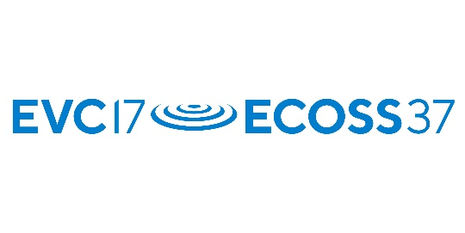

IUVSTA-Elsevier Student Awards: Application Form

Full name of Applicant:
(Block CAPITALS)

Signature of Applicant:

Date of award of first degree:
(Note: within seven years of the start date of conference)

Please attach a copy of the degree certificate.

Full street address of research laboratory:

Department /Unit #

City / Zip Code

Phone /Fax

E-mail

Title of paper submitted to the conference:
(Block CAPITALS)

Name, dates and location of conference
to be attended:
(Block CAPITALS)

This form must be accompanied by a (scanned) letter on official stationery completed by a staff member of your research laboratory and giving the following signed statement:

Name of Applicant:
(Block CAPITALS)

Name of staff member:
(Block CAPITALS)

Function title of staff member:

E-mail

(Block CAPITALS)

I confirm that the above named Applicant is enrolled in a research course at this Institution, will be submitting a paper and plans to attend the above conference (note that only ONE student from the above research laboratory will be supported).

Signature of staff member:

The application form and support documents together with the abstract of the planned conference contribution shall be sent to the chair of the conference (address below) and shall arrive before the general abstract submission deadline.

Address:
Martin McCoustra
EVC-17/ECOSS-37
IUVSTA-Elsevier Award
Institute of Physics
37 Caledonian Road
London N1 9BU
United Kingdom

https://iop.eventsair.com/evc17-ecoss37/
Email: M.R.S.McCoustra@hw.ac.uk

