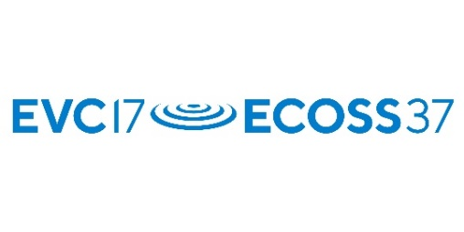

UKRI/STFC ECR travel Awards: Application Form

UKRI/STFC travel awards are aiming to provide a financial support for attending EVC-17/ECOSS-37.

Eligibility

The scheme is meant for Early Career Researchers (defined as being 35 years or under), who have limited support to attend the meeting.

The applicant could be a researcher, an engineer, a PhD student, graduate, undergraduate or technician.

The applicant must be a 1st author for the oral or poster talk and the EVC-17/ECOSS-37 abstract should be accepted.

Full name of Applicant:

Title of submitted abstract:

Signature of Applicant:

Please fill your employment or education details.

I am employed/work as: researcher / PhD student / graduate / undergraduate /technician
delete as appropriate

Full address of university/laboratory:

Department /Unit #

City / Post Code

Phone

E-mail

This form must be accompanied by a (scanned) letter on official stationery completed by a Senior staff member of your research laboratory and giving the following signed statement:

Name of Applicant:

Name of staff member:

Function title of staff member:

E-mail

I confirm that the above named Applicant is
- enrolled in a research course at this Institution / work under my supervision (management)
(delete as appropriate),
- as a researcher / PhD student / graduate / undergraduate /technician / ________________________
(delete as appropriate or write),
will be submitting a paper and plans to attend the above conference (note that only ONE student from the above research laboratory will be supported).

Signature of staff member:

The application form and support documents together with the abstract of the planned conference contribution shall be sent to the chair of the conference (address below) and shall arrive before the general abstract submission deadline.

Address:
Martin McCoustra
EVC-17/ECOSS-37
IUVSTA-Elsevier Award
Institute of Physics
37 Caledonian Road
London N1 9BU
United Kingdom

https://iop.eventsair.com/evc17-ecoss37/
Email: M.R.S.McCoustra@hw.ac.uk

