Supporting Resilience of Internet Art through the Executable Archive Framework
Case-study of Virtual Reality Modeling Language & Flash Artwork

Natasa Milic-Frayling |  | Michael Takeo Magruder
Intact Digital Ltd  United Kingdom  natasamf@intact.digital |  | Takeo.org  United Kingdom  m@takeo.org

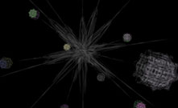
Figure 1 Star shape configuration that connects a series of infinitely complex virtual sculptures generated from the single word 'world' translated into society's most common languages.
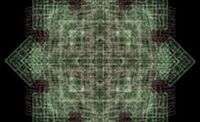
Figure 2 Intricate and infinitely complex texture of individual sculptures generated using VRML and Flash.
Abstract – We present a case study of an artist-led reconstruction of Internet art, triggered by the obsolescence of the Virtual Reality Modeling Language (VRML) and Adobe’s Flash software. The study provides insights into the ongoing management of technology configurations throughout an artwork’s life cycle in order to maintain consistency in its presentation and interaction. Guided by the artist’s requirements for the integrity of the artwork, we evaluated multiple software configurations to achieve quality (Q), stability (S), longevity (L) and scaled online access (A) of the artwork installations. These installations were explored within the Executable Archive framework, centered on long-term artwork integrity and continual maintenance of software environments to ensure reliable access. The study reveals the artist’s priorities that guided preservation actions and the importance of access requirements as an integral part of the artwork reconstruction. The study demonstrates that the Executable Archive framework can make Internet art more resilient.

Keywords – Internet art, VRML, Cortona3D, Flash
Conference Topics – Resilience. Innovation.

Introduction
In December 2020, Adobe ceased support for Adobe Flash and, from 12 January 2021, blocked Flash content from running in the Flash Player to protect users from security risks. This sent shockwaves through artists’ and authors’ communities with concerns about impact on collections of digital artworks that use Flash and Flash Player to reach Web audiences ([1], [2], [3]).
From its inception, Flash played an essential role in the online creative landscape, providing a then missing capacity of the Web to support animation and visual-design consistency across platforms. With the standardization and adoption of the Virtual Reality Modeling Language (VRML), authors could also specify platform-independent 3D objects with rich structures, textures, sounds and interaction. ParallelGraphics’ Cortona3D viewer for VRML provided additional creative opportunities by enabling artists to combine VRML with Flash textures. All artworks using these technologies are now affected. This has prompted actions by memory institutions and specialist preservation organizations, such as Rhizome [4], who provide processes and tools to preserve complex digital artefacts. Contemporary artists who manage their artwork throughout its entire life cycle, from inception to publishing and archiving, must now find ways to keep their art alive.
We present a case study of reconstructing World[s], an Internet art piece (Fig. 1 & 2) by contemporary artist Michael Takeo Magruder. World[s] is representative of the artist’s works that blend VRML and Flash technologies. The artist and the team of experts at Intact Digital Ltd engaged in a joint effort to explore principles of reconstructing and extending use of this Internet artwork.

Artwork Reconstruction Approach
Considering the critical role that software components play in World[s], we conducted the study within the Executable Archive framework [5] that complements traditional archives with hosting and long-term care of software environments needed to use archived digital media.
Prior work on digital art reconstruction raised practical questions around authenticity ([6], [7], [8]) and preservation decisions ([9], [10], [11], [12], [13], [14]). As a result, we paid particular attention to the artist’s preferences and priorities when similar issues emerged. As it transpired, the artist’s concerns revolved around four art reconstruction objectives: quality (Q), stability (S), longevity (L) and scaled online access (A). Q.S.L.A. objectives are an integral part of the artist’s creative practices and publishing strategy. Thus, throughout the reconstruction process, we revisited the artist’s past practices and considered how to extend them to increase the resilience of the artist’s Internet artwork in the face of the changing technological ecosystem and risks to long-term artwork integrity. These four objectives guided our reconstruction work.
Furthermore, the previous use of Executable Archive framework [5] demonstrated quality assurance processes for specialized software installations that are needed in highly regulated domains where archived data must remain usable for decades. Such software is subject to rigorous testing by software vendors and well-established Computer System Validation practices by IT support staff. We expanded the Executable Archive framework with processes to deal with complexities of artwork integrity that include dependencies among multiple software with different life-cycle and artist’s idiosyncratic use of technologies to create unique artwork experiences.

Study Contributions
The artist led reconstruction of World[s] provided an opportunity to apply the Executable Archive framework to a bounded, performant, browser-based artwork dependent on multiple software technologies. As a case study, it complements prior conservation efforts of similar art pieces by considering the end-to-end process, from archiving to reconstruction and active use. It demonstrates how this approach leads to specific practices that make Internet art resilient to obsolescence risks:
- Artwork maintenance. The artist typically modifies the artwork technical configurations during its prime performance period, making pragmatic choices that are guided by the sense of authenticity of the artwork experience. This justifies the approach of replacing obsolete technical components during artwork reconstruction and long-term maintenance, subject to the quality assessment of the intended user experience.
- Artwork access. Active use of artworks is an essential artistic objective, and the reconstruction process must take into account the interaction between legacy software installations and contemporary technologies for hosting and remote access to the artwork installations.
- Artwork integrity metrics. Due to the complexity and intricacies of the art pieces like World[s], it is challenging to arrive at an effective way of characterizing artwork integrity requirements and mapping them onto specifications for artwork installations. In our study, we adopted an iterative process that evolved the artwork specifications through testing and evaluating different installation configurations.
In the following, we provide background information about the problem at hand and reflect on related research. We describe the artwork reconstruction process and then discuss open problems of characterizing the artwork installations and importance of ongoing IT support.

Background

The Art Collection
The internet art collection created by the artist
Michael Takeo Magruder is an example of performant digital artworks from the early 21st century. The artwork World[s] (2006(v1.0), 2009(v1.1)) is a representative piece that combines VRML and Flash plug-ins to enable textured 3D rendering of audio-visual art elements.
The artist maintains a Web portal with detailed descriptions of his art pieces, including documentation, videos, and still images (see Appendix A). The artist also manages a repository of digital media files and selected versions of software used to create and publish the art pieces. The Web portal serves as an archive of the artist’s work. In the past, the artworks have been displayed both in situ, in galleries and museums, and online. The artist maintains old PCs with these original installations. However, due to the recent obsolescence of Flash, online installations are not possible anymore.
The objective is to revitalize the Internet art collection for online use. This requires a careful technical set up since the original operating system, browser versions, and VRML and Flash plugins are neither supported nor secure. We used a local, isolated instance of the World[s] installation on a physical PC in the artist’s studio as a reference installation and a benchmark for specific aspects of quality and stability. However, even this reference installation needed to be extended and modified to achieve the Q.S.L.A. objectives.

Software and Artwork Integrity
In World[s], the artist uses multiple software technologies: Cortona3D VRML viewer and Flash Player plug-ins for the Internet browser with DirectX rendering and GPU acceleration to achieve the artwork aesthetics and the requisite user interaction. World[s] 3D interactive sculptures are presented through intricate visual and audio effects (Fig. 1 & 2). The reconstruction and long-term use of World[s] thus requires a principled approach to managing artwork installation complexities and adoption of processes and procedures to ensure artwork integrity over time, as supported by the Executable Archive Framework (Fig. 3).
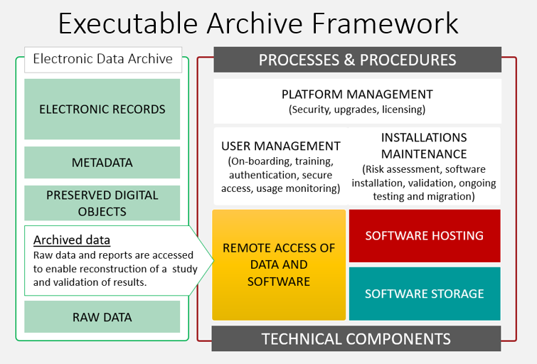
Figure 3 The Executable Archive framework complements electronic data archives with technical components and processes to manage legacy software installations and environments.

Artwork by Michael Takeo Magruder
World[s] 2006(v1.0), 2009(v1.1)
http://www.takeo.org/nspace/ns018/
Artwork elements
- 106 files @ 13.9MB, in a single directory
- 28 VRML (wrl): compressed and signed (no Cortona3D logo)
- 26 Flash (swf):
- 52 Audio (wav): lossless, 16bit, stereo, 8kHz
- start file = ns018.wrl

Executable Archive
The Executable Archive Framework highlights data and software integrity as key requirements for long-term digital preservation [5]. Archived data integrity is commonly achieved through secure storage, reliable access control and regular file fixity checks. In contrast, software integrity for archival use is given less attention, particularly by archives that restrict their practices to a pre-defined set of formats (e.g., PDF) with broadly used readers (e.g., Adobe PDF Reader). However, in highly regulated sectors, like life-sciences, data must remain immutable and software integrity is required by Good Laboratory Practices (GLP) [15] regulations to ensure that scientists can reconstruct decades old studies from archived data.
Within the Executable Archive Framework, software use is enabled through a Software Library platform that hosts validated legacy software installations, provides secure remote access and includes IT support services for long-term software maintenance [5].

Software Validation
Complex scientific protocols typically involve use of sophisticated instruments to collect data and specialized software to interpret and analyze the instrument data. The instruments and the software are subject to rigorous Computer System Validation procedures. Software integrity is strictly monitored; no changes during the software operation are allowed without a well-documented change process.
These Computer System Validation instructions are helpful when creating software installations for long-term archival use. IT specialists create virtualized and secure software installations within a Software Library and maintain them for reliable processing of study data that is kept in an electronic archive. Scientists then use software installations through remote access technologies, such as Virtual Desktops (Citrix) and Remote Desktops (Microsoft) to reconstruct studies.
These end-to-end considerations, from archiving to active use, are important to determine effective reconstruction approaches and set-up appropriate validation processes. Each technical component, from hosting machines to remote access technologies, can affect the software performance and user experience. Thus, the validation process needs to be systematic and comprehensive, covering all the components that support use of data and software installations.

Artwork Integrity
The Computer System Validation practices used in scientific research typically involve software applications that are widely deployed and tested by vendors following standardized procedures. In contrast, validation of Internet art installations is complex and non-standard. First, artists use multiple software technologies that are managed separately, with different levels of support and different release and obsolescence schedules. Second, artists are likely to combine and apply software in non-standard ways, to explore new creative opportunities. Thus, the previous applications of Executable Archive Framework to individual software integrity and Computer System Validation are helpful but not sufficient.
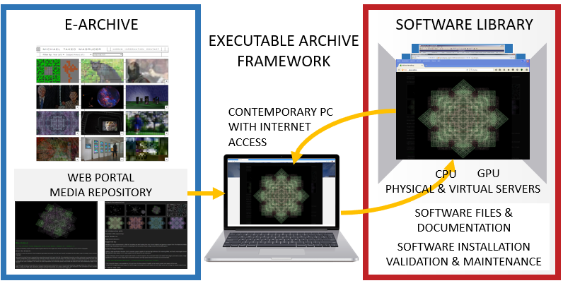
Figure 4 The Executable Archive framework extends traditional e-Archive and digital media repositories with a Software Library to manage software installations on physical and virtual servers. This enables safe use of art installations that require non-secure software components.
From discussions with the artist, it was clear that the quality of interactive experiences is an important aspect of artwork integrity. The quality refers to the visual, audio and interactive experience that results from the computing environment (hardware, operating system, network connectivity, etc.), the software components, and the digital media. When preparing World[s] installations for exhibition, the artist would tailor the computing environment to produce the intended artistic effects. The installations would change across art exhibitions as the artist made adjustments to achieve consistency in the quality of the artwork expression.
With this in mind, reconstructing an artwork affected by software obsolescence can be viewed as a task to identify a configuration that retains the intended quality and increases the artwork’s resilience to emerging technical issues. Considering the complexity of multiple software interactions in World[s], we extended the Executable Archive procedures from pre-specified validation of individual software to combinatorial validation of multi-software installations by applying emerging qualification criteria.
Indeed, in the case of World[s], the reference installation that the artist recreated on a standalone PC was helpful to convey the correct artistic expression and to reason about acceptable departures from that reference expression as we considered factors related to Q.S.L.A. objectives and compared new installations against the initial qualification criteria. Explorations of Q.S.L.A. objectives were conducted within a Software Library (Fig. 4) that effectively extended the artist’s archive into an Executable Archive. The Software Library provided a secure platform for hosting software environments with the artwork installations and remote use of the artwork through virtual desktops that are accessed via standard Internet browsers.

Related Work

Preservation of Digital Art
Concerted efforts, platforms, and tools have brought significant advances in preserving digital art ([4], [9], [12], [16], [17], [18], [19]). Researchers have identified key issues with unbounded and networked Internet artwork and explored approaches to engage meaningfully with their scale, complexity and dynamic nature. We have seen successful efforts to preserve self-contained (i.e., bounded) digital art using migration, virtualization, emulation and porting. We have also seen success with reverse engineering digital art installations.
A relatively recent obsolescence of Flash (31 Dec 2020) motivated a significant effort in the preservation of electronic literature and net artworks. Our work contributes to efforts to address the obsolescence of Flash ([10], [20]). We focus on the operational aspects of art presentation and delivery (i.e., on its active use), while managing the security risks of out-of-support software and complex interactions between contemporary and legacy technologies.
The notion of authenticity in relation to digital artefacts and experience has been essential for assessing the quality of the digital preservation activities ([6], [7], [8]). Through the consideration of artwork integrity, we show how the artist sets the boundary between experiential and technological aspects of the digital artwork and decides which aspects are essential to maintain.

Management of Software Obsolescence
Internet art and computational art forms in general rely on technologies that are produced and used within the global software ecosystem. Thus, it is instructive to consider how software obsolescence is managed in a broader context.
In engineering and electronic systems management, software obsolescence is considered alongside a more general concern of Diminishing Manufacturing Sources and Material Shortages that affects maintenance and leads to the decommissioning of systems ([20], [21], [22], [23]). Software, including open source and Commercial-Off-The-Shelf (COTS), becomes unusable due to functional, technological and logistical obsolescence ([24], [25]). With software, we are particularly aware of issues with:
- Software vendor no longer producing a software product (end-of-sale)
- Inability to extend or renew licensing agreements (legally unprocurable)
- Software vendors, distributors and other third parties ceasing to provide support (end-of-support).
COTS software, in particular, has end-of-sale and end-of-support dates that may be separated by long periods of time. That is taken into account in the system ‘sustainment’ practices that involve maintenance, support, and upgrade to improve the system capacity to endure. By maintaining and upgrading the system, its availability is maximized while controlling the cost and footprint [21].
The end-of-sale and end-of-support are key events that affect artwork integrity and trigger the reconstruction activities. With a lack of planning for sustainment, most of digital art suffers [2]. Conducting the artwork reconstruction and enabling long-term use, requires constant awareness of the changes in the technology landscape and planning for the component replacement as licensing, operational and security issues arise.
At the same time, the obsolescence cannot be stopped or reversed unless all the stakeholders are engaged ([25], [27], [28], [29]). Thus, the focus is on measures for mitigating the impact, depending on the type of obsolescence. In the case of software obsolescence, one may consider re-developing or modifying software to work in a new development environment or hosting it within a virtual environment.
Our work complements the past preservation efforts by considering artwork resilience and long-term sustainment in the context of the creative process. This includes economic aspects of enabling Internet art access at scale which were considered at the time of artwork creation and publishing and remain essential for the preservation planning and long-term availability.

Case Study: World[s]

Method
For the case study we adopted a hybrid method, combining ethnographic and co-creation activities that involved the artist and the Intact Digital team comprising an IT specialist and a computer scientist. Initial scoping of work was established through exchange of information about the system requirements for World[s] installation and recorded online sessions where the artist provided a historical account of the World[s] creation and publishing, rationale behind the selection of technologies and a demonstration of an on-premises installation. The artist created recordings of the local installation and transferred software and digital media to Intact Digital for the purpose of the artwork reconstruction. The reconstruction activities were divided among the team members to cover installation, qualification and documentation of the created artwork instances.
Since each installation is carefully managed in dedicated physical and virtual environments, we optimized resources by selecting software versions based on the artist’s experience with technical issues in the past and gradually substituted obsolete components to meet Q.S.L.A. objectives. During this process, the artist’s instructions and requirements became more specific and the artist’s relative priorities of Q.S.L.A. objectives became more crystalized. For example, one of the installations deemed acceptable involves a trade-off between the economically and technologically sustainable global access and the rendering quality.
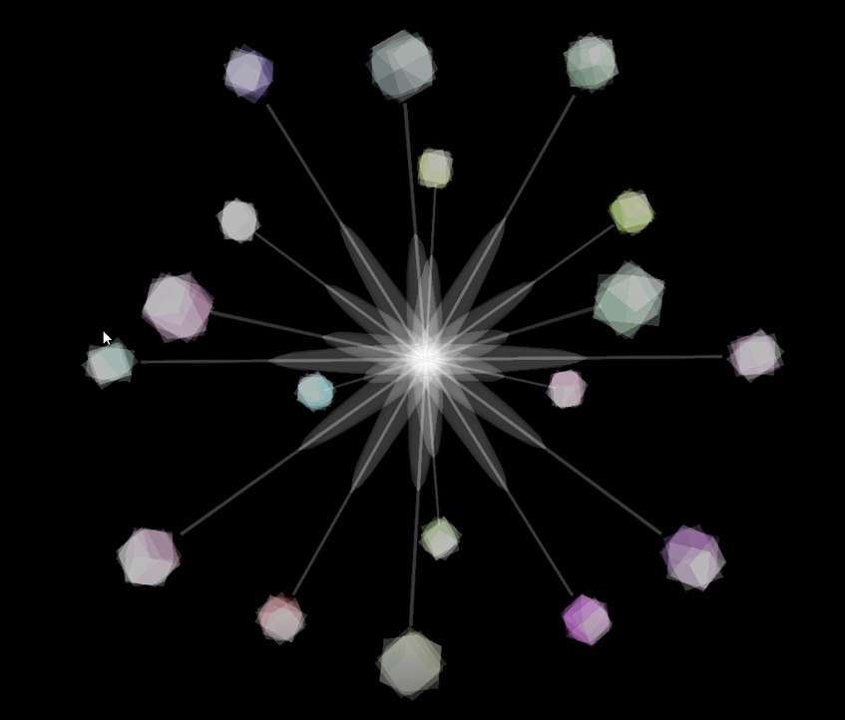 | 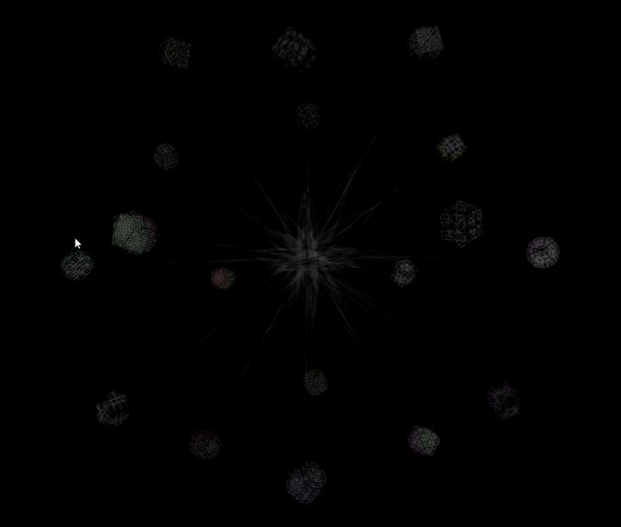
- The main interface star structure with connected digital sculptures. | - The start structure correctly rendered with Flash textures.
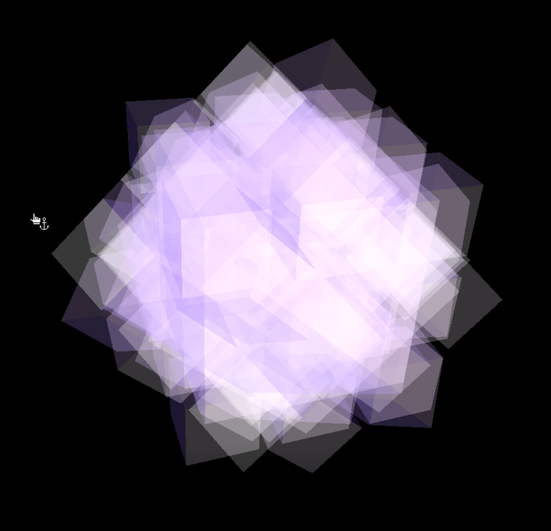 | 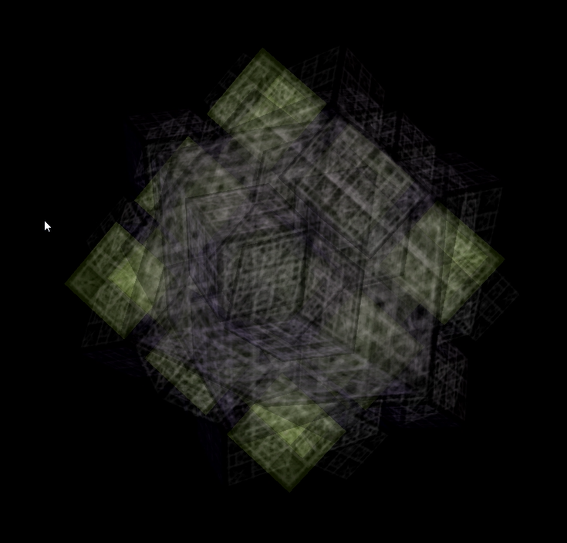
- Cortona3D rendering of one of the individual sculptures. | - The same digital sculpture correctly rendered with Flash textures.
Figure 5 A combination of Cortona3D v.5.0 and earlier versions of Flash causes delays in the rendering of textured sculptures. Resizing Cortona3D window causes textures to disappear altogether.

The work was conducted in two phases:
Phase I. Technical feasibility assessment, involving (a) identification and sharing of artwork digital assets, (b) specifying initial artwork installation and performance requirements and (c) assessing the feasibility of artwork installation.
Phase II. Performance qualification, involving iterations of physical and virtual installations: (a) creation of local installations by the artist, in the artist’s studio, on a dedicated physical computing device and (b) re-creation of the artist’s artwork configurations by the IT specialist within a local IT environment and in the data center, within the Software Library. Work on the data center installations was facilitated through using virtual desktop facilities and included use of virtualized and physical computing resources.

Phase I: Technical feasibility
Preparations for the work began with the considerations of the artist’s immediate concerns about visual and interactive aspects of the World[s] artwork that depend on DirectX, Cortona3D VRML and Flash plugins with supporting GPU capabilities. In World[s], the Cortona3D plug-in is used to render 3D geometry that the artist specified using VRML, overlaying them with textures generated through Flash. When running an artwork instance, a browser uses Cortona3D for VRML rendering and Cortona3D receives textures from Flash. Generally, past VRML renderers did not support import of Flash textures. Cortona3D was unique in providing that extended feature and therefore, it is considered an essential component of the artwork reconstruction that cannot be substituted.
For scaled Internet access, one important factor was GPU cost. In the past, the artist would purchase hardware for individual PCs used for art display. Similarly, during the study, no virtual GPU resources were used within the Software Library platform. All the GPU units were physical, on individual PCs, or attached to a physical server that was accessed remotely. Furthermore, since server configurations can support multiple user sessions, they provide more economical scaling of artwork access. That immediately implies that an optimal artwork installation would need to be compatible with the server operating system (OS), e.g., MS Server 2019, as opposed to the Windows 7 OS used in the artist’s reference installation.
INITIAL TECHNICAL SPECIFICATION
World[s] - VRML + Flash Internet Artworks
Test System (Software)
- Windows 7 64-bit pro Service Pack 1 (last updated 20/02/2015)
- Internet Explorer 11: v 11.0.9600.17728
- Cortona3D Viewer 7.0.185 64-bit
Test System (Hardware)
- CPU: Intel Core2 6600 (dual core @ 2.4GHz)
- RAM: 3GB DDR2-800
- GPU: AMD Radeon HD7750 800MHz - 1GB DDR5
- Storage: 60GB SATA SSD
- Display: 1920x1080p, 60Hz, 32-bit colour
- Audio: onboard stereo
IE 11 & Flash Setup
- both set to no updates
Cortona3D Preferences
- General: Background Color = black
- General: Gradient Color = None
- General: CPU load = Highest Frame Rate
- General: Display Frame Rate = None
- General: Console Mode = Auto Launch
- Scene: NA
- Renderer: Direct X9. Select:
  - Anti-aliasing real-time (if possible),
  - Optimize textures for quality
  - Use Textures for Mip-mapping
  - Limit Texture Size Disabled
- Navigation: Default
- Skin: Default
We started with the technical specifications of the reference installation created by the artist that included Microsoft Windows 7 64-bit, Adobe Flash Player 11.2.202.228, ActiveX 64-bit, Cortona3D Viewer 7.0 r185 64-bit and Internet Explorer 11. The first objective was to investigate interactions among four technical components and their behavior with and without a GPU. Thus, we experimented with different installation environments:
- Physical PC with Windows 7 and a GPU
- Physical PC with Windows 10 and a GPU
- Virtual PC with Windows 7 and no GPU.
The initial findings suggested that interactions between Cortona3D, DirectX and Flash needed to be given a careful consideration:
- The Flash based textures sometimes failed to load and disappeared (Fig. 5)
- Opening VRML files themselves led to inconsistent results.
Furthermore, experiments with DirectX and OpenGL showed a significant degradation of OpenGL rendering, thus ruling out a possibility of replacing DirectX.

Phase II: Performance qualification
The second phase focussed on identifying a configuration that satisfied Q.S.L.A. objectives, including the World[s] user experience through a browser and at scale. For all practical purposes, we treated O.S.L.A. as the artwork integrity requirements that the installations within the Software Library needed to meet. While fully functional, the artist’s local installations of World[s] could not be exposed to the Internet due to the Flash obsolescence and therefore could not achieve longevity and access objectives.
We divided artwork implementation activities into two streams with related goals: (1) creation of local installations on a physical PC to guide the quality assessment and (2) creation of installations in the Software Library environment to satisfy Q.S.L.A. criteria. During the implementation work, the team consulted the artwork documentation, audio-visual recordings and still images and, in addition to email communication, conducted four 2-hour discussions about specific issues encountered with various configurations of the technical components. The initial focus was on the quality and stability. This required navigating through the space of options by combining multiple versions of Flash, Cortona3D, DirectX and Browsers (180 possible configurations). Table 1 shows a selection of technology releases that were selected for explorations.
Table 1 Versions of software used in the explorations of the World[s] installations. Considering that 4 components are involved in each configuration, one is dealing with a large optimization space.
Flash | VRML plug-in | Renderer | Browser
Macromedia Flash 8.0.42.0 (2006) | Cortona3D 5.0 r150 (2006) | DirectX 5 (1997) | Firefox 1.5.0.1 (2007)
Adobe Flash 11.2.202.228 (2012) | Cortona3D 5.1 r157 (2007) | DirectX 7 (1999) | Firefox 52.9.0 (2018)
Adobe Flash 32.0.0.101 (2018) | Cortona3D 5.1 r161 (2007) | DirectX 9 (2002) | Internet Explorer 8 (2009)
 | Cortona3D 6.0 r179 (2009) |  | Internet Explorer 11 (2013)
 | Cortona3D 7.0 r185 (2011)

    - Components Interaction
Influence of Cortona3D releases. The artist explored a number of system configurations on the local PC, evaluating their quality and stability. The selection of Cortona3D 5.0 and DirectX versions were made to mimic the historical installations. The core components comprising Cortona3D, DirectX and Flash, including GPU, were considered as essential and non-interchangeable with alternatives. The operating system and the Internet browser were treated flexibly.
The artist’s familiarity with the Cortona3D releases, led to an informed decision to stay with the Cortona3D 5.0 version and, in case of required upgrade, skip Cortona3D 6.0 which was known for a number of technical problems. That decision naturally led to the selection of the browser. Historically, Cortona3D 4.0 and earlier versions had plug-ins for Internet Explorer (IE) separate from other browsers. Starting with Cortona3D 5.0 version, the same plug-in was used across browsers. In fact, even for Cortona3D 5.0, the installation interface had a checkbox to indicate whether the plug-in is used with IE or other browsers, suggesting that the plug-in might work differently for other browsers.
Influence of Flash versions. As early observations suggested, the overlaying of VRML geometry elements with Flash textures suffered from inconsistent behaviour. The rendering qualities were resolved by the use of Cortona3D, 5.0 r150 with the later version of Flash 11.2. The artist preferred that configuration from the quality and stability perspective.

Access Requirements
In order to allow secure use of non-supported browsers with Flash and Cortona3D plug-ins, the IT expert set up physical computing devices with remote access through a virtual desktop that enabled use of the artwork while blocking the Internet inbound traffic. With this security protection, the user could conveniently interact with the artwork through a virtual desktop within a modern browser while the platform and the installations were safe from cyberattacks (Fig. 4).
We tested the performance of IE 11 with Cortona3D 5.0 r150, and Flash 11.2 running on MS Windows Server 2019, equipped with a GPU. The interaction was enabled through a Citrix virtual desktop. We discovered that a combination of a multi-session environment using MS Windows Server with remote access, Cortona3D 5.0 r150, and GPU was incompatible. We identified Cortona3D 5.0 r150 as a likely cause. More precisely, the way Cortona3D 5.0 r150 plug-in establishes a context for the use of the GPU (e.g., through a remote desktop) was not compatible with a multi-session use of Windows. We tested a modified configuration Cortona3D 7.0 r185, a newer version of the plug-in, and confirmed that it allowed the GPU to be used within the multi-session Windows environments.
Thus, the final configuration for meeting Q.S.L.A. objectives comprised Cortona3D plug-in v7.0 r185, Internet Explorer 11.1790.17763.0 and Macromedia Flash ActiveX plug-in 8.0 r42. Since the original World[s] artwork was created and aesthetically optimised for Cortona3D 5.0, we needed to conduct detailed quality and stability assessments to determine the implications of using Cortona3D 7.0. It turned out that Cortona3D 7.0 introduces flicker during artwork rendering. However, from the artist’s perspective, the trade-off between the changed visual effects and cost-effective online access was deemed acceptable.
This completed the reconstruction of the World[s] artwork that satisfied the Q.S.L.A. objectives:
- Quality and stability are ensured through the compatible versions of Flash, Cortona3D, DirectX and Internet Browser.
- Longevity is extended through the use of MS Server 2019 OS which is fully supported and secure.
- Access is enabled through secure and fully supported Citrix virtual desktops, from any contemporary browser; thus, staying true to the nature of Internet art. MS Server environment supports scaling through multi-user access.

Discussion
The World[s] reconstruction case study provided a number of important insights for the digital art management practices.
Since fundamentally dependent on digital technologies, Internet artwork can be sustained only through carefully managed computing environments. Our collaborative effort, involving the artist and IT specialists, resulted in a clear understanding of the core and supporting technologies. By exploring the dependencies among them, we identified technological components that must be retained and those that could be replaced. The choice of the operating system and the browser, for example, were never seen as an integral part of the World[s] artwork and therefore could be chosen more flexibly to achieve longevity in terms of vendor support, licensing and security updates. Having multiple options for implementing the artwork installations increases its resilience to the technology obsolescence.
At the same time, dealing with a combinatorial set of possible configurations for the artwork installation (Table 1) required reliance on the artist’s experience and intuition about ways a specific technology would process art media, i.e., audio-visual material, and programming scripts. Based on the World[s] reconstruction effort we can affirm:
- Importance of considering end-to-end use scenario
It is critical to take a holistic view and ensure that the full set of requirements for artwork use are included in the artwork reconstruction process. As we have seen, publishing World[s] as an online Internet art installation, through remote access to a hosting server with GPU and browser plug-ins, requires all the components to work in concert. We had to make a change to the original specifications and include a more recent version of the Cortona3D plug-in to enable GPU usage in remote access sessions.
- Importance of ongoing maintenance and support
As physical and virtual computing platforms change and remote access technologies evolve, Internet artwork installations will need to be revisited and adjusted. Ideally, the art creation process would involve sustainment plans that include maintenance, support, and upgrade. This is already common in architecture, engineering and manufacturing, and can be introduced as part of the art appraisal and value retention efforts.
- Importance of comparison and benchmarking
The World[s] reconstruction process confirmed practical challenges in capturing artwork characteristics and providing an operational guide for re-installations. In contrast to scientific scenarios where the integrity of software and data are coupled to provide standard presentations of results, digital art involves intricate audio-visual effects and interactive properties that are difficult to define and capture. During the World[s] reconstruction we have observed a few important aspects:
- Attention trigger—Considerations of a specific artwork property, e.g., lighting or colour intensity, increased when an artwork configuration showed unexpected outcomes, e.g., a significantly better or a significantly worse quality compared to previous instances or set expectations.
- Evolving quality criteria—The artist’s view is considered as ultimate criteria for the quality of the artwork installation. However, that view may evolve with the artist’s exposure to different options and opportunities for changes that are perceived as improvements.
- Benefits of version management—The iterative process of optimizing the artwork configuration and assessing the quality of installations was facilitated by easy access to previous attempts. Within the artist’s studio, the artist systematically explored and stored different versions of the artwork installations and discussed them with the IT specialist. Similarly, the IT specialist used the Software Library platform to set up convenient remote access to the server hosted installations. This suggests that the version management of the artwork configurations should be an essential part of the long-term care and quality assurance. Executable Archive framework supports that practice and incorporates Software Library as a platform to facilitate access to prior installations.

Concluding Remarks
Our study demonstrated the use of the Executable Archive framework to reconstruct and increase the resilience of Internet art affected by technological obsolescence. It illustrated a principled way of identifying core and supporting components to achieve Q.S.L.A. objectives. By treating the Internet art reconstruction as an extension of the artist’s ongoing care of art installations, the artist and the technical team ensured the use of legacy software through contemporary technologies for remote access that are supported and secure. Compared to related efforts that use cloud resources and virtualization ([4], [19], [30]), such technologies are used as a means of scaling, stability and audience reach rather than preservation.
Generally, the Executable Archive framework extends the standard archiving and digital preservation practices with IT processes and procedures that support installation, validation, monitoring and long-term maintenance of software essential for the artwork use. The World[s] case study demonstrated that such an approach can re-vitalize and protect the artistic and cultural value of the Internet art from the Flash obsolescence. Our future work will build on the insights from the case study and explore opportunities to generalize the approach to a broader range of digital artworks.

ACKNOWLEDGMENT
We acknowledge the contributions of M. Willcock who implemented artwork installations and a value of the Internet Archive in identifying and collecting past versions of software used in digital art, including Cortona3D, DirectX and Flash installations. We thank Adam Farquhar for insightful feedback on our study and advice on improving the manuscript.

REFERENCES
- Grigar, Dene M., and Stuart A. Moulthrop. "Pathfinders: Documenting the Experience of Early Digital Literature." (2015).
- Mladentseva, Anna. "Responding to obsolescence in Flash-based net art: a case study on migrating Sinae Kim’s Genesis." Journal of the Institute of Conservation 45, no. 1 (2022): 52-68.
- Salter, Anastasia, and John Murray. "E-Lit after Flash: The Rise (and Fall) of a “Universal” Language." Electronic Literature as Digital Humanities: Contexts, Forms, and Practices (2021): 267.
- Dragan Espenschied, ‘Emulation or it Didn’t Happen’, Rhizome, https://rhizome.org/editorial/2020/dec/21/flash-preservation/ (accessed 28 February 2021).
- Milic-Frayling, Natasa, and Marija Cubric. "EXECUTABLE ARCHIVES: Software integrity for data readability and validation of archived studies." (2021).
- Innocenti, Perla. "Rethinking authenticity in digital art preservation." (2012): 63-67.
- Innocenti, Perla. "Bridging the gap in digital art preservation: interdisciplinary reflections on authenticity, longevity and potential collaborations." (2012): 71-83.
- Innocenti, Perla. "Bridging the gap in digital art preservation: interdisciplinary reflections on authenticity, longevity and potential collaborations." (2012): 71-83.
- Ensom, Tom. "Revealing hidden processes: instrumentation and reverse engineering in the conservation of software-based art." In AIC 46th annual meeting, Houston, Texas, USA. 2018.
- Fiadotau, Mikhail. "Growing old on Newgrounds: The hopes and quandaries of Flash game preservation." First Monday (2020).
- Hedstrom, Margaret and Christopher A. Lee, ‘Significant Properties of Digital Objects: Definitions, Applications, Implications’, Proceedings of the DLM-Forum (2002): 221.
- McGarrigle, Conor. "Preserving Born Digital Art: Lessons From Artists’ Practice." New review of information networking 20, no. 1-2 (2015): 170-178.
- Phillips, Joanna. "Reporting iterations: a documentation model for time-based media art." Revista de Historia de Arte-Performing Documentation in the Conservation of Contemporary Art 4 (2015): 168-179.
- Quaranta, Domenico. "From Context to Content: On the Preservation of Net-based Art." In Science and Art, pp. 452-476. 2020.
- OECD Guidance on Principles of GLP Data Integrity https://www.oecd.org/officialdocuments/publicdisplaydocumentpdf/?cote=env/cbc/mono(2021)26&doclanguage=en
- Guez, Emmanuel, Morgane Stricot, Lionel Broye, and Stéphane Bizet. "The afterlives of network-based artworks." Journal of the Institute of Conservation 40, no. 2 (2017): 105-120.
- Laurenson, Pip. "Authenticity, change and loss in the conservation of time-based media installations." Tate papers 6, no. Autumn (2006).
- Lurk, Tabea, Dragan Espenschied, and Juergen Enge. "Emulation in the context of digital art and cultural heritage preservation." PIK-Praxis Der Informationsverarbeitung Und Kommunikation 35, no. 4 (2012): 245-254.
- Rechert, Klaus, Patricia Falcao, and Tom Ensom. "Introduction to an emulation-based preservation strategy for software-based artworks." Tate Research Publications (2016).
- Poppe, Erik, Eduard Wagner, Melanie Jaeger-Erben, Jan Druschke, and Marina Köhn. "Is it a bug or a feature? The concept of software obsolescence." (2021).
- Sandborn, Peter, and William Lucyshyn. "Sustainment Strategies for System Performance Enhancement." In Handbook of Adv. Performability Engineering, pp. 271-297. Springer, 2021.
- Starling, James K., Youngjun Choe, and Christina Mastrangelo. "Identifying DMSMS availability risk at the system level." International Journal of Production Research 59, no. 10 (2021): 2905-2925.
- Tomczykowski, Walter. "DMSMS Acquisition guidelines: Implementing parts obsolescence." 2001. US Department of transportation, Federal Aviation Administration. Obsolescence and Life Cycle Management for Avionics. 2015.
- Feldman, Kiri, and Peter Sandborn. "Integrating technology obsolescence considerations into product design planning." International Design Engineering Technical Conferences and Computers and Information in Engineering Conference., 2007.
- Jensen, Peter Byrial, Linda Nhu Laursen, and Louise Møller Haase. "Barriers to product longevity: A review of business, product development and user perspectives." Journal of Cleaner Production 313 (2021): 127951.
- Boissie, Kevin, Thomas Vigier, Marc Zolghadri, and Sid-Ali Addouche. "Business Intelligence and Obsolescence Engineering: Prediction, Performance and Innovation, Linked Destinies." In Int. Design Engineering Technical Conferences and Computers and Information in Engineering Conf., vol. 85413, p. V005T05A019. American Society of Mechanical Engineers, 2021.
- Bartels, Bjoern., Ermel, Ulrich., Sandborn Peter. Et Pecht, G., Strategies to the prediction, mitigation and management of product obsolescence, John Wiley & Sons, 2012.
- Box, Jo., Extending Product Lifetime: Prospects and Opportunities, European Journal of marketing, 34–49, 1983.
- Van Nes, Nicole, and Cramer Jaqueline., Influencing Product Lifetime through Product Design., Business Strategy and the Environment, 286-299, 2005.
- Dirk von Suchodoletz, Klaus Rechert, and Isgandar Valizada, ‘Towards Emulation-as-a-Service: Cloud Services for Versatile Digital Object Access’, The International Journal of Digital Curation 8 (2013): 132.

Appendix

Internet artwork collection
World[s] v1.1 by: Michael Takeo Magruder with Drew Baker, 2006(v1.0) - 2009(v1.1) http://www.takeo.org/nspace/ns018/ is part of the artist’s collection of VRML-Flash Internet artworks produced between 2004 and 2014.
Description of the artwork from the https://takeo.org:

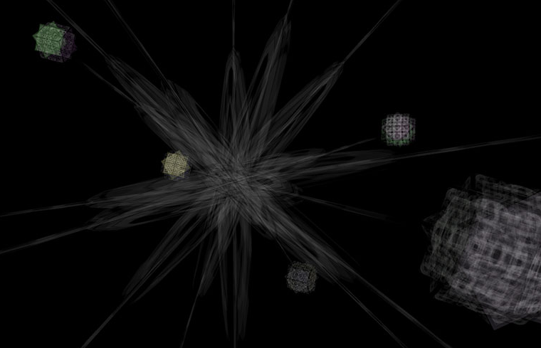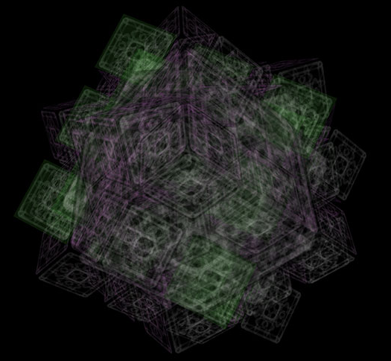
In Collaboration with:
Drew Baker [ VRML programming]
With Thanks to:
Hugh Denard [ discourse]
Supported by:
World[s] v1.0 was commissioned in 2006 for Soundtoys.net with funding from Arts Council England and generous support from The Watershed Media Centre; King's Visualisation Lab, Centre for Computing in the Humanities, King's College London; and ParallelGraphics.
Artwork Requirements:
[gallery] High-specification Windows 7/8/10 computer system capable of real-time high definition 3D rendering (VRML and Flash); multi/single-channel high definition video system; 5.1/2.1 audio system; and HCI device for user interaction.
[online ] Windows 7/8/10 computer system with Firefox or Internet Explorer; the Cortona3D Viewer and Adobe Flash plugins; and stereo audio. A high-specification CPU/GPU, colour display with ≥1024x768 resolution and high-speed Internet connection are recommended.

World[s] http://www.takeo.org/nspace/ns018/
v1.1 by: Michael Takeo Magruder with Drew Baker, 2006(v1.0) - 2009(v1.1)

About the Artwork:
World[s] is a series of dynamic virtual sculptures generated exclusively from the word 'world' translated into the native script of society's most common languages.
Each word in its text format is imported into a two-dimensional 32x32 pixel Flash file. The embedded characters are then vectorized, re-proportioned into a square configuration, and multiplied at 90° intervals and their respective mirrored states. The result is a group of mandala-esque entities less than 1KB in size that can be infinitely expanded without pixilation. These visual elements are then rasterized as 64x64 pixel bitmaps which are subsequently translated into sonic analogues. The visual and audio equivalents are inherently paired and provide the basis for the next evolutionary stage of the artwork.
These pairings are then incorporated into a three-dimensional space defined by a set of Virtual Reality Modeling Language (VRML) files. Within this virtual realm, a series of simple cubic structures oscillate at the terminal points of a central rotating star. Each structure is the summation of four possible rotational states (0°, 45°x, 45°y, 45°z) of a prototype cube that is texturized and auralized by a single pair.
When a viewer selects one of these basic elements, the entire realm is destroyed and a new complex formation is created within the void. The newly generated architecture is derived entirely from the single prototype cube that was selected by the viewer. This cube is multiplied and arranged into a perfect 3x3x3 lattice. The lattice is then quadruplicated in a manner identical to its basic precursory structure, and an exponentially more complex 'world' is formed.
Interacting with the furthest extremities or the innermost depths of the construct initiates a mechanism of self-destruction and an ensuing regeneration of the interface star. Though this process, a cyclic relationship between the work's evolutionary states is created.

