Fostering a Data Infrastructure for the Humanities and Social Sciences
A Case Study in Japan

Ui Ikeuchi | Shinsuke Ito |  | Yukio Maeda
Japan Society for the Promotion of Science (JSPS),  Bunkyo University  Japan  ikeuchi@bunkyo.ac.jp  0000-0002-5680-1881 | Japan Society for the Promotion of Science (JSPS),  Chuo University  Japan  ssitoh@tamacc.chuo-u.ac.jp  0000-0002-5239-7391 |  | Japan Society for the Promotion of Science (JSPS),  The University of Tokyo  Japan  ymaeda@iss.u-tokyo.ac.jp  0000-0001-8934-0420
Kiyonori Nagasaki |  | Takeshi Hiromatsu
Japan Society for the Promotion of Science  Japan (JSPS),  International Institute for Digital Humanities  nagasaki@dhii.jp  0000-0002-5485-0567 |  | Japan Society for the Promotion of Science  Japan (JSPS),  The University of Tokyo  sna99237@biglobe.ne.jp

Abstract – For research institutions in the humanities and social sciences in Japan, it is difficult to maintain and operate data archives on a long-term basis. Therefore, the Japan Society for the Promotion of Science (JSPS) launched the "Program for Constructing Data Infrastructure for the Humanities and Social Sciences" in FY 2018 with a five-year timeframe. The program provides (1) the Japan Data Catalog for the Humanities and Social Sciences (JDCat) to enhance data discoverability, (2) ”A Guide to Data Sharing in the Humanities and Social Sciences”, (3) funding and consultation to five institutions, and (4) an online data analysis system. Through these activities, the program aims to promote long-term preservation and re-use of data in the humanities and social sciences.

Keywords – Data Infrastructure, Humanities and Social Sciences (HSS), Closs-search System

Conference Topics – Community

Introduction
There are various types of data in the humanities and social sciences (henceforth, HSS), including individual data from social surveys, statistical tables from official statistics, texts of historical materials, image data, and many other types of data. The "Program for Constructing Data Infrastructure for the Humanities and Social Sciences" aims to promote collaborate research domestically and internationally, thereby promoting HSS through building a comprehensive data infrastructure that researchers can utilize to share data on HSS research across disciplines and countries while fostering a shared culture among researchers and institutions for HSS by funding and consultation.

Fostering a Data Infrastructure

Japan Data Catalog for the Humanities and Social Sciences (JDCat)
In July 2021, JSPS and the National Institute of Informatics (NII) launched Japan Data Catalog for the Humanities and Social Sciences (JDCat), a cross-search system for social sciences data from four research institutes: JGSS Research Center at Osaka University of Commerce; Panel Data Research Center at Keio University; Center for Social Research and Data Archives, Institute of Social Science, the University of Tokyo; and Institute of Economic Research, Hitotsubashi University. From November 2021, JDCat added humanities data from Historiographical Institute, the University of Tokyo and began full-scale operation as a cross-search system for both HSS data. As shown in Fig. 1, JDCat has a faceted search function, which allows users to find data without knowing the technical terms. Prior to it, the project created JDCat schema derived from schemata of JPCOAR (Japan Consortium for Open Access Repository) and DDI (Data Documentation Initiative).

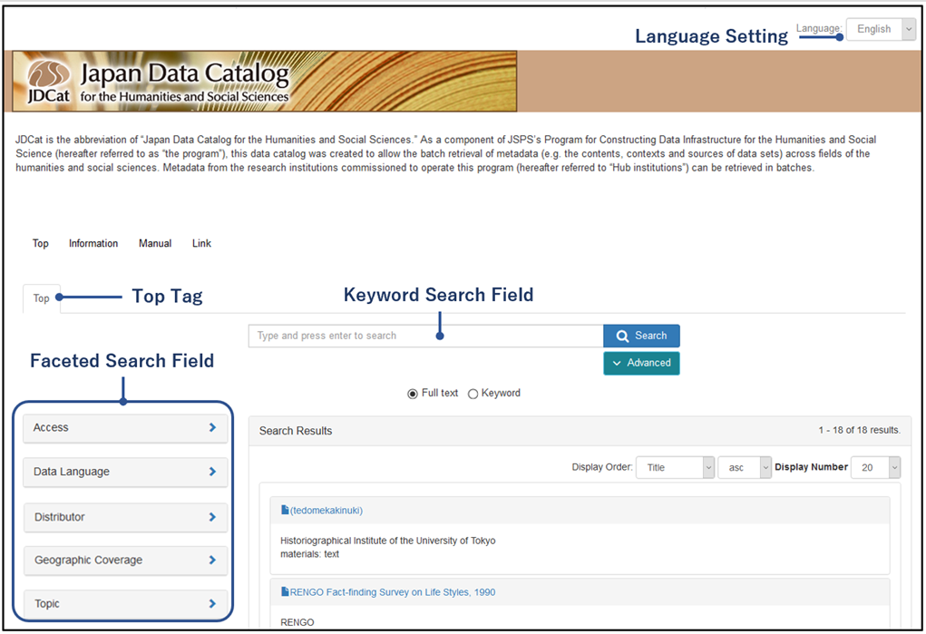
Figure 1: JDCat search screen

“A Guide to Data Sharing in the Humanities and Social Sciences”
The program published “A Guide to Data Sharing in the Humanities and Social Sciences”[1] in 2021. The purpose of the Guide is to help advance research in fields of the HSS. The Guide covers standards for metadata and formatting, Data Management Plan (DMP), data preservation, and data confidentiality. It helps young researchers and graduate students in fields of the HSS to effectively manage data for sharing and long-term preservation.

Funding and consultation
Under this program, five institutions were selected through an open call for proposals. The program has provided funding and advice for the long-term operation of data archives. The development of JDCat was carried out in cooperation with five institutions, meeting on a regular basis.

Online data analysis system
The JSPS and NII have developed an online data analysis system. This system allows users to create and run R and Python programs to analyze data retrieved from JDCat without having to install statistical software or download data. Analysis programs and results can be published and shared. The system is expected to be used for collaborative research and education.

Outcomes and future challenges
As a result of four years of activities, over 7,000 metadata from five institutions have been harvested and can be cross searched in JDCat. The cross searching of data in the fields of HSS by a wide range of users will lead to the use of data in combinations that have never been seen before and to the creation of new research results and joint research that transcends disciplines.
Future challenges for this program are to create a structure that allows institutions interested in data archiving to participate, to collaborate with data archives internationally, and to develop human resources with expertise and skills in the long-term preservation and utilization of data.

REFERENCES
- Program for Constructing Data Infrastructure for the Humanities and Social Sciences, Steering Committee Working Group. A Guide to Data Sharing in the Humanities and Social Sciences, Japan Society for the Promotion of Science Japan, 2021. https://www.jsps.go.jp/j-di/data/guide/tebiki_p.pdf

https://jdcat.jsps.go.jp/
https://jgss.daishodai.ac.jp/english/index.html
https://www.pdrc.keio.ac.jp/en/
https://csrda.iss.u-tokyo.ac.jp/english/
https://www.ier.hit-u.ac.jp/English/index.html
https://www.hi.u-tokyo.ac.jp/index.html

