Appraisal and Selection on a Long-term Preservation Repository?
Can you repeat that, please?

Luís Faria | Miguel Guimarães | Miguel Ferreira
KEEP SOLUTIONS  Portugal  lfaria@keep.pt | KEEP SOLUTIONS  Portugal  mguimaraes@keep.pt | KEEP SOLUTIONS  Portugal  mferreira@keep.pt

Abstract – In this article we describe the way MoReq 2010 has been used to guide the development of appraisal and selection workflows in an open-source long-term digital repository system. Even though the destruction of records is an irreversible process that is deem contrary to the mission of a long-term digital preservation repository, we argue that there are enough real-world use case scenarios that justify the need to bring these features to digital repositories as well further demystifying the idea that digital archives are places where records come to die, and instead reinforce the notion that these can used as vessels to revitalize information and support operational systems in the day-to-day business operations.
Keywords – Appraisal, Selection, Preservation, Repository, RODA.
Conference Topics – Innovation.

Introduction
Long-term digital preservation repositories have long been viewed as the final destination for digital objects (or records) that are at the end of their lifecycle (also known as “inactive records” in certain spheres) and are defined for permanent retention. But this concept, inherited from paper-based records management, is found to be inadequate for electronically-generated records [1], where the mutability, versatility and complexity of the records (data and metadata) and their dependency on intermediate systems (software and hardware) blurry the division between active and inactive records and the requirements of the activities necessary to preserve them for the time-span they are defined to retained.
This new reality also affects how and when records are transferred from production systems (i.e. the system where the records were originally created) to archival systems and blurries the division between both systems, which ends up causing an overlap between the requirements of both systems and the information that is maintained by each of these system in any given time. One of the issues found in this context is related to the moment in the information life-cycle when a record should entail additional considerations regarding digital preservation, (defined in form of a preservation plan, which might require activities to be performed that may not be supported by the production system) and the moment after which a record could, should or must be eliminated from the original system where it was produced. Some institutions, such as Portuguese National Archives, determine that as a general rule-of-thumb additional digital preservation activities should be done to records that are older than 7-years. Although the adequateness of such a general rule is debatable, it is easy to find situations where the retention period of those records ends after the record has been transferred to the long-term preservation archive. Transfer of electronic records is also very different from paper-based records, as records can be maintained in both systems, or partially destroyed or completely eliminated from the production system. But, independently of how transfer is performed, the archival system needs to support the records disposal and retention workflows.
This was the challenge encountered by the Swedish Customs (Tullverket), i.e., to add disposal and retention features to RODA, an open-source long-term digital preservation repository used by archives and other large institutions to safekeep digital records and auxiliate in the implementation of digital preservation plans.
RODA is a digital repository solution that delivers functionality for all the main units of the OAIS reference model. RODA is capable of ingesting, managing and providing access to the various types of digital objects produced by large corporations or public bodies. RODA is based on open-source technologies and is supported by existing standards such as the Open Archival Information System (OAIS), Metadata Encoding and Transmission Standard (METS), Encoded Archival Description (EAD), Dublin Core (DC) and PREMIS (Preservation Metadata).
This paper documents the standards chosen to guide the requirements for the development of disposal and retention workflows, the additional requirements brought by case-studies of archives in different countries, and the technical details of how these features were included in RODA version 4 released in March 2021.

Selection and Appraisal, Retention and Destruction
Traditionally, in an archival context, appraisal is the process of determining if records and other materials have permanent (archival) value, i.e., which are to be kept for specified periods of time and which are to be destroyed. Only the records selected for permanent retention are expected to be transferred to a more permanent archival facility. This decision process typically takes place where the records were originally created (e.g. in the production system).
The evaluation process determines based on legal requirements and on current and potential usefulness, which records should be retained and for how long. This process is in itself a multiple decision-making process inside whatever structure is relevant, that being a small group, a larger department, a whole organization or the more traditional archival approach involving retention rules that go beyond organizational boundaries.
Currently, records may be selected for transfer to an archival system even if they are not for permanent retention. This happens when the retention period is longer than the “preservation period” of the production system. The “preservation period” refers to the amount of time after which a record should be subject to preservation actions and other assessment activities, defined in the preservation plan of the institution and that are not feasible to be done in the system that currently holds the records.

Appraisal Strategies
Appraisal and the definition of the disposal schedule and retention period of records, may be done at many levels, such as fonds or collections, series, files, or even at item level [2]. Studied use cases from the Swedish Customs and the Portuguese National Archives showed two different strategies to define intra- and inter-institutional disposal schedules and retention periods for records.
The Swedish Customs define their disposal schedules and retention periods using the archival hierarchy, which is based on ISAD(g), structuring their records by their retention periods. In this use case, records are organized in series in the archival hierarchy, which determine the retention period for all records within the context of that series (i.e. by inheritance).
The Portuguese National Archives, on the other hand, define the disposal schedules and retention periods using a centralized hierarchical classification system that is process-oriented. Records are classified using classes from a common taxonomy. Records can be classified using multiple classes. National “classification schemes” such as these define the possible record classes and set the relationship between the classes and the records disposal action and retention period [3]. This allows the definition of a disposal classification hierarchy that is orthogonal to the local archival classification hierarchy, as they may have incompatible purposes and objectives.

Disposal Schedule
Taking into account the requirements and approaches from both the use cases analyzed, the most promising standard that establishes a disposal and retention process was MoReq 2010:
A record, once it has been created in a MoReq Compatible Record System (MCRS), can never be deleted in full, as if it had never existed. This concept of accountability is important to good records management: although the complete record and its content no longer exist, there remains a residual record to show that it was once held by the MCRS. The residual record, which remains with the MCRS for the life of the system, proves not only that a record was once active but also, and possibly more importantly, that the record was properly disposed of under an appropriate disposal schedule.
It is the record’s disposal schedule that determines how long a record is retained and how it is subsequently disposed of at the end of its retention period. [4]
Disposal schedules are categorized by the following attributes:
TABLE I
Disposal schedule attributes and description categorization
Field | Description | Mandatory
Title | The identifying name or title of the disposal schedule | Yes
Description | Description of the disposal schedule | No
Mandate | Textual reference to a legal or other type of instrument that provides the authority for a disposal schedule | No
Scope Notes | Guidance to authorized users indicating how best to apply a particular entity and stating any organizational policies or constraints on its use | No
Disposal Action | Code describing the action to be taken on disposal of the record (Possible values: Retain permanently, Review, Destroy) | Yes
Retention Trigger Element Identifier | The descriptive metadata field used to calculate the retention period | Yes  (if Disposal Action is different from Retain permanently)
Retention Period | Number of days, weeks, months or years specified for retaining a record after the retention period is triggered | Yes  (if Disposal Action is different from Retain permanently)

The MoReq 2010 standard was developed for Electronic Record Management Systems, which is not an exact fit for a long-term digital preservation repository. Not all disposal actions defined in the MoReq2010 are supported. Transfer workflow was found to be outside of scope for this development project because, for the analyzed cases (Swedish Customs and Portuguese National Archives) the archive is still currently seen as the final stop of the record holding-systems journey. Therefore, it was decided that RODA would only support three types of disposal actions: Retain permanently, review, and destroy. Also, due to budget constraints and a limited foreseen use by the sponsoring institution, the review lifecycle is not fully supported to the extent that is defined in the MoReq2010 standard.
Records marked to be retained permanently do not define a retention period. Records marked for review or destroy actions have an associated retention period which needs to be configured during the disposal schedule creation. A descriptive metadata field of type “date” is used as an input to calculate the retention period, based on the associated disposal schedule, which may have different granularities: days, weeks, months, or years. There is also an option to have no retention period meaning the record is ready to continue the review or destruction life-cycle depending on the disposal action.
Records with disposal schedules associated with them will have certain operations disabled, even by users with administration permissions, such as “Remove record”. In order to delete records that are under a disposal schedule they need to be disassociated first and then deleted.
The list of the disposal schedules available for records in the repository is available in the “Disposal policies” top-page in RODA (Fig. 1). A disposal schedule can be associated with a record manually or automatically (more details below). Once a record is associated with a disposal schedule, the disposal schedule can no longer be completely eliminated from the system. Instead, it becomes disabled, serving as evidence that it was once associated with a record and that it may have affected its disposal.
RODA offers at the disposal schedule level three different roles. A role to list and view disposal schedule information, a role to manage disposal schedule information and a role to associate or disassociate disposal schedule from records.
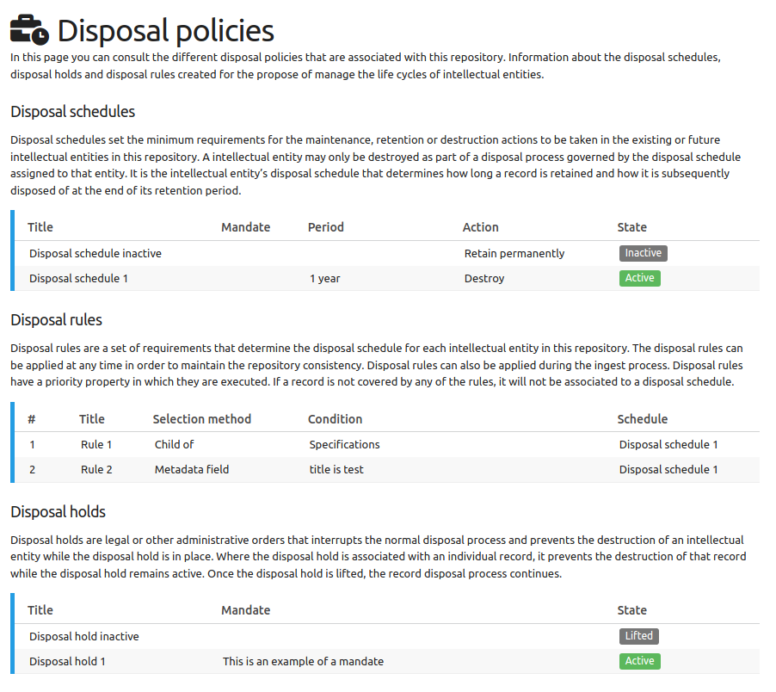
Figure 1 RODA: Disposal policies.

Disposal Actions
While all disposal schedules must conform to the MoReq2010 disposal process, they may specify different behaviors [4]. This behavior is defined by a different disposal action, which must specify one of four different possible outcomes:
- Retain permanently;
- Review at the end of the retention period;
- Transfer at the end of the retention period;
- Destroy at the end of the retention period.
As explained before, the transfer disposal action is not to be supported in this development iteration. The other disposal actions are detailed below, further detailing technical details of how RODA implements them.

Retain Permanently
An important aspect of records management is the preservation of important records for very long periods of time, including the ability to designate some records that are never to be discarded. This is done by applying a disposal schedule with a retention trigger that specifies permanent retention. [4]
Although RODA's main drive is long-term preservation of records elected for permanent conservation, additional controls were added to ensure that records with a “retain permanently” disposal schedule may not be deleted by operations, even by users with administration roles. To perform such operations, a user must first change or remove the disposal schedule associated with the record.

Review (Partial Support)
There are some occasions when the importance of a record and the length of time it should be retained are not known at the time the record is created, and cannot be calculated simply from subsequent events (such as transfer to the archive). It may also be that, in some jurisdictions, the retention period is so long that it is felt that the guidance for their retention may change in the intervening period. Under these circumstances, where there is reasonable doubt about their final destiny, records can be scheduled for later review, rather than for permanent retention, transfer or destruction.
The outcome of the review must include the application of a disposal schedule to the record based on the review decision. The new disposal record will replace the previous schedule associated with the record and will then specify the ultimate fate of the record, or it may be used to schedule another late review, or to retain the record permanently. [4]
The acceptable review periods are defined in the list of disposal schedules, which allow to define a policy on how reviews are done and for how long the definition of the disposal action can be postponed for a record.
MoReq further defines that the disposal schedule can set strict limits for how long a review confirmation can take. In RODA, records can be marked to be reviewed after a retention period, but the workflow for review confirmation is not supported. Records simply must be assigned with a new disposal schedule to get out of the review list, be it a destruction, a retain permanently schedule, or a (predefined) review schedule with a larger retention period.
RODA provides a dashboard where one can search through the list of records that are overdue for review, allowing users to inspect them and to set, for each or in batch, a new disposal schedule to retain permanently, destroy or review with a different retention period.

Destroy
When an active record is destroyed, its metadata and event history are pruned and its content is deleted. The remaining metadata of the record, along with their remaining event history, make up the residual record [4], which serves as evidence that the record once existed.
Pruning is an important process in ensuring the proper destruction of the content of records, especially in sensitive environments where these events and metadata may reveal information about the original content of the record and may be able to be used to partially (or fully) reconstruct the destroyed content. [4]
In RODA, pruning of metadata is configured by an XSLT per supported metadata schema (e.g. EAD, Dublin Core, etc.). This allows the customization of how metadata is pruned for each type of record metadata schema. This is a static configuration for all records that must be in place before destroying the records, but it can iteratively be improved and extended via configuration, although it cannot affect existing residual records.
RODA presents a list of records that are overdue for destruction, as shown in Fig. 2, which can be searched and filtered in several ways. A disposal confirmation can be initiated by selecting from records that are overdue the ones the user wishes to destroy. Then, a formal destruction workflow takes place, where a printable report is finally produced.
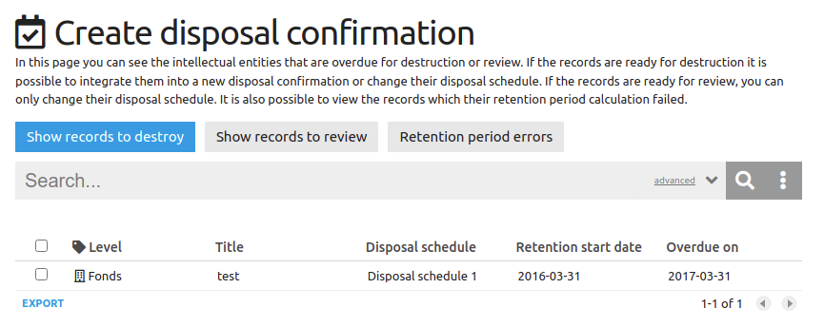
Figure 2 RODA: Create disposal confirmation.
When the records destruction finally happens, the descriptive metadata will be pruned and all its associated files will be removed, leaving the record in a RESIDUAL state.

Disposal Rules
Disposal rules are a set of requirements that determine the disposal schedule for each record in the repository via a selection method.
This is an extension to the MoReq standard that allows users to select a batch of records and associate a disposal schedule to them. This functionality offers a powerful mechanism to automate the definition of retention periods for several records at once. During the ingest workflow it is possible to associate a disposal schedule to the record being ingested simply by defining a set of rules.
TABLE II
Disposal rule attributes and description categorization
Field | Description | Mandatory
Order | Order by which the rules will be applied to records | Yes
Title | The identifying name or title of the disposal rule | Yes
Description | Description of the disposal rule | No
Schedule | Disposal schedule that will be associated with the record | Yes
Selection Method | Condition that will trigger the disposal rule. | Yes

The disposal rules must have an order, a title, a disposal schedule and a selection method. The description attribute is optional. The order attribute allows for rules to be prioritized. The title identifies the name of the disposal rule. The description gives more information about the rule itself. The schedule attribute refers to the disposal schedule that will be associated with the record. The selection method is the condition that will trigger the disposal rule (see Table II).
Regarding the selection method there are two possible values that are currently supported: “child of”, or “metadata field”. “Child of” means that all descendants of the selected record in its hierarchical organization within the catalog will have the disposal schedule associated. “Metadata field” method is related to the record’s own descriptive metadata. Currently it only supports exact matches. The metadata fields can be configured and therefore tailored to comply with the institution's retention policy.
Disposal rules can be applied during the ingest workflow via a plugin that acts as an additional ingest step, or to the whole repository when run manually by a user. When applying to the whole repository there are two options available: 1) override previous disposal schedule associations; or 2) preserve disposal schedules that have been manually associated to a record while overriding automatic associations.
RODA ships with two user roles that are dedicated to the management of disposal rules. A role aims to list and view disposal rules information and a role to manage disposal rules information.

Disposal Holds
Disposal holds are legal or other administrative orders that interrupt the normal disposal process and prevent the destruction of an intellectual entity while the disposal hold is in place. [4]
When lifting a disposal hold all intellectual entities that were on hold can resume the normal disposal process. After the lift the disposal hold remains as an historical reference and it cannot be reused. Disposal holds can only be deleted if they were never associated with an intellectual entity.
When a record is being held by a disposal hold, even if it is not associated with a disposal schedule, RODA disallows certain operations from being performed, even to users with administration permissions. If a record is associated with a disposal hold, operations such as remove record, move record (in the archival hierarchy); create, edit or delete descendants; create, edit or delete representations; and edit descriptive metadata for this record or any of its descendants are disabled. These constraints are applied to keep the record and its descendants safe and unaltered until the legal or administrative mandate that caused the disposal hold is lifted.
Disposal holds are categorized by the following attributes:
TABLE III
Disposal hold attributes and description categorization
Field | Description | Mandatory
Title | The name or title of the disposal hold | Yes
Description | Description of the disposal hold | No
Mandate | Textual reference to a legal or other instrument that provides the authority for the disposal hold | No
Scope Notes | Guidance to authorized users indicating how best to apply the hold and stating any organizational policies or constraints that may affect its application | No

RODA offers three user roles to manage disposal holds. A role that is able to list and view disposal holds information, a role to manage disposal holds information and a role to associate or disassociate disposal holds from records.

Disposal Confirmation
In MoReq 2010, disposal (or destruction) confirmation is the period up to when the destruction of the record is to be executed, but the standard does not provide any more guidance on how this process should be done. Based on the analyzed use cases, specially from the Portuguese National Archives, we were able to verify that the actual destruction of records might need to be approved by a managerial authority in the organization or even a third-party outside the organization, for example, the Portuguese National Archives is required to explicit consent for the deletion of records in any Portuguese government agency.
To allow the support for this use case, a formal disposal confirmation workflow was added to RODA. This enables an administrative (signed) confirmation to be pursued prior to destruction of records. This confirmation is done by producing a report that aggregates all necessary metadata from the records to be destroyed in printable format (paper or PDF). This report should be formally accepted by the respective authoritative body, after which the destruction must be explicitly requested by the operator (which might not be the same person).
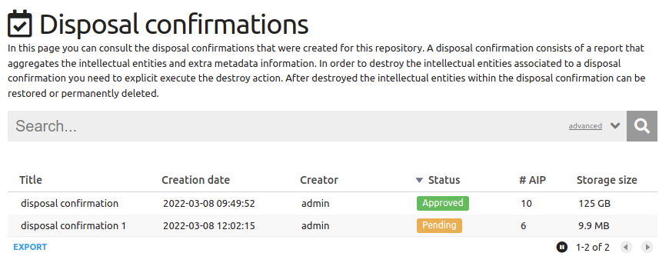
Figure 3 RODA: Disposal confirmations.
RODA presents a dashboard (Fig. 3) which displays pending, approved, restored or permanently deleted disposal confirmations.
The list contains metadata about the number of records affected by the disposal confirmation (“# AIP” column) and storage size that was or will be reclaimed by the permanent destruction of the records affected by the ruling.
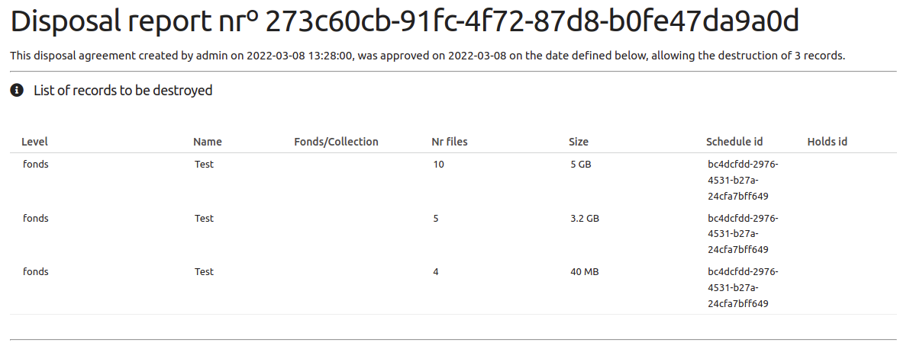
Figure 4 RODA: Disposal confirmation report.
Disposal confirmations with a pending state are still waiting for a confirmation to initiate the destruction process. After the destruction is confirmed, the batch of records identified in the disposal confirmation will be either restored or permanently destroyed (Fig. 4). Automatic permanent destruction after a period can also be configured. But after the initial destruction operation the records are already removed from the repository. This safety net feature is an extension to the MoReq2010 procedure and is further explained in the “Disposal Bin” section.
The disposal confirmation report can be customized to meet the institution branding requirements and informational needs. There are two levels of customization, one referring to the report displayed on RODA’s interface and the other related to the report that will be printed-out. This customization is done via a templating system to tailor the report to the institution's branding and bureaucratic needs and procedures for destroying records.
Once a record is assigned to a disposal confirmation, the record itself and its descendants can no longer be associated with another disposal schedule or disposal hold. The operations of remove record, move record (in the archival hierarchy); create, edit or delete descendants; create, edit or delete representations; and edit descriptive metadata for this record or any of its descendants are disallowed.
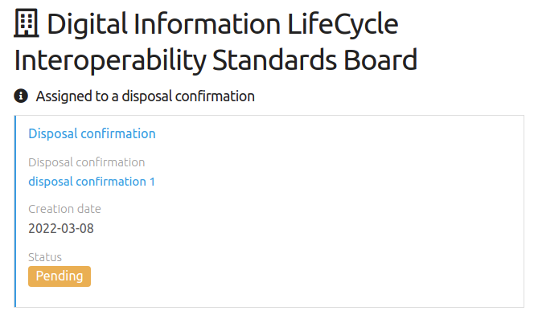
Figure 5 RODA: Record assigned to a disposal confirmation
As depicted in Fig. 5, each record provides detailed information of the disposal schedules, holds and confirmations associated with it, and also presents the calculated retention period as well as the destruction operation details.
At the disposal confirmation level, RODA implements five user roles. A role to list and view disposal confirmation information, a role to manage disposal confirmation information, a role to destroy records according to the disposal confirmation, a role to restore destroyed records according to the disposal confirmation and a role to permanently delete destroyed records according to the disposal confirmation.

Destroyed Records
Active records and residual records are logically separated since their meaning and use is completely different. To list and search through the destroyed records there is a special page, only available to authorized user roles. This page allows users to search through the pruned metadata and inspect the events and metadata of destruction operations, including the disposal schedule, disposal holds that affected the record retention, the parties involved in the disposal confirmation and the authorization for destruction. All this information is accessible via a single-entry point (Fig. 6).
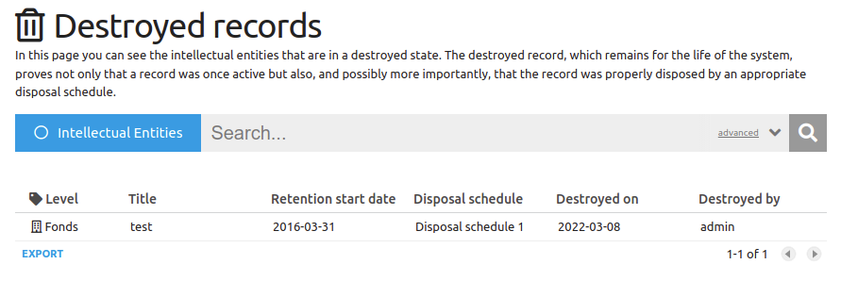
Figure 6 RODA: destroyed records.
RODA also provides visual cues to better identify records that are destroyed and when they were destroyed (Fig. 7).
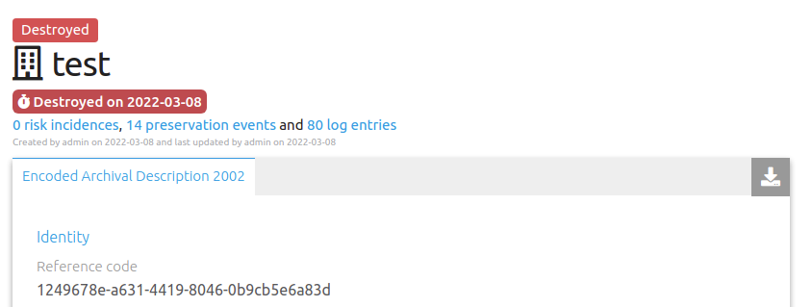
Figure 7 RODA: Destroyed record with visual cues.

Disposal Bin
Destruction of records is an irreversible process that is contrary to the main drivers of a long-term digital preservation repository. Due to that fact, an additional safety net feature was included to allow users to recover records that were improperly destroyed.
During the destruction of the records, a copy of each record is created in a logically separated storage, inaccessible for any RODA process except for the “restore” or “permanent destruction” actions. After destruction, a whole disposal confirmation can be either permanently deleted or restored to the previous state.
The restore process will recover all AIPs to their state previous to destruction and mark the disposal confirmation as restored. When this action is performed, the whole batch of records will be restored as the confirmation authorization (now revoked) was done for the entire set of records and not just a few of these. Records will be again overdue for destruction and the restored disposal confirmation can no longer be changed. A new disposal confirmation will need to be created to destroy all or part of the previously restored records.
Permanent deletion will remove the backup and make the destruction irreversible. The disposal confirmation will be marked as “deleted” and it can no longer be changed. The permanent destruction can also be set up to be automatic after a period of time, for example permanently deleting records after one month of the destruction being confirmed.
Restore and permanent deletion operations require special user roles to be executed.

Preservation Metadata
All disposal related activities over records are fully documented in preservation metadata using PREMIS events. These events can be related to specific records (object-level events) or to the whole archive (repository-level events). The preservation metadata document the provenance of records and also their final destination, ensure all relevant actions made in the records are properly recorded and follow a well-defined procedure, supporting the case for the authenticity of the digital objects and their proper destruction.
Every disposal related operation creates a preservation event which can be listed and inspected in the Preservation Event page (Fig. 8). Preservation event types were selected based on the provided controlled vocabularies. A summary of each preservation event per disposal operation can be consulted in Table IV.
TABLE IV
Preservation events created by disposal operations
Disposal operation | Preservation event type (and level)
Associate or disassociate a disposal schedule | Policy assignment (object-level)
Associate or disassociate a disposal holds | Policy assignment (object-level)
Lift a disposal hold | Policy assignment (object-level)
Assign or withdraw a record to a disposal confirmation | Update  (object-level)
Destroy the record via disposal confirmation action | Destruction  (object-level)
Restore record from disposal bin | Recovery  (object-level)
Create a disposal confirmation report | Creation  (repository-level)
Remove a disposal confirmation report | Deletion  (repository-level)
Permanently delete records from disposal confirmation report | Deletion  (repository-level)

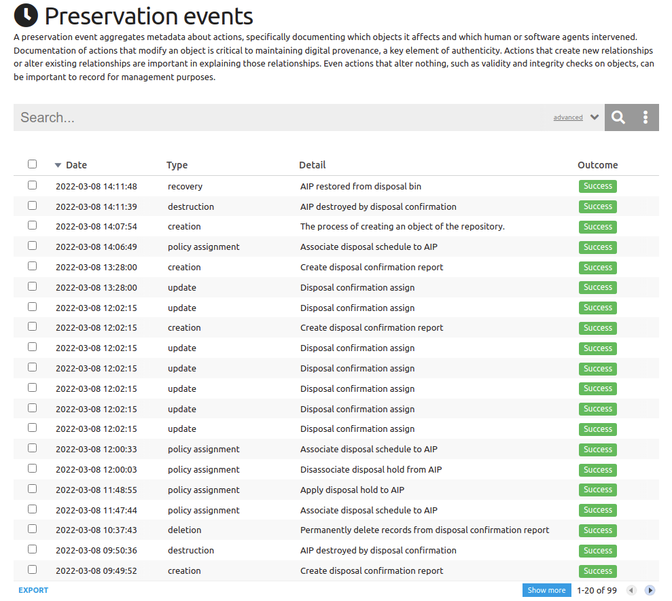
Figure 8 RODA: Preservation events.

Conclusion
Long-term digital preservation repositories have been presented with new challenges as they are exposed to more complex use case scenarios and used by different types of institutions.
That is the case of the Swedish Customs, in which internal policies, and national and European legislation (e.g. GDPR) bring data retention requirements to records that are in scope for long-term preservation activities.
The policies and workflows that govern the disposal of records are very different from country to country and institution to institution. In some situations, the destruction may be authorized by the same person operating the archive, in others the top-management of the institution must be involved in the authorization process, while in other cases destruction policies are centralized and applicable to multiple institutions, thus requiring the involvement of external parties in the authorization process.
Although strong guidance was provided by process definitions included in MoReq 2010, some extensions were required to ensure the use cases identified in the case studies were supported.
Furthermore, special attention was given to additional controls and recording of evidence, to ensure disposal procedures were correctly followed and to provide evidence that records were deleted following proper procedures. Preservation metadata is produced in every disposal-related operation to ensure these processes are documented.
The capacity to fit different jurisdictions, policies, disposal approaches and organizational structures was ensured by designing a customizable workflow that includes ability to tailor disposal schedules, how they are associated with records (manually or automatically), how the retention period is calculated, how record metadata schemes fit into the retention period calculation, how record metadata schemes are pruned upon destruction, what information is available in the disposal confirmation reports and their design, and which users are able to use each of the available operations.
A great importance is given to be clear and evident on which disposal policies are installed and effective and how they were set up in the past. A global view of the disposal policies in effect is available in the “Disposal Policies” dashboard, and every record provides clear information of which disposal policies affect them and what is the calculated retention period.
Although destruction seems to be antagonistic to the core objectives of a long-term digital preservation repository, it is a necessary process to comply with policies and legal requirements to which institutions are subject to. It then becomes essential to ensure that destruction is done following proper procedures and guarantee that no record was destroyed when it should not be.
Historically, records in (national) archives have been exempt from the legal requirements to destroy information as records were expected to be preserved forever, but long-term preservation is no longer limited to (national) archives and thus must expand their capabilities to support digital preservation in every type of institution.
The disposal features described in this paper have been released in March 2021 on RODA 4. These features are available on GitHub and can be inspected on the product demonstration site.

ACKNOWLEDGMENT
We would like to thank the Swedish Customs by sponsoring the development of the disposal features presented in this paper, and ensuring that the resulting developments did not only fit their own use case but more general use cases from the user community. A special thanks to Magnus Wåhlberg for taking the time to study and re-design the Swedish Customs requirements to follow the relevant standards and ensuring the result would serve not just his institution but also the entire world.

REFERENCES
[1] Z. M. Yusof and R. W. Chell, “The Records Life Cycle: an inadequate concept for technology-generated records,” Inf. Dev., vol. 16, no. 3, pp. 135–141, Sep. 2000, doi: 10.1177/0266666004240413.
[2] Internationaler Archivrat and International Council of Archives, Eds., ISAD(G): General international standard archival description; adopted by the Committee on Descriptive Standards, Stockholm, Sweden, 19-22 Sept. 1999, 2. Ed. Ottawa: International Council of Archives, 2000.
[3] A. Lourenço, J. C. Ramalho, M. R. Gago, and P. Penteado, “Plataforma CLAV: contributo para a disponibilização de dados abertos da Administração Pública em Portugal,” Cad. BAD, no. 2, Art. no. 2, 2019, doi: 10.48798/cadernosbad.2047.
[4] DLM Forum Foundation, Modular requirements for records systems : core services & plug-in modules (version 1.1), volume 1. LU: Publications Office, 2011. Accessed: Mar. 07, 2022. [Online]. Available: https://data.europa.eu/doi/10.2792/2045

https://www.roda-community.org
https://www.loc.gov/standards/premis/
https://id.loc.gov/vocabulary/preservation/eventType.html
GDPR: General Data Protection Regulation
https://github.com/keeps/roda
https://demo.roda-community.org/#welcome

