Bit Preservation using the Open Source Bitrepository.org Framework
Use, benefits, robust design principles and enhancements during the past ten years

Eld Zierau | Mathias S. Jensen | Rasmus B. Kristensen
Royal Danish Library  Denmark  elzi@kb.dk  0000-0003-3406-3555 | Royal Danish Library  Denmark  masj@kb.dk | Royal Danish Library  Denmark  rbkr@kb.dk

Abstract – The Royal Danish Library has used the open source Bitrepository.org framework as basis for bit preservation of Danish cultural heritage for the past ten years. This poster will present the capabilities of the BitRepository.org framework with respect to how it can support advanced bit preservation on changing software and media technologies. The Bitrepository.org framework enables use of storage of copies on all types of current and future media, it supports daily bit preservation operations, it enables setup with high access possibilities as well as providing a basis for high operation security at all levels. The poster will also present experience with the use of the BitRepository.org as well as how the Royal Danish Library uses it for different levels of bit safety, confidentiality, access and costs.
Keywords – bit preservation, open source, information security, independence, future proof.
Conference Topics – Resilience; Community.

Extended Abstract
This poster will present the Danish bit preservation solution with focus on the underlying open source software framework BitRepository.org, which the Royal Danish Library has used for ten years for bit preservation of Danish cultural heritage. Furthermore, the background for the development of BitRepository.org and its actual use for securing Danish cultural heritage bits will be presented.
As for all bit preservation solutions, the framework can be seen as an implementation supporting the three main principles of bit preservation:
- A number of copies of data
- Independency between copies of data with respect to technology, organization and placement
- Frequent Integrity checks of copies both locally on copies and between copies
The terminology used corresponds to the following general view of a bit repository with bit preservation.
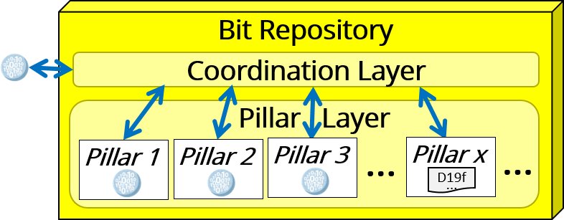
Figure 1 A general view of a bit repository with bit preservation
The Coordination Layer includes services like integrity checks between different copies, and each Pillar represents the organization and technology in serving the storage and safety of an individual copy.
The poster will present the capabilities of the BitRepository.org framework as a basis to support advanced bit preservation including various requirements to:
- bit safety, by allowing pillar services for the different copies of data to be instantiated on different technologies and media, in different organizational environments at different places, and with high independency between the different pillars.
- confidentiality, by supporting encrypted communication between components and allowing offline pillars as well as security around the individual copies. Furthermore, in 2022 encrypted copies will be supported. This is needed when copies are placed at another organization.
- sustainability, by being independent of the implementation of the different pillar services with respect to changing software & media technologies and geographical and organizational location, e.g. the Royal Danish Library is currently replacing one of the pillar services in order to obtain independence between copies.
- access, by making it possible to have pillars that are particularly well suited for access purposes, e.g. the Royal Danish Library has recently transferred the Danish web archive (Netarkivet) to the BitRepository.org framework, where one of the pillar services is designed to support access via Wayback applications.
- costs, by making it possible to have pillars with cheap storage facilities such as tapes, and to some extend by being an open source framework.
The poster will include a description of the robust design principles which enable fulfillment of these requirements. One of the main principles is that components of the system must have no direct knowledge of each other’s implementation. This principle is ensured by design of a common message protocol, which is the only common knowledge between the components of the system. The poster will therefore also include an illustration of how this protocol is implemented.

The poster will also contain a description and illustration of the services that support execution and monitoring of bit preservation actions in the daily operation, e.g. actions like checks of missing files, consistency checks of checksums across all involved copies, surveillance of recalculation time for checksums for individual copies, the possibility of replacing faulty copies, and various monitoring operations.
The poster will also describe why the Royal Danish Library joined forces with the Danish National Archives to develop Bitrepository.org in the first place, and why we are still convinced that this is the best solution for our bit preservation. This description will be accompanied by a presentation of our current implementation, and the recent additions to support further independence and support of placing pillars with encrypted data in e.g. an organization under foreign jurisdiction.
If animated posters are possible, we will provide an animation presenting a demo of parts of the system.
We will be happy to provide a supplementary short paper, if wanted.

REFERENCES
The references provide some literature about the practices of bit preservation [1,2,3], which also includes some description of Bitrepository.org [2,3], as well as references to the criteria and usage guide which is helpful in evaluating bit preservation solutions.
- D. S. H. Rosenthal, “Bit Preservation: A Solved Problem?”, Proceedings of the 5th International Conference on Preservation of Digital Objects, London, Great Britain, 2008, pp. 274-280.
- E. Zierau, “The Rescue of the Danish Bits”. Proceedings of the 15th International Conference on Preservation of Digital Objects, 2018, DOI: 10.17605/OSF.IO/U5W3Q.
- E. Zierau, “Comparing How To Take Care of Humans’ and Bit-streams’ Lives”, Proceedings of the 18th International Conference on Preservation of Digital Objects, 2021.

One Wayback application is e.g. described here: https://en.wikipedia.org/wiki/Wayback_Machine

