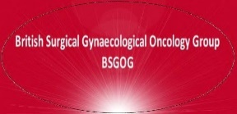
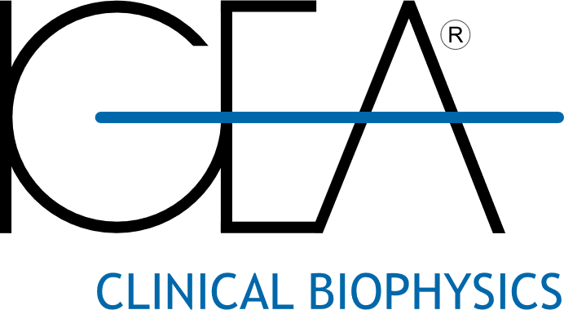

Event: British Surgical Gynaecological Oncology Group (BSGOG) 2024 Annual Conference
Date: 10th July 2024
Venue: Spaces at the Spine, Liverpool, UK
Conference Registration Cost: £75 per delegate
Programme:
08:45: Introduction: Raj Naik, Christophe Pomel, Roberto Tozzi, Georgios Androutsopoulos, Mohamed Mehasseb

09:00: Surgical Video 1: Bowel Resections in Advanced Ovarian Cancer – Gwenael Feron (TBC)
09:30: Surgical Video 2: PlasmaJet Resection/Ablation in Ovarian Cancer & PlaComOv Trial – Simon Butler-Manuel
10:00: Surgical Video 3: Robotic Rad Hyst & Vaginal Cuff Prep: RAC Trial Update – Henrik Falconer
10:30: Surgical Video 4: Laparoscopic Rad Hyst & Vaginal Cuff Preparation – Denis Querleu & Cherif Akladios
11:00: Surgical Video 5: ICG for Bowel Anastomoses – David Jayne (colo-rectal surgeon, Leeds)
11:30: Discussion 1: Update on SHAPE Trial – Marie Plante
12:00: Discussion 2: Update on ROCC Trial and Trials in Stage I Cervical Disease – Nadeem Abu-Rustrum
12:30: Discussion 3: Update on TRUST Trial – Christina Fotopoulou
(13:00: Lunch Break)
14:00: Sponsored Session:
Stryker, ICG Technology Update
PlasmaSurgical Technology Update
Intuitive Surgical, Robotic Technology Update
IGEA Medical, Electro-Chemotherapy Technology Update

15:00: Discussion 4: Update on ROCKETS Trial – Sudha Sundar
15:30: Discussion 6: Update on MIRRORS Trial – Christina Uwins
15:45: Discussion 8: Robotic Simulation & Training the Trainers - Tom Ind
16:00: Discussion 9: Mastery Study - Marielle Nobbenhuis
16:15: Discussion 10: HIPEC Trials - Des Barton & Owen Heath
16:30: Discussion 11: ICG and vulva cancer studies - John Butler
16:45: Discussion 12: Ano-colic anastomoses: Side to End or End to End? - Ioannis Kotsopoulos
17:00: Discussion 13: EndoCare Trial - Emma Crosbie
17:15: Discussion 14: Tailored Endometrial Surgery by Molecular Profiling - Mara Kyrgiou
17:30: Discussion 15: KolGo TRG GCIG Surgical Studies from India - Asima Mukhopadhyay
17:45: Discussion 16: Mental Health in SOCQER2 Patients – Aati Lakhiani
18:00: Discussion 17: HGSOC & 2 week wait referrals – Audrey Kwong
18:15: Discussion 18: CERVANTES Trial Update – David Cibula (TBC)

19:00-21:00: Informal Educational/Networking Event at Local Restaurant (limited spaces available, delegates required to pre-book attendance with In-Conference)
(note: all live surgeries dependent on case presentation and suitability)

