Tweet
The full #FIS21 programme with speakers is available now!
Check it out! 👉 http://bit.ly/FIS-21Prog

@FISConf @biainfection #IDTwitter #AMR #InfectionPrevention

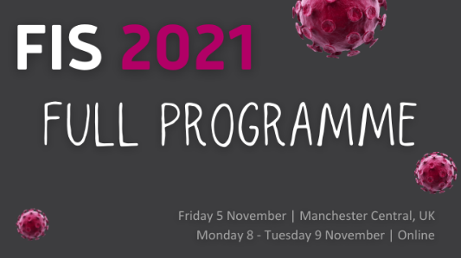

#FIS21 has been awarded 1⃣5⃣ CPD credits by @RCPath (5 - physical event, 10 - online event).

Any additional #online presentations viewed following the live event can be self-accredited via your CPD portfolio
🎙️ http://bit.ly/FIS-21Prog
@FISConf @biainfection #IDTwitter #AMR

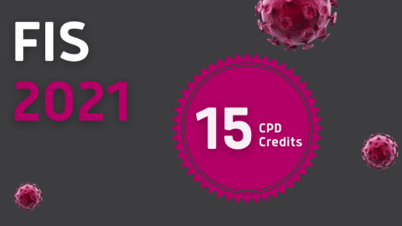

#FIS21

5 November | Manchester (limited)
✅ FIS plenary lectures
✅ Networking opportunities
✅ Oral papers
✅ Exhibition
8 - 9 November | Online (unlimited)
✅ 3-stream programme
✅ Online posters
✅ Sponsor area

👉https://bit.ly/FIS-21

@FISConf @biainfection #IDTwitter #AMR

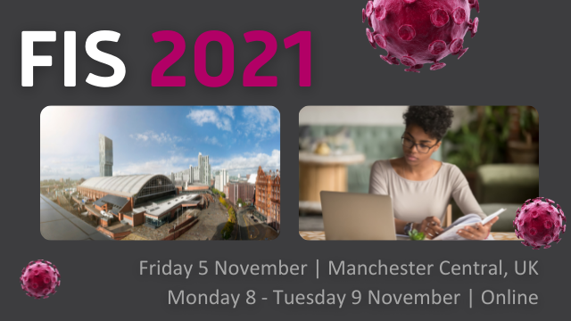

#Online delegate registration for #FIS21 is #FREE for attendees from low & lower-middle income countries?

Join us online 8-9 Nov

🌍 http://bit.ly/FIS-21Reg

@biainfection #IDTwitter #AMR #InfectionPrevention

