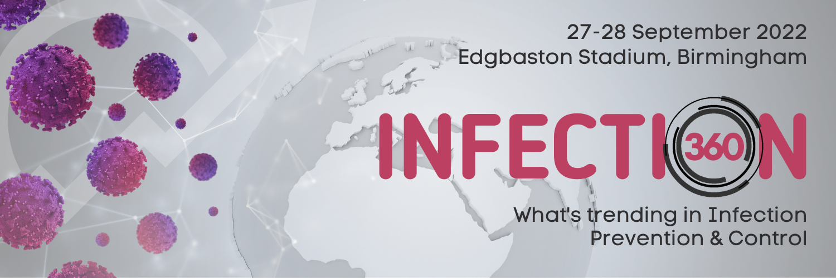

Join us from 27 to 28 September 2022 at Edgbaston Stadium in Birmingham for the inaugural Infection 360 Conference, where renowned speakers within infection prevention discuss technology and its part in combatting new and existing pathogens.
The programme is designed to appeal to all those working within infection prevention and control and public health across clinical and non-clinical areas.
Day 1: SSI, Sepsis, COVID-19 and other emerging pathogens
Day 2: Healthcare buildings as a source of air and water borne infection
The programme has been awarded 8 CPD credits by the Royal College of Pathologists and The Water Management Society
Featuring a large exhibition where companies will be showcasing new products and technologies within infection prevention.
Registration, Programme and abstract submission at: www.infection360.co.uk

Supported by BSI and The UK Sepsis Trust
Organised by Fitwise Management Ltd.

