Tweet
#FIS21 hosted by @biainfection has now launched!

✅Delegate registration open
✅Abstract submission open
✅Programme highlights
📅Friday 5 November @mcr_central UK

&

📅Monday 8 - Tuesday 9 November #Online

👉 https://bit.ly/FIS-21
#IDTwitter #AMR @FISConf
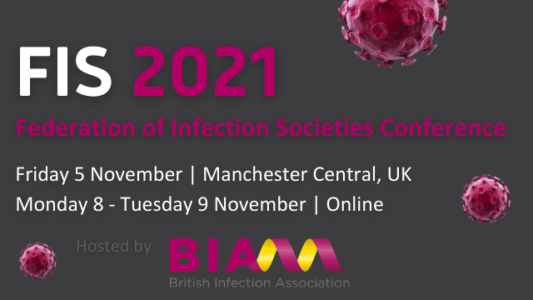
#FIS21 delegate registration is open

Join us: 5 Nov, Manchester & 8-9 Nov #Online
💻FIS Member: £95 physical event / £50 virtual event
🌍Virtual attendees from low & lower-middle income countries: free
Register👉http://bit.ly/FIS-21Reg
@biainfection #IDTwitter #AMR @FISConf

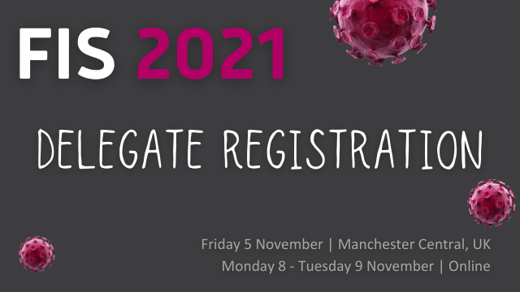

The #FIS21 abstract submission portal is open!
Submit an abstract for consideration as a #virtual poster and/or in-person oral presentation
⏰Submission deadline: Friday 27th August
Info & templates 👉 http://bit.ly/FIS-21Abstracts

@biainfection #IDTwitter #AMR @FISConf

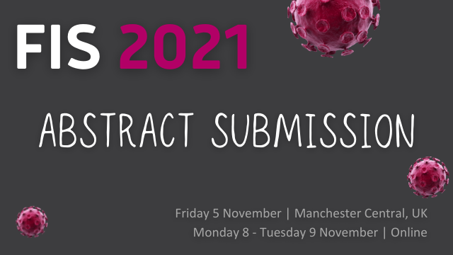

#FIS21 highlights:

5 November | Manchester
✅ FIS plenary lectures
✅ Networking opportunities
✅ Oral papers
✅ Exhibition
8 - 9 November | Online
✅ 3-stream programme
✅ Online posters
✅ Sponsor area

👉https://bit.ly/FIS-21

@biainfection #IDTwitter #AMR @FISConf

Programme Update @FISConf! 📢
We are delighted to announce that the full #FIS21 programme is now available to view
👉 http://bit.ly/FIS-21Prog

@biainfection #IDTwitter #AMR #InfectionPrevention
