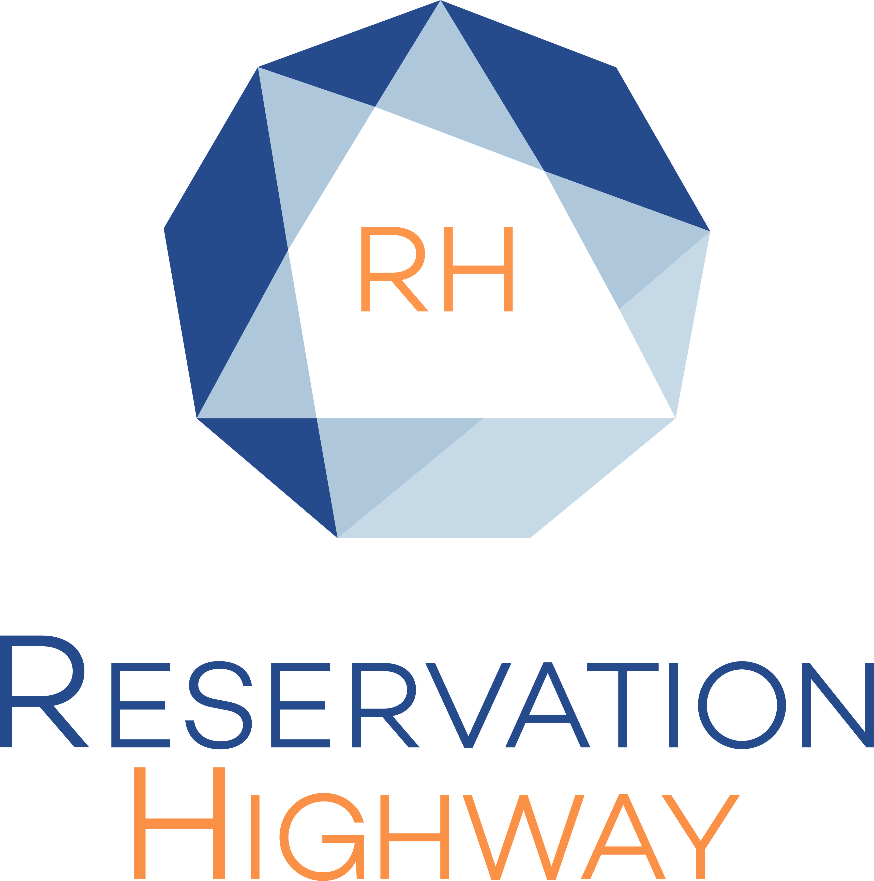


7th MARCH 2024 NATIONAL CONFERENCE CENTRE BIRMINGHAM
Reservation Highway has arranged specially negotiated rates at selected hotels.

EARLY BOOKING HIGHLY RECOMMENDED PLEASE BOOK BY Wednesday 7th February 2024

Bookings made after this date will be on a request basis and subject to availability, rates may vary.

Book on-line www.reservation-highway.co.uk/otc24

Telephone our helpdesk +44 (0) 1423 525577 Email admin@reservation-highway.co.uk

Hotel | Distance to venue | Car parking | Star  Rating | Terms | Double/Twin for single use | Double/Twin
Windmill Village Hotel | 11 minute drive | Free | **** | BB | £165 | £175
Manor Hotel Meriden | 7 minute drive | Free | **** | BB | £145 | £155
Holiday Inn Birmingham City Centre | 20 minute train | £16 | *** | BB | £127 | £127
Strawberry Bank Hotel | 7 minute drive | Free | *** | BB | £99 | £109
Ibis Birmingham New Street Centre | 20 minute train | £15 | ***  Budget | BB | £79 | £86

All rates are quoted per room per night and inclusive of VAT at the prevailing rate. Terms are BB = Bed Breakfast
Parking OSP = on site hotel parking. Where charges are shown these apply per day and are subject to change without prior notice
Star ratings advertised by Reservation Highway follow the guidelines set out by VisitBritain and the AA.

Booking form – please complete and return

Name(contact)…………………………………………………………………………………………………………………………………

Company Name………………………………………………………………………………………………………………………………

Town………………………………………………Country………………………………...Postcode…………………………………..

Telephone………………………………………...………….Email………………………………………………………………………..
Bookings are confirmed by email, please print clearly
Hotel 1st Choice

Hotel 2nd Choice

Guest names | Room type | No. of guests | Arrival date | No. of nights
Please indicate how you wish to secure your booking:

◻ Proforma invoice to be sent (payment to be made in full 21 days prior to arrival)

◻ Credit card guarantee (payment made to the hotel direct on departure)

Card type: (please circle) VISA MASTERCARD AMEX

Card No: -- -- -- -- / -- -- -- -- / -- -- -- -- / -- -- -- -- Expiry date: -- -- / -- --

Security digits may be required by some hotels to complete the transaction please give a contact telephone number below where the cardholder can be contacted.

Telephone……………………………………………………….
No charge is taken from this credit card by reservation highway. The card is used to guarantee your accommodation with the hotel. They may charge the card for non-arrival or late cancellation (cancellation policy for 9 rooms or less is 7 days prior to arrival unless otherwise stated on your confirmation.) All hotel accounts must be settled upon departure.

RESERVATION HIGHWAY LIMITED. WELLS HOUSE, 8 COLD BATH ROAD, HARROGATE. NORTH YORKSHIRE HG2 0NA
TEL: 01423 525577 FAX: 01423 525599

