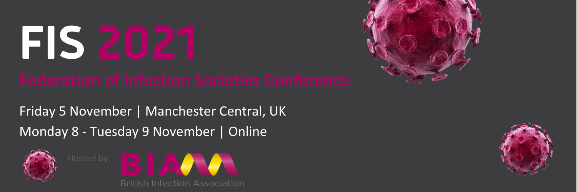

The Federation of Infection Societies Conference 2021 is the largest UK infection conference that brings together delegates involved in all aspects of infection from basic science, infection prevention, antimicrobial stewardship and clinical practice.
- 5 November| Manchester
The face-to-face day of conference will feature the FIS plenary lectures, networking opportunities, oral papers and exhibition
- 8 – 9 November | Online
The 2 online days will comprise a 3-stream programme which includes sessions hosted by a broad selection of the infection community, online posters and sponsors area
Programme and registration available: https://fitwise.eventsair.com/fis-2021/

