**Aldosterone related glomerular injury can be prevented through matrix metaloprotease 2 and 9 inhibition and glycocalyx preservation.**

**Background.** Aldosterone contributes to end organ damage in heart failure and renal disease. Mineralocorticoid receptor inhibitors slow disease progression but side effects including hyperkalemia limit their use clinically and so novel therapeutic targets need to be sought. Damage to the endothelial glycocalyx (a luminal biopolymer layer) results in endothelial dysfunction and albuminuria, key elements of aldosterone related disease. We sought to investigate if the glomerular endothelial glycocalyx is affected by aldosterone and the therapeutic potential of glycocalyx preservation in this model.

**Design.***In vitro* we modeled disease using conditionally imortalised human glomerular endothelial cells (CIGEnC) exposed to 0.1nM aldosterone. The surface expression of glycocalyx components was studied to identify glycocalyx damage. The expression of key glycocalyx depleting enzymes was then studied to identify the underlying mechanism of damage. *In vivo* 0.6μg/g/day of aldosterone was delivered to mice by subcutaneous minipump and 1% NaCl was given in drinking water. Tail cuff plethysmography was used to measure mouse blood pressure changes. A new multiphoton microscopy technique was developed to simultaneously measure the glycocalyx depth using FITC conjugated wheat germ agglutinin lectin (green) and the glomerular sieving coefficient for albumin using Alexa Flour 488 conjugated albumin (red) for the first time. Serial measurements were made in the same glomeruli to study changes following aldosterone exposure. The effect of matrix metalloproteases 2 and 9 inhibition on glycocalyx preservation, glomerular albumin leakage and albuminuria were subsequently evaluated as a potential therapeutic intervention.

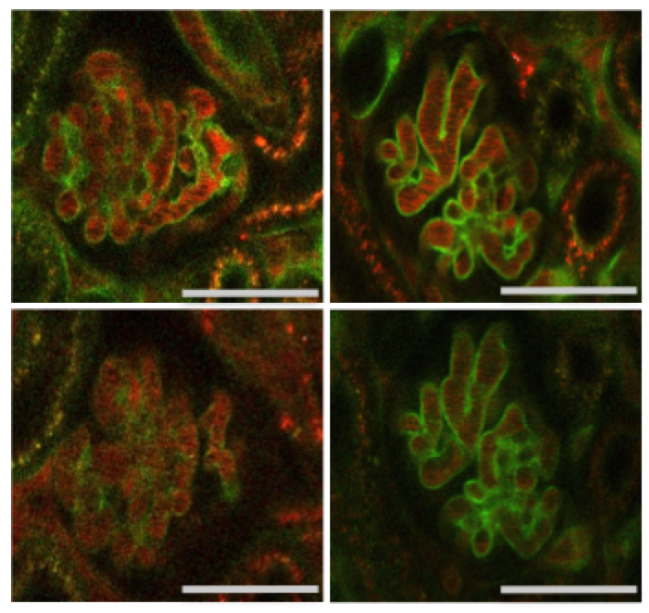**Findings*.*** CIGEnC exhibited reduced cell surface heparan sulphate (70%) and syndecan 4 (65%) following exposure to aldosterone for 5 days. Loss of these key glycocalyx components resulted in impaired shear stress sensitivity consistent with functional glycocalyx impairment. In two mouse strains aldosterone caused albuminuria in the absence of detectable changes in blood pressure. Aldosterone and salt exposure rapidly increased the glomerular sieving coefficient for albumin (6-fold). These changes occurred simultaneously with a 47% decrease in glomerular endothelial glycocalyx thickness. Targeting matrix metalloproteinases 2 and 9 with a specific inhibitor preserved the glycocalyx (Figure 1 – representative images demonstrating glycocalyx preservation on day 5), blocked the rise in glomerular sieving coefficient and prevented albuminuria.

Figure 1. Serial multiphoton images of mice glomeruli in situ at baseline and following 5 days exposure to salt and aldosterone +/- MMP 2/9 inhibitor. MMP2/9 inhibitor preserves the glomerular endothelial glycocalyx (green signal). Bar = 50µm

Day 0

Day 5

Salt aldosterone and MMP2/9 inhibitor

Salt aldosterone and vehicle treatment

Day 5

Day 0

**Conclusion.** Together these data suggest that preservation of the glomerular endothelial glycocalyx through MMP 2 and 9 inhibition may limit the pathological effects of aldosterone on the glomerulus, free from the inherent risk of hyperkalemia associated with systemic mineralocorticoid receptor blockade. Further investigation is warranted to evaluate this novel therapeutic approach in human disease.