**Introduction**: P2X7 is an ionotropic receptor for extracellular ATP which has previously been shown to be important in inflammation and fibrosis and may also play a role in autoimmunity. P2X7 is expressed by most immune cells although studies investigating its presence on neutrophils have generated conflicting results. We have investigated the presence of P2X7 on neutrophils and the role of P2X7 in inflammatory responses of neutrophils and PBMC in ANCA associated vasculitis (AAV).

**Methods:** Neutrophils and PBMC were isolated from whole blood from healthy controls (n=15) and patients with AAV (active, n=24 and remission, n=9) using dextran sedimentation and percoll gradient. Cell surface staining for P2X7 was analysed by flow cytometry. P2X7 pore formation following stimulation with ATP was assessed by large molecular weight dye uptake (To-pro-3) and analysed by flow cytometry. To assess cytokine production in functional studies cells were stimulated with 100µg/ml of IgG containing MPO-ANCA (isolated from plasma exchange fluid of patients with MPO-AAV) or 1µg/ml LPS followed by either 10 μM of P2X7 antagonist (A438079) or DMSO control for 30 minutes then 5mM ATP for 30 minutes.

**Results:** Cell surface staining analysed by flow cytometry showed that P2X7 was present on the cell surface of neutrophils and this was up-regulated in patients with active AAV compared to those in remission or healthy controls (Figure 1a). Levels of P2X7 were similar between patients who were MPO-ANCA positive and those who were PR3-ANCA positive. In 4 of 5 patients for whom both acute and remission samples were available, cell surface expression of P2X7 was lower in the remission sample than at acute presentation. P2X7 on neutrophils was functional and cells could form large pores in response to stimulation with ATP and produce IL1β in response to stimulation with LPS and ATP. PBMC from patients with AAV also showed a trend to up-regulation of cell surface P2X7 although to a lesser degree than on neutrophils which may reflect that this is a mixed population of cells. (Figure 1b). When PBMC were stimulated with MPO-ANCA IgG and ATP there was significant IL1β release and this was inhibited by A438079 (Figure 1c).

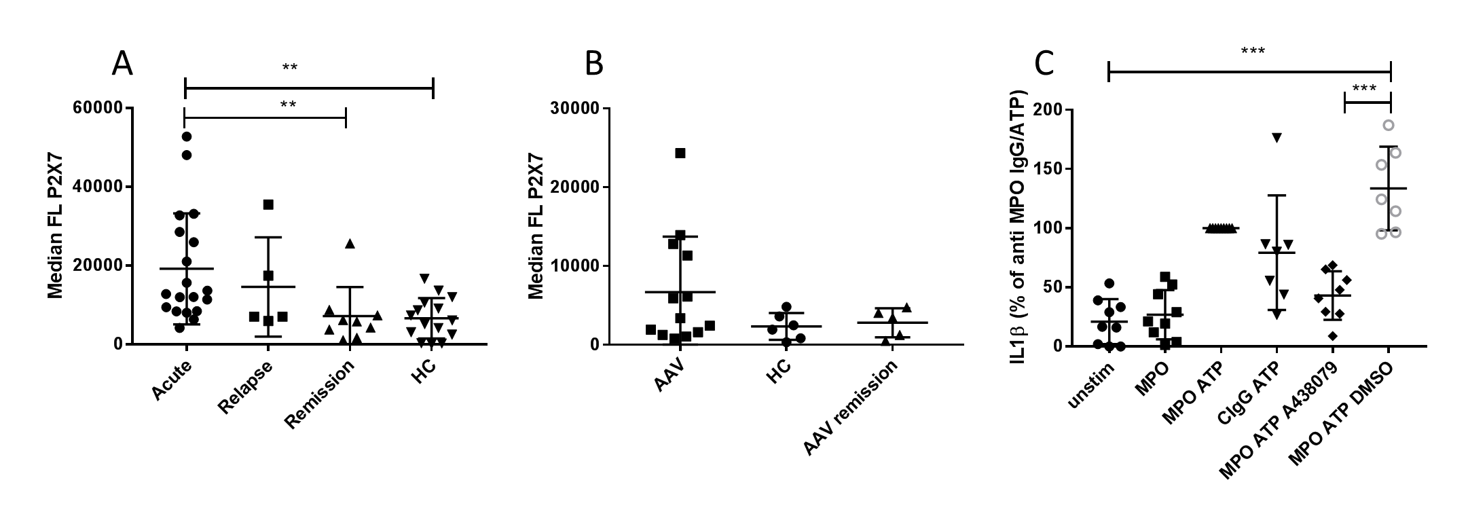Figure 1. (A) Cell surface P2X7 expression on neutrophils from patients with AAV and healthy controls (HC), (B) Cell surface P2X7 expression on PBMC from patients with AAV and healthy controls (HC), (C) IL1β production from PBMC stimulated with MPO-ANCA IgG, and ATP. This is inhibited by P2X7 antagonist (A438079). Statistical analysis with Kruskall-Wallis test with Dunn’s post test correction, **p<0.01, ***p<0.001

**Conclusions:** Human neutrophils and PBMC express functional P2X7 and cell surface receptors are up-regulated in patients with active AAV compared to healthy controls or patients in remission. When PBMC are stimulated with MPO-ANCA and ATP there is P2X7 dependent IL1β release. These results suggest P2X7 and its downstream pathways may have a role in mediating inflammatory responses of monocytes and neutrophils in AAV.