**ACUTE KIDNEY INJURY CALCULATED USING ADMISSION SERUM CREATININE UNDERESTIMATES THE IMPACT ON 30-DAY AND 1-YEAR MORTALITY AFTER ACUTE STROKE.**   
  
**Abstract**

**INTRODUCTION AND AIMS:**

Acute kidney injury (AKI) is associated with poor outcomes in a number of conditions. Diagnosing AKI is challenged by reliance on changes in serum creatinine (SCr) from a known baseline. Kidney Disease Improving Global Outcomes (KDIGO) recommends the use of preadmission SCr values as the gold standard; however this data can be missing in up to 50% of patients. Where preadmission SCr is missing, KDIGO suggest back-calculation of baseline SCr by assuming a preadmission glomerular filtration rate (GFR) of 75 mL/min/1.73m2. To date, there is limited evidence of the performance of surrogate methods in AKI diagnosis and first SCr on admission appears to be widely used in AKI research. We therefore sought to determine AKI incidence via different diagnostic methods using a cohort of acute stroke admissions in the United Kingdom. We also explored predictors of AKI and mortality.

**METHODS:**

Data was collected from all stroke admissions to a large tertiary centre between December 2012 and September 2015. Anonymised data from the Sentinel Stroke National Audit Programme (SSNAP) and electronic health records were combined. AKI was defined as per KDIGO. AKI rates were calculated using 1) preadmission SCr (AKIpre), 2) first SCr on hospital admission (AKIadm), 3) minimal SCr during hospital admission (AKIlow), 4) back-calculated SCr assuming a GFR of 75 mL/min/1.73m2 using the Modification of Diet in Renal Disease (MDRD) equation (AKIMDRD) and 5) back-calculated SCr assuming a GFR of 75 mL/min/1.73m2 using the Chronic Kidney Disease Epidemiology Collaboration (CKD-EPI) equation (AKIEPI).

**RESULTS:**

Of 1440 admissions, 725 (50.3%) had a preadmission SCr. Subjects with a preadmission SCr were older (74.83 ±14.09 vs 69.04 ±16.33, P<0.001), less were male (50.5% vs 57.6%, P=0.009) and had more comorbidities including hypertension (52.1% vs 43.4%, P=0.001), diabetes (24.1 vs 16.7%, P=0.001) and CKD stage 3 or greater (38.2% vs 25.8%, P<0.001). 282 patients had one or no blood tests during admission, leaving 443 included in the final analysis. The rate of AKI using preadmission SCr was 18.7%, compared with 19.9% using first SCr, 41.1% using minimal SCr, 37.0% using back-calculated MDRD GFR and 40.2% using back-calculated CKD-EPI GFR. Misclassification rates were correspondingly lowest with first SCr (17.4%) and highest with computed CKD-EPI GFR (34.8%). In a multivariable regression analysis, pre-existing CKD was the strongest risk factor for AKI (OR 2.78, 95% CI 1.69-4.57; P<0.001).

Preadmission SCr used to diagnose AKI (AKIpre) was associated with increased 30-day mortality (28.9% vs 13.9%: P=0.001; OR 2.64; 95% CI 1.36-5.12: P=0.004) after multiple adjustments. AKI calculated by admission SCr (AKIadm) was also associated with increased 30-day mortality (adjusted OR 2.10; 95% CI 1.10-4.03: P=0.026). A further model was constructed entering in both AKIpre and AKIadm and in all cases only AKIpre was retained.

Having an episode of AKI was associated with decreased survival at 1 year (Figures 1 and 2) (AKIpre 50.6% vs 26.9%: P<0.001; Log rank test=19.73; P<0.001 and AKIadm 43.2% vs 28.5%: P<0.001; Log rank test=6.93; P=0.008 respectively). In multivariable Cox regression analyses, both AKIpre and AKIadm were associated with increased 1-year mortality (adjusted HR 1.90, 95% CI 1.32-2.76; P=0.001 and 1.47; 95% CI 1.01-2.15: P=0.046). Again, additional modelling entering in both AKIpre and AKIadm resulted in only AKIpre being retained.

**CONCLUSIONS:**

Using first SCr on admission to diagnose AKI we demonstrate a comparable incidence to using preadmission SCr. Other surrogate methods produced high AKI misclassification rates and should probably not be used in stroke patients. AKI is a common complication following acute stroke and is associated with increased 30-day and 1-year mortality. AKI-associated mortality appears to be underestimated using admission SCr to calculate AKI compared with preadmission SCr. Given that this method is commonly used to deal with missing preadmission SCr values in AKI research, this urgently requires further exploration.

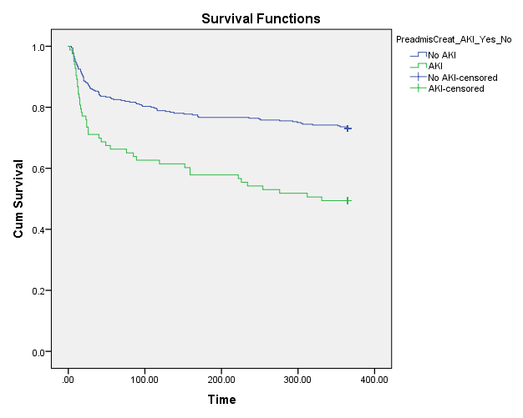

**Figure 1**. Kaplan-Meier survival curve at 365 days using preadmission SCr to diagnose AKI.

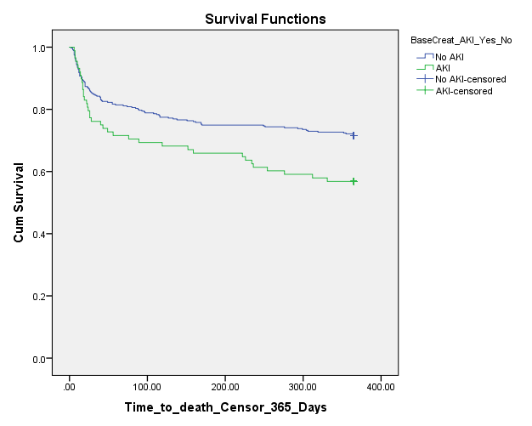

**Figure 2**. Kaplan-Meier survival curve at 365 days using admission SCr to diagnose AKI.