**THE RELATIONSHIP BETWEEN PATIENT ACTIVATION LEVEL AND SELF-PERFORMED TREATMENT RELATED TASKS AMONG PATIENTS RECEIVING IN-CENTRE HAEMODIALYSIS: THE SHAREHD COHORT STUDY.**

**Background:** The patient activation measure (PAM) categorises individuals into levels ranging from feeling passive and overwhelmed to adopting behaviours needed to support their health. Higher PAM levels are associated with better outcomes across a range of long-term conditions. Shared Haemodialysis Care (SHC) supports people who dialyse at hospital centres to be involved in their own treatment, undertaking as many dialysis related tasks as they feel able. This enhanced person-centred approach improves care experience and gives more people the confidence to choose home or self-care dialysis, which is associated with better quality of life. We explore the baseline relationship between tasks and patient activation.

**Methods:** Twelve renal centres are participating in a series of breakthrough collaborative learning events (workshops) to test different ways of increasing patient engagement with tasks. These tasks relate to patients’ own dialysis care, from basic observations through to machine set-up and establishing access. A phased introduction using a stepped wedge design will evaluate the impact of an increased focus on SHC on the number of patients doing 5 or more of 14 dialysis tasks. Data collection includes a range of instruments, supplemented by interviews with patients, carers and staff members.

**Results:** 586 patients were recruited at 12 centres. Baseline patient characteristics and PAM levels were comparable to UK Renal Registry reported prevalent UK HD population. Prior to the introduction of SHC, tasks such as observations, handwashing and applying pressure to their fistula were undertaken by 30-60% of patients, but less than 15% lined, primed and programmed their machine or undertook self-needling. Across the twelve trusts the overall participation in five or more tasks was 32.4% (188/581, 95% CI 28.6% - 36.2%), younger patients (57.4 vs 64.9 years, P<0.001) and those with fistulas (84.1 vs 67.2%, P<0.001) were more likely to do five or more tasks. Patients undertaking five or more tasks at baseline had a significantly higher EQ5D-5L quality of life utility (0.751 vs 0.669, 95% CI of difference in means 0.03 - 0.13, P<0.001) and PAM score (65.3% vs 52.0%, 95% CI of difference in means 10.0% - 17.3%, P<0.001). A positive relationship between tasks and PAM was identified (1.74% increase in PAM score per task, P<0.001).

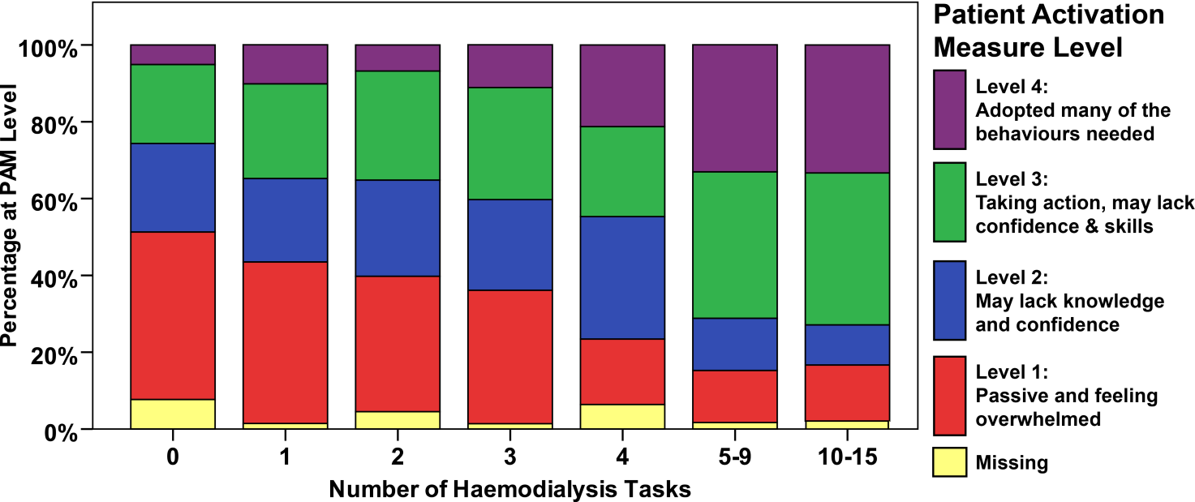

**Conclusion:** We found a relationship between patient activation and the number of dialysis related tasks that patients are able to undertake. The relationship between low tasks and low EQ5D5L may represent underlying physical frailty impacting both measures. The longitudinal evaluation will demonstrate whether there is a temporal relationship between these domains and whether involvement of trusts in a SHC quality improvement collaborative can be a means to increase patient activation.