**Coding CKD in primary care matters: evaluation of a CKD learning health system in east London.**

**Background:** In the UK, the majority of people with chronic kidney disease (CKD) stages 3-5 are managed in primary care. The 2017 National CKD Audit (NCKDA) identified that on average 70% of biochemically identifiable CKD cases have a diagnostic code, with wide variation in practice performance. Evidence from the audit has demonstrated that process measures (blood pressure to target, statin prescribing, flu immunisation, uACR measures) are all lower in uncoded cases. Additionally, the NCKDA shows associations between coding in primary care and lower rates of unplanned hospital admissions and deaths.

**Aim:** Use of quality improvement methodology to support improved coding and primary care CKD management as part of an integrated Community Kidney Service in three Clinical Commissioning Groups in east London.

**Method**: a) The development of electronic case finding and dashboards, using EMIS Web practice data, for quarterly feedback at practice, cluster and CCG level. b) Practice facilitation to support coding, management and other elements of the kidney service, with additional nurse led facilitation for lower performing practices. c) Engagement of local CCGs in providing support and incentives for behavioural change among practices.

**Results:** Dashboards were constructed from routine clinical data from every practice in participating CCGs. All three CCGs showed significant coding improvement over a one year period post intervention (regression for post intervention trend p<0.001), with the top performing CCG increasing from 76% to 90% of CKD cases coded, the weakest CCG increased from 52% to 76%. Variation in practice performance was also reduced.

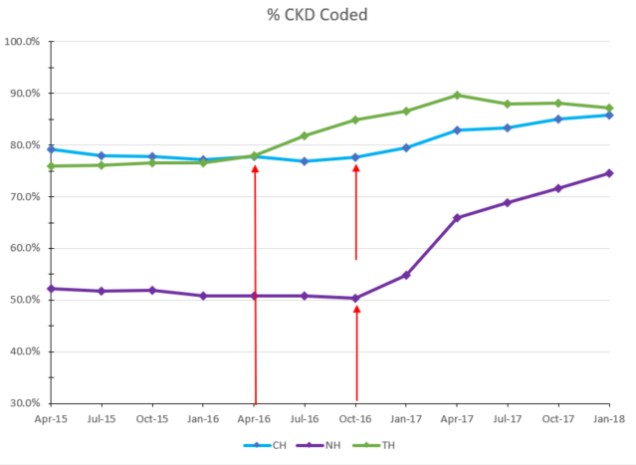

**Conclusions:** Improving CKD coding and management in primary care requires investment in data sharing between practices, and an alignment of managerial and clinical views on resourcing for change. Data driven facilitation to support practices which perform less well is necessary to improve equity in patient care.