Background:

CrossFit is a popular high-intensity workout encompassing gymnastics, strength and conditioning and requiring high repetitions of functional movements. It has a huge commercial worldwide following. Published literature surrounding exertional rhabdomyolysis related to CrossFit workouts exists in the form of case reports only, but such cases highlight the potential for this condition to be severe.

Case Report:

We describe a 37-year-old male who presented with coca-cola coloured urine and swollen, tender abdominal muscles two days following a strenuous CrossFit abdominal workout. His workout involved a high number of repetitions of sit-ups using a glute-ham developer bench. (Figure 1) This sit-up technique is incorporated into CrossFit workouts because it ensures the fullest range of movement possible, and the abdominal muscles contract isometrically throughout the entire movement.

Initial serum creatinine was 117 µmol/L and creatine kinase was 72880U/L. He had no past medical history, and denied any over the counter or performance-enhancing drug / supplement use. The creatine kinase peaked at 103970 U/L before falling and creatinine peaked at 143 µmol/L before falling to 123µmol/L (Figure 2). The patient was treated with intravenous fluids  (6 litres per day of 0.9% sodium chloride supplemented with oral fluid.)

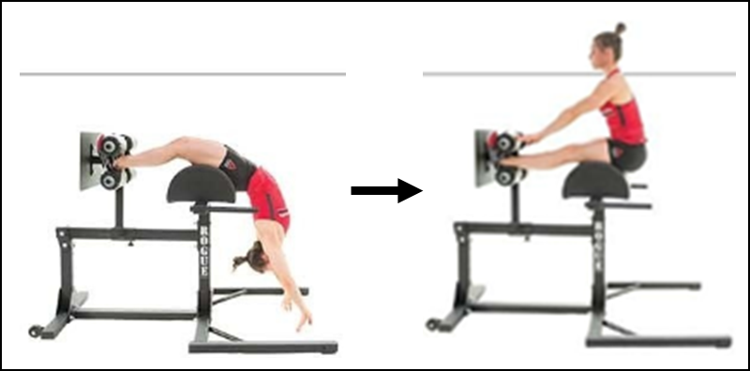

Figure 1: Glute-Ham Developer (GHD) Sit Up

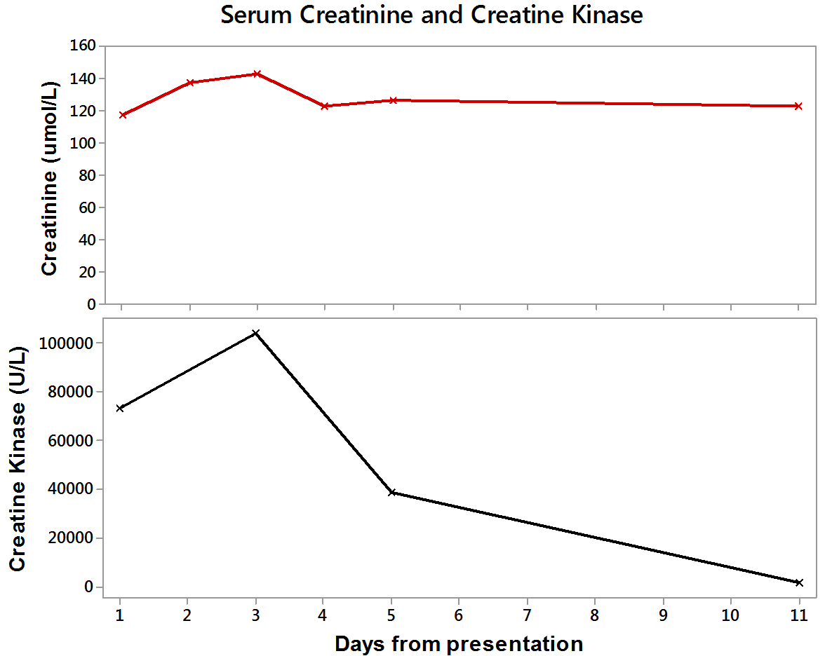

Figure 2: Trend of creatine kinase and creatinine over time post-work out

Conclusions:

This case illustrates rhabdomyolysis directly related to CrossFit workout in a gentleman with no known metabolic or renal disease. CrossFit-induced rhabdomyolysis is a potentially severe condition that can result in significant hospital admission.