**Cytomegalovirus infection is a risk factor for venous thromboembolism in ANCA-associated vasculitis**

**Background**

Patients with ANCA-associated vasculitis (AAV) have an increased risk of venous thromboembolism (VTE) that appears to be linked to heightened inflammatory activity. Cytomegalovirus (CMV) infection is associated with endothelial dysfunction and hypercoagulability whilst acute CMV infection has been linked to VTE in immunosuppressed and immunocompetent individuals. We investigated whether CMV seropositivity confers an increased risk for VTE in patients with AAV.

**Methods**

We retrospectively collected data from 259 consecutive patients with a new diagnosis of AAV on disease phenotype, creatinine at diagnosis, C-reactive protein (CRP) at diagnosis, requirement for dialysis, malignancies, VTE, and age at VTE occurrence. CMV serostatus was determined at diagnosis via detection of anti-CMV IgG in serum by ELISA.

**Results**

Thirty patients had a total of 38 VTE episodes (19 deep vein thromboses and 19 pulmonary embolism episodes) during a median follow up of 8.5 years (IQR 4.6-12.4). One VTE episode was provoked by a dialysis catheter. Out of the 30 patients, 18 developed VTE within the first year and 12 within the first 90 days after diagnosis. Age, gender, disease phenotype and history or subsequent development of malignancy, were not associated with VTE occurrence. Patients that developed VTE had a higher CRP at diagnosis (median 122 mg/L, IQR [58-237] vs. 38 [15-109]; p<0.001), higher creatinine at diagnosis (240 mol/L [131-615] vs. 160 [91-352]; p=0.051) and were more likely to have required dialysis (p=0.014) compared to those with no VTE. Twenty-five of 157 CMV-seropositive patients had at least one VTE compared to 5 of 102 CMV-seronegative patients (p=0.009). On univariable Kaplan-Meier analysis the hazard ratio for VTE was 2.8 (95% CI [1.3-5.7]; p=0.006) for CMV-seropositive compared to CMV-seronegative patients (Figure 1). Multivariable Cox regression analysis identified CMV-seropositivity (HR 4.0 [1.2-13.0]; p=0.022), CRP at diagnosis (1.05 [1.01-1.08] per 10 mg/L increase; p=0.005) and requirement for dialysis (3.3 [1.1-10.4]; p=0.038) as factors independently associated with VTE.

**Discussion**

Our findings identify CMV infection as a novel risk factor for VTE in AAV. The mechanisms whereby CMV exerts this effect require further investigation but may involve inflammation-induced viral reactivation, contributing to increased endothelial damage and hypercoagulability.

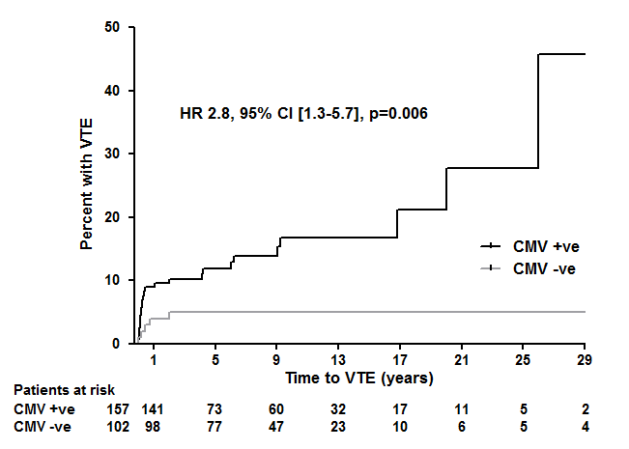

**Figure 1** Time to first VTE episode in CMV-seropositive (n=157, black line) and CMV-seronegative (n=102, grey line) AAV patients.