The proportion of elderly patients requiring haemodialysis (HD) continues to increase. Vascular access in this group presents an ongoing challenge. Many of these patients are unsuitable for AV fistula formation (AVF). Central venous catheters (CVCs) are the alternative option for vascular access. CVCs are associated with complications including infection, catheter occlusion, migration and venous thrombosis. (1) Catheter fracture is a rare complication of CVC use. Subsequent embolization has been described and can lead to life threatening complications. Subclavian CVC fractures are attributed to repeated compression between the clavicle and the first rib, known as the ‘pinch-off syndrome’. (2) Catheter fracture and subsequent embolization is thought to be avoided by using the right internal jugular (RIJ) approach. (3) We report a case of a fractured tunnelled central venous catheter placed using the right internal jugular approach.

**Case Presentation**

An 87 year old caucasian female, with end stage renal failure secondary to hypertensive nephropathy, commenced HD in 2005. Initial vascular access was via an AVF. In 2012 she had a tunnelled CVC following AVF thrombosis. Due to poor calibre veins and obese arms, further AVF was not possible. A Medcomp Hemo-Flow ® 28cm 14.5F tunnelled silicone dialysis catheter was placed in the RIJ vein. She received HD via this catheter without complication for the next five years. In October 2017, on aspiration and returning blood to each of the arterial and venous lumens, blood was noted to appear from the exit site. Examination revealed no evidence of subcutaneous swelling or tenderness. Chest x-ray was normal. When the lines were connected to the dialysis machine, bleeding stopped and dialysis proceeded unremarkably with no further evidence of catheter dysfunction. Four weeks following the initial symptoms, when dialysis was initiated, further blood was noted from the exit site. Dialysis was discontinued and the patient proceeded to catheter exchange. The old catheter was examined revealing a longitudinal fracture (Fig1).

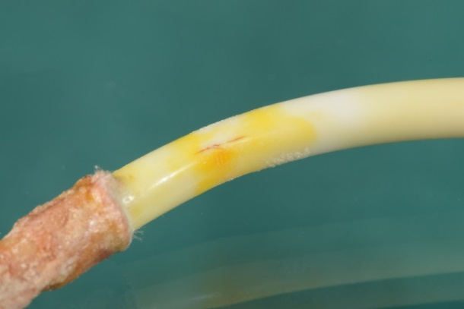

Figure 1: Longitudinal fracture identified distal to the cuff

**Discussion**

Fracture of HD catheters is a rare complication of tunnelled CVC placement. It is more frequently encountered in lines placed using the subclavian approach due to mechanical forces encountered between the first rib and the clavicle (the pinch off syndrome). This case illustrates that fracture can also occur with a catheter placed using the IJ approach. We speculate the aetiology of this fracture is secondary to material fatigue as the line had been in situ for five years. To date, no reported cases describe fracture of a right internal jugular catheter secondary to material fatigue. This may be a problem increasingly encountered in the HD population because of the increasing frequency of CVCs used in the elderly who have no alternative access options and are not candidates for renal transplantation. Routine replacement of central venous catheters is not recommended according to current KDIGO guidelines.

**References**

1. Lok CE, Foley R: Vascular access morbidity and mortality: Trends of the last decade. Clin J Am Soc Nephrol 8: 1213–1219, 2013 3. Combe, C., Pisoni, R., Port, F., Young, E., Canaud, B., Mapes, D., & Held, P. (2000).
2. Dialysis Outcomes and. Practice Patterns Study: Data on the use of central venous catheters in chronic hemodialysis. Nephrologie 22(8), 379-384.
3. R.E. Kusminsky, Complications of central venous catheterization. J Am Coll Surg, 204 (2007), pp. 681-696