**Use of Renin-Angiotensin-Aldosterone-System inhibitors in Heart Failure patients with CKD; role of Hyperkalaemia**

**Introduction:** Chronic kidney disease (CKD) is common in patients with heart failure (HF), associated with high mortality and multiple hospital admissions. Despite the poor prognosis, CKD-HF patients are often deprived of the benefits of life prolonging medications, due to presumed risk of hyperkalaemia. However prevalence of hyperkalaemia as a deterrent to the use of Renin-Angiotensin-Aldosterone-System inhibitors (RAASi) in stable CKD-HF patients is unknown.

**Methods:** This study evaluated the prevalence of hyperkalaemia and its risk factors in inner-city, multi-ethnic, stable heart failure patients with estimated GFR less than 60 ml/min/1.73m2 and analysed the impact of hyperkalaemia on the use of RAASi, particularly in patients with left ventricular systolic dysfunction (LVSD; EF<50%) and severe CKD (stage4-5); using SPSS 25.

**Results:** The age of the 266 CKD-HF (63% with LVSD) patients seen between March and December 2017 was 74±11 (mean±SD) years, eGFR 41±13 ml/min/1.73m2, diabetes 40% and serum potassium 4.56±0.60 mmol/L. 12 patients had potassium >5.5 mmol/L and one patient had potassium >5.9 mmol/L. 86% of all patients were on beta-blockers and 73% on RAASi.

CKD 3 patients (218 patients; 82%) were more likely to be on RAASi than CKD 4-5 patients (78% vs 46% p=0.000) (Figure 1); despite having same serum potassium (4.54±0.60 vs 4.69±0.58; p=0.180) (Figure 2). There was no difference in presence of hyperkalaemia (>5.5 mmol/L between CKD 3 and CKD4-5 (p=0.458). LVSD patients were more likely to be on RAASi than patients without (80% vs 59%; p=0.000). There was no difference in age, prevalence of LVSD or diabetes between CKD 3 and CKD 4-5 patients.

Patients with low ejection fraction on RAASi had same serum potassium compared to patients not on RAASi (4.62±0.54 vs 4.52±0.69; p=0.343) but higher eGFR (44±12 vs 35±13; p=0.000). There was no difference in presence of hyperkalaemia in patients with or without RAASi (p=0.663).

**Conclusion:** The data from the study suggest that RAASi therapy is limited in patients with CKD, more so in severe CKD with eGFR<30 ml/min/1.73m2. The restricted use of RAASi in CKD-HF patients with LVSD is not explained by hyperkalaemia; however patients on RAASi have lower eGFR.

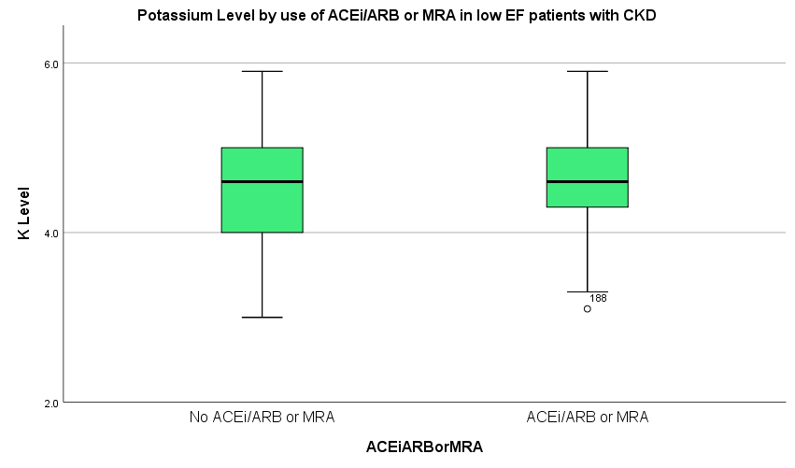

Acknowledgement: Dr Racquel Lowe Jones is funded by the International Society of Nephrology and UK Kidney Research