Fast and fearless, or slow and scared? Fear of falling, balance, and gait speed in CKD

Objectives: CKD patients have poor functional capacity including reduced gait speed (GS). Pertinently, slow GS is an independent risk factor for mortality and clinical outcome in CKD. It is well-established in older adults that poor balance is a factor in slow GS, along with a greater ‘fear of falling’ (FoF) (termed ‘fearful gait’). FoF refers to the lack of self-confidence that normal activities can be performed without falling. It is recognised that greater FoF can be caused by impaired balance. It has been hypothesised that, in older adults with a higher FoF, slower GS is an adaptation to stabilise postural sway (i.e. poor balance). However, no research has investigated the collective relationships between GS, balance, and FoF in any population.

The aim of this study was to investigate whether FoF mediates the association between balance and gait speed in CKD patients (i.e. if a patient has poor balance, do they walk slower because they are more ‘fearful of falling’?). If so, interventions (e.g., exercise) should aim to simultaneously improve physical skills and fall efficacy (i.e. one's confidence to perform activities of daily living without falling).

Methods: 22 CKD (55±18 years, 13 male, eGFR 44±27ml/min/1.73m², BMI 30±50kg/m²) were studied. Centre of Pressure (CoP) area (mm²), measured over 30 seconds (two-legged, eyes open) using a Fysiometer, was used as an indicator of standing balance performance and postural stability. ‘Usual’ GS was assessed over 4m. FoF was measured using the Falls Efficacy Scale-International (FES-I). This measures the level of concern about falling during social and physical activities on a 4-point Likert scale (range 11 to 64). Data was assessed using partial correlation (r) and mediation analysis (50,000 bootstrapping, CI90) using the supplementary PROCESS macro (SPSS). Age, sex, BMI, and eGFR were used as covariates in all statistical tests.

Results: The mean CoP (balance) score was 42.9±47.1mm², GS was 3.7±0.9 m/s, and FES-I score was 20.1±9.7. Mediation analysis revealed a significant indirect effect of balance on GS through FoF, ab = 0.24, BCa CI [0.05, 0.66]. FoF (mediator) could account for one third (32%) of the total effect (i.e. the relationship between balance and GS), P_{M} = .32.
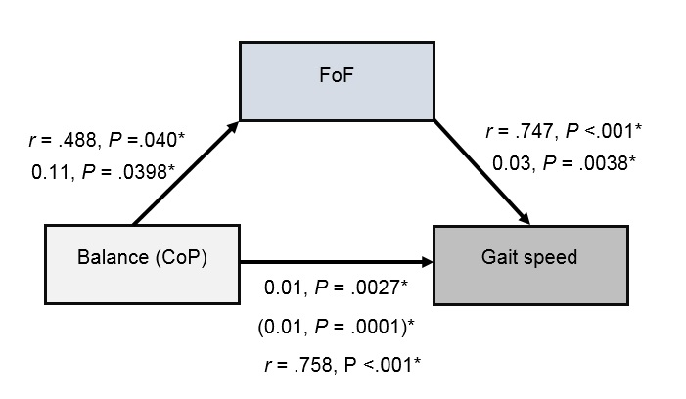
Conclusion: We found that in CKD, greater FoF significantly mediates the relationship between balance and GS (i.e. patients with poor balance have reduced GS, and this, in part, can be due to having a higher FoF). This supports other research that suggests defensive changes to gait, often cited as risk factors for falling (e.g., decreased stride length and speed), may be stabilising adaptations related to FoF. This suggests that in CKD patients with higher FoF, slow GS may be a useful and safety adaptation to optimise their poor balance. This indicates that both balance and fall efficacy are important determinants of GS, and interventions to address both will help improve functional capacity and independence in CKD.

