**Background:** Sepsis and Acute Kidney Injury (AKI) are two major health problems, both arising primarily in the community and their coexistence is associated with high morbidity and mortality, especially in the elderly population. Recent NICE guidance dictates that AKI detection in the context of suspected infection presenting to hospital identifies high risk individuals requiring sepsis bundle and antibiotics within 1 hour. However such laboratory assistance for risk stratification is lacking in primary care.

**Aim:** This is a pilot project at 1200 nursing home residents covered by a single GP practice (Salford Care Homes) evaluating the use of Point of Care (POC) creatinine testing with handheld devices for real time diagnosis of AKI to support clinical decision making.

**Methods:** To evaluate the technology we obtained concurrent POC creatinine values from fingerstick capillary samples using StatSensor (NOVA) handheld analyzer and creatinine values from serum samples measured by Siemens Advia 2400 Jaffe in our laboratory from patients presenting to A&E, and also nursing home residents. Pearson’s correlation coefficient was used to test the correlation between capillary POC and serum creatinine levels. Agreement between the two methods was assessed with Bland Altman plot. A clinical group of primary and secondary physicians reviewed the results with a view to designing a clinically meaningful algorithm to be used in nursing homes.

**Results:** In total 59 paired samples from 57 patients were obtained. Mean age was 76.6 years and 29 were female. Mean serum creatinine was 95.03 ±43.5µmol/L (range 18- 228) and mean POC creatinine was 117.59±68.6µmol/L (range 44- 336). There was a very good correlation between POC and serum creatinine values (r= 0.812, p<0.001, Figure 1A). Agreement analysis showed that overall the 95% limits of agreement contained 93% (55/59) of the difference scores and 3 out of the 4 values outside the limits of agreement were observed in mean creatinine values above 200µmol/L. POC creatinine was higher than serum creatinine in 85% (50/59) of the cases. Mean difference between POC creatinine and serum creatinine was 32.5µmol/L (Figure 1B). Based on the results an algorithm (Figure 2) was agreed by clinicians in primary and secondary care.

**Conclusion:** POC showed reasonable agreement with laboratory assays to detect normal and abnormal creatinine values and can be used as a rule-in rule-out real time diagnostic tool for AKI in the community. This 6 month pilot project will incorporate the use of POC testing in the assessment of suspected infection in nursing homes. The aim is to assist primary care physicians in deciding if patients with suspected infection require urgent admission to hospital, if they can be managed in the community or if discussions about ceiling of care or end of life care should take place. Data will be collected prospectively to assess:

1. Adoption of technology. Measure: number of POC use (fortnightly)
2. If POC test result affects decision making. Measure: number of POC tests affecting decision/total of POC tests
3. Impact on Length of Stay, ICU admission rates and 30 day mortality in sepsis-associated community acquired AKI (case studies)
4. Reduction in unnecessary referrals to A&E. Measure: number of patients with suspected infection discharged from A&E within 24 hours

Figure 1

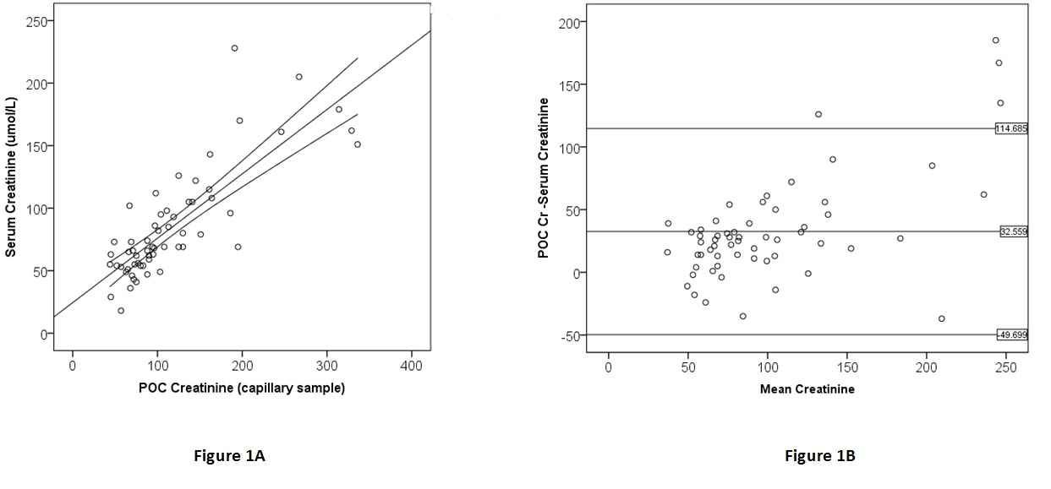

Figure 2

