**Age Stratified Response to IV Cyclophosphamide for the treatment of ANCA associated vasculitis**

**Background:** We report from our >10 year experience of IV cyclophosphamide (dose adjusted for age, weight and renal function) for the induction of remission and relapse rates, when stratified according to age.

**Methods:** We collected data on 183 patients with ANCA vasculitis, who received induction treatment with IV Cyclophosphamide, in combination with steroid, and plasma exchange (if creat>500, rapidly progressive course or evidence of pulmonary haemorrhage). Data were collected from paper and electronic medical records of patients attending our vasculitis service over a 13-year period. In patients in whom a stable remission was achieved, withdrawal of corticosteroids would typically begin at 18 to 24 months, and withdrawal of Azathioprine or MMF at 36 to 48 months.

**Results:** Eighty-five patients had anti-PR3 antibodies; 90 anti-MPO and 8 antibody negative (fig. 1). All successfully completed induction immunosuppression treatment and were started on maintenance treatment. Mean age was 65 years (range 18-89) (fig. 2). 86 (47%) Female. Mean follow up was 66 months (range 6-170). There was no significant difference in the follow up period between age groups. There was a significant trend towards an increased relapse rate in the younger age groups (figs 3 and 4).

**Conclusions:**We report on a large cohort of patients treated with IV cyclophosphamide with a prolonged follow up period. Using the dosing regimen for pulsed IV cyclophosphamide as per the CYCLOPS trial we report a higher relapse rate in our younger patients. This may be due to the higher incidence of anti-PR3 disease in this population, however, it may also be due to the crude weight/age/GFR dosing regimen currently followed. We propose that this dosing regimen may need review to account for the discrepancy we have found.

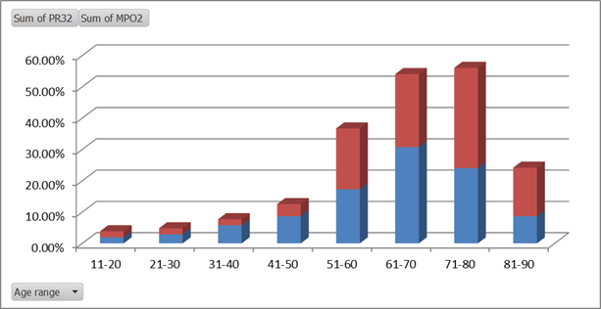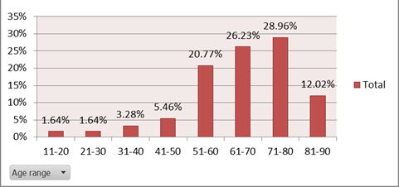

Fig 1: Increasing frequency of anti-MPO in the older age groups. Fig 2: Age distribution in this cohort

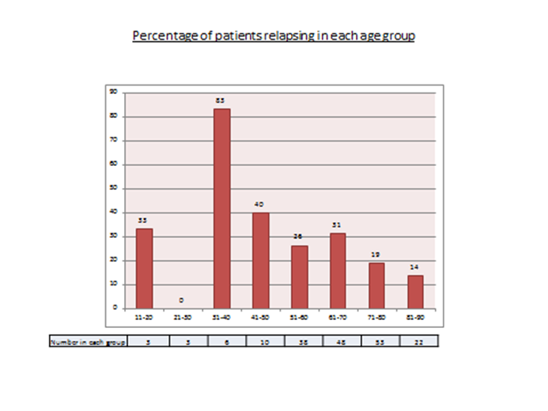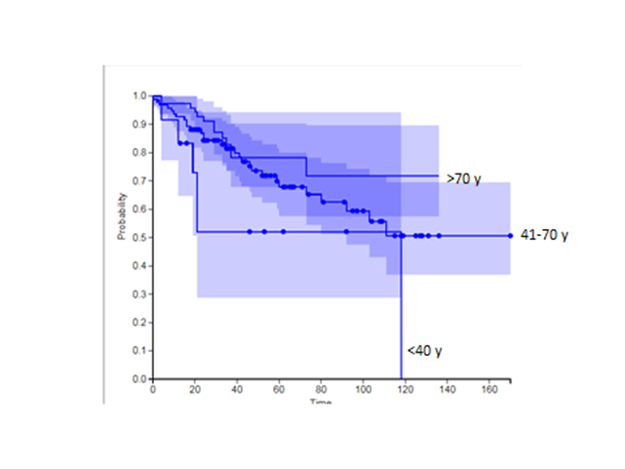

Fig 3 and 4: Age stratified relapse after induction with IV cyclophosphamide.