**Vancomycin Toxicity Successfully Treated with Haemodiafiltration**

**Introduction**

Vancomycin is an extremely powerful antibiotic with increasing clinical usage1, 2. It is a glycopeptide with known ototoxicity and nephrotoxicity4 necessitating monitoring of drug levels to ensure treatment is within the therapeutic range (10-20mg/L). Monitoring guidelines and dose adjustments vary but generally require monitoring after the 3rd dose and subsequently. Monitoring is also required after dose adjustment.

**Case**

A 48 year old woman with baseline normal renal function (creatinine 55μmol/L) attended the emergency department of her local hospital with leg pain, for which she had been taking non-steroidal anti-inflammatory drugs (NSAIDs), and was treated for cellulitis. On microbiology advice she was treated with Vancomycin, Piperacillin/Tazobactam (PT) and Clindamycin. Initially Vancomycin was started at a dose of 1 gram twice daily. Following the third dose levels were found to be sub-therapeutic at 4.2 mg/L and the dose was increased to 2 grams twice daily, outside of normal protocol.

Clinically the cellulitis improved. Over the subsequent four days the patient developed oliguria and worsening bilateral leg oedema. Results were not checked for four days after the dose was increased, rather than the recommended 18 hours/three doses3. Subsequent tests revealed an AKI stage 3 with serum creatinine of 411μmol/L. No Vancomycin level is available from this time. Antibiotics were stopped at this point and three days later creatinine had continued increase to 547μmol/L; Vancomycin level at this time was elevated at 44.7 mg/L, despite no dose for three days.

Renal function continued to deteriorate, reaching a creatinine of 693μmol/L necessitating transfer to our hospital for renal replacement therapy (RRT). At transfer Vancomycin level was 35mg/L six days following last dose. The patient was treated with four sessions of haemodiafiltration (HDF) on consecutive days – *see figure 1*. The patient was subsequently discharged with a creatinine of 382μmol/L and an undetectable Vancomycin level for outpatient follow up. At three month review the patient’s renal function had returned to normal (serum creatinine 88μmol/L).

***Figure 1*** *– Vancomycin and creatinine trends*

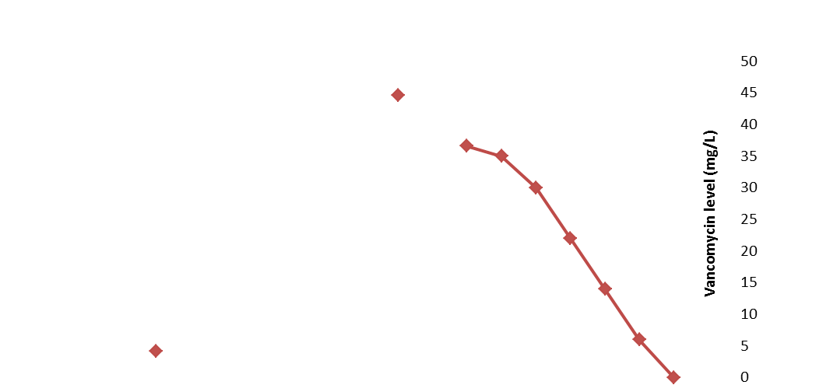**Discussion**

*Arrow = last dose of Vancomycin*

*Dotted line = start of HDF*

*■= Creatinine*

*■= Vancomycin*

*Arrow = last dose of Vancomycin*

*Dotted line = start of HDF*

*■= Creatinine*

*■= Vancomycin*

This case highlights the importance of recognising Vancomycin as a risk factor for AKI. This patient was at high risk due to the presence of sepsis and NSAID use. Her risk was then compounded by being prescribed PT, which is associated with a higher rate of AKI when co-prescribed with Vancomycin5. This patient was given a high dose of Vancomycin (≥4g/day), which has been shown to have both a higher rate, and a more rapid onset of AKI6. Trough levels several days following last dose remained high (44.7mg/L). Levels above 35mg/L are associated with an 81.8% incidence of AKI4. HDF was chosen over haemodialysis (HD) as the mode of RRT due to the pharmacokinetics of Vancomycin. Vancomycin is a large glycopeptide compound with a molecular weight of ~1450 Da7and is protein bound. Drug clearance is enhanced with HDF compared with HD. Given the increased use of Vancomycin, in clinical practice, we feel there is likely to be an increase in the incidence of Vancomycin toxicity resulting in AKI.

**References**

1. William R. Jarvis, *Epidemiology, Appropriateness, and Cost of Vancomycin Use*, Centre for Disease Control and Prevention, US Public Health 1998;26

2. Burke A. Cunha, MD, V*ancomycin Revisited: A Reappraisal of Clinical Use*, Critical Care Clinics - Volume 26, Issue 4( 2008)

3. South Eastern Trust, *South Eastern Trust Antibiotic Guidelines*, <http://microguide.horizonsp.co.uk/viewer/set/> (accessed 5th January 2018)

4. Oluwatoyin Bamgbola , *Review of vancomycin-induced renal toxicity: an update*, Therapeutic Advances in Endocrinology and Metabolism2016, Vol. 7(3) 136–147

5*.*Bhargyashri Navalkele et al, *Risk of Acute Kidney Injury in Patients on Concomitant Vancomycin and Piperacillin–Tazobactam Compared to Those on Vancomycin and Cefepime*, *Clinical Infectious Diseases*, Volume 64, Issue 2, 15 January 2017, Pages 116–123

6. Lodise TP, Lomaestro B, Graves J, Drusano GL. *Larger vancomycin doses (at least four grams per day) are associated with an increased incidence of nephrotoxicity. Antimicrob Agents Chemother*. 2008;52:1330-

7. Michael J Rybak, The Pharmacokinetic and Pharmacodynamic Properties of Vancomycin, The Pharmacokinetic and Pharmacodynamic Properties of Vancomycin, *Clinical Infectious Diseases*, Volume 42, Issue Supplement_1, 1 January 2006, Pages S35–S39