**Background:** Cardiovascular disease (CVD) is the primary cause of morbidity and mortality among patients with chronic kidney disease (CKD). In CKD-related CVD, structural and morphological changes occur in the vascular bed leading to arterial stiffness, matrix deposition and calcification that have been described as accelerated arterial aging. These changes are mediated by the activation of vascular smooth muscle cells. Altered DNA methylation has been proposed to mediate the aging process and is also a manifestation of CKD. Our aim was to investigate tissue specific changes in DNA methylation that occur in CKD-related CVD.

**Methods:** DNA methylation analysis was performed (Illumina EPIC array) in bisulfite converted genomic DNA, isolated from the arterial media of 25 recipients (CKD patients; epigastric artery) and 7 donors (controls; renal artery) during kidney transplantation procedures. Bioinformatics analysis was performed using Bioconductor packages in R software (SNP and XY chromosome-related CpG sites were excluded). BMIQ and Combat analysis were used for normalization and to correct for technical variation respectively. Methylation-specific PCR was used to validate the array data. P-values were adjusted for multiple comparisons. Gene and protein expression, using RT-qPCR and immunohistochemistry, were then explored for loci of interest. DNA methylation age was estimated using the algorithm by Horvath *et al*.

**Results:** 3x105 differentially methylated CpGs encompassing 703 differentially methylated regions (DMRs) were identified in cases versus controls (adjusted *p*<0.05. Significant enrichment was found in promoters, exons, introns and 5’ UTRs. DMRs were found in or in proximity to interfering RNAs (miR-196b) along with genes associated with vascular remodeling and ECM production (e.g.*COL6/7/9*, *MMP2*) and signaling mechanisms involved in fibrosis and vascular pathologies (e.g. *TGFβ1, FGF1/6)*. Of particular interest was increased DNA-methylation at the *HOXA5* locus (adjusted *p*-value 6.5x10-8) a gene which has recently been reported to have a role in flow-mediated arterial pathology. Along with methylation specific PCR validation we identified a strong inverse association between DNA-methylation at this locus and *HOXA5* gene and protein expression (Figure 1). Consistent with this reduced *HOXA5* gene expression was observed in CKD arteries versus healthy controls. DNA methylation age and chronological age were highly correlated but there was no evidence of higher DNA methylation age in CKD cases (Figure 2).

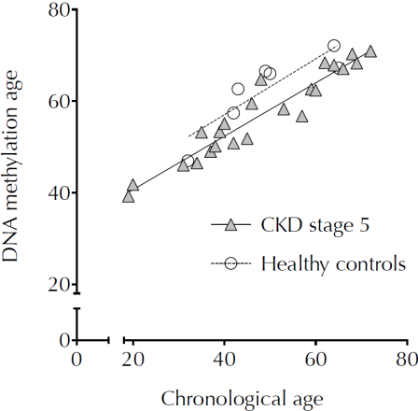UKKW%20DNAmeth.pdf

**Figure 2**

**Figure 1**

**Conclusion**

Overall, these data demonstrate altered arterial media DNA methylation in CKD-related CVD and implicate novel biological pathways including those related to flow-mediated pathology such as *HOXA5*. However, the methylation profile does not reflect a process of accelerated aging.