**Randomised controlled trial comparing high-dose versus low-dose intravenous iron supplementation in haemodialysis: the *PIVOTAL* trial (*P*roactive *IV* ir*O*n *T*herapy in di*AL*ysis patients): rationale, study design, and baseline data**

***BACKGROUND & RATIONALE***

IV iron supplementation is a maintenance standard-of-care treatment for haemodialysis patients worldwide. However, the optimum dose balancing risk versus benefits is unknown. The *PIVOTAL* study was designed to address this shortfall in the evidence base.

***AIM OF STUDY***

To compare the effect of a proactive high-dose, with a reactive low-dose, IV iron regimen on all-cause mortality and non-fatal cardiovascular events (primary endpoint), as well as on the incidence of infections, ESA dose requirements, and other secondary endpoints.

***STUDY DESIGN***

Prospective, randomised and open, with blinded endpoint evaluation (PROBE)

*-- EudraCT 2013-002267-25.*

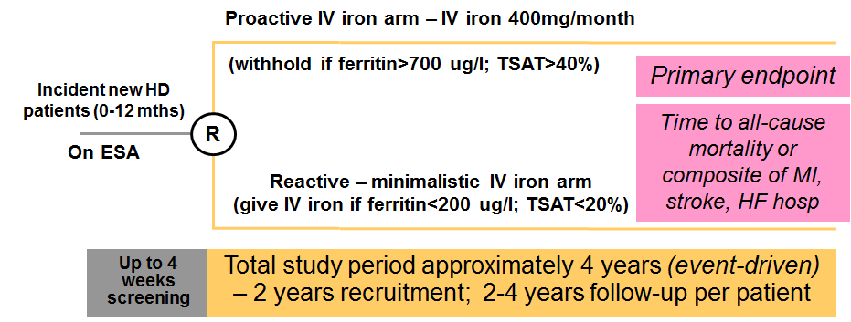

***RESULTS***

*PIVOTAL* commenced in November 2013 with a planned sample size of 2080 patients. By June 2016, 2142 patients were recruited across 50 UK sites. The study is powered on accruing 944 primary endpoint events and is expected to complete in 2018. Baseline demographic data are as follows:-

|  |  |  |  |
| --- | --- | --- | --- |
| Age* *(years)* | 64 (52, 75) | Systolic BP* *(mmHg)* | 144 (128,160) |
| Gender *[male/female]* | 65.2 / 34.8% | Diastolic BP* *(mmHg)* | 73 (64, 83) |
| Ethnicity *[white/black/Asian/other]* | 79/9/9/3% | Haemoglobin* *(g/l)* | 106 (96,115) |
| Diabetics/Non-diabetics | 44/56% | Ferritin* *(ug/l)* | 216 (133, 304) |
| Smoking *[current/former/never]* | 12/25/63% | TSAT* *(%)* | 20 (16, 24) |
| Weight* *(kg)* | 80 (67, 95) | CRP* *(mg/l)* | 6 (4,14) |
| BMI* *(kg/m2)* | 28 (24, 33) | ESA dose\***♯** *(i.u./week)* | 8000 (4000,12000) |

*\*[median (IQR)]*

**♯***ESA dose for darbepoetin and Mircera converted to i.u./week using standard conversion factors*

***CONCLUSIONS***

The *PIVOTAL* study will provide important information on the optimum dosing regimen of intravenous iron in haemodialysis patients. With the exception of the ferritin level, which *a priori* is lower in *PIVOTAL* due to the inclusion criteria of the study (<400 ug/l), the baseline demographic data are very similar to those from the UK Renal Registry.