**FIBRIN SHEATH STRIPPING AND CATHETER EXCHANGE FOR FAILED TUNNELLED DIALYSIS CATHETERS**

**INTRODUCTION:** Tunnelled dialysis catheters (TDC) remain an important tool for dialysis vascular access. In the 2014 Renal Registry report 51% of patients in the UK commenced haemodialysis using a central venous catheter. The majority of these patients remaining on dialysis convert to an arteriovenous fistula or graft. In a small proportion of patients a fistula or graft cannot be established and a TDC is needed for long term dialysis.

TDC failure with a blood flow rate below 250ml/min can be caused by tip mal-placement, thrombus and fibrin sheath formation. Over-the-wire TDC exchange with disruption of the any fibrin sheath has been shown to be effective at restoring flow but catheter survival following exchange and/or striping compared to de novo insertion is unknown.

**METHODS:** Consecutive TDC procedures performed at a single renal centre between July 2001 and November 2017 were studied. During TDC exchange under fluoroscopy, the tip is pulled back to the SVC over a wire and venogram is performed to detect a sheath. When present the sheath is stripped using a 25mm Goose-neck snare passed from the ipsilateral femoral vein. Catheter survival from insertion or exchange and/or stripping until removal or replacement was compared using the Kaplan-Meier method and log-rank test.

**RESULTS:** 2649 TDC were inserted into 2053 patients with 1999 patient-years follow-up. Of these, 370 (14.0%) of the TDC required intervention for low blood flow rates as follows:

Sheath stripped but TDC not exchanged 23 cases (6.2%, 20 patients); sheath stripped and TDC exchanged 78 cases (21.1%, 51 patients); no sheath and line exchanged 269 cases (72.7%, 177 patients).

Catheter survival following stripping & exchange was not significantly different to exchange alone, where no sheath was present. Log-rank analysis confirmed statistical significance between all other pair of groups.

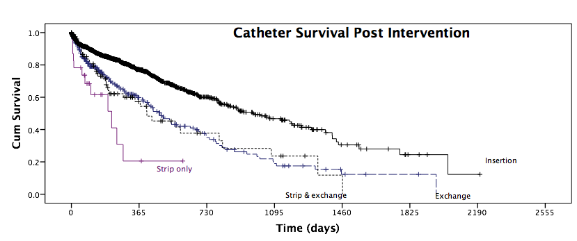

|  |  |  |  |  |  |  |  |  |
| --- | --- | --- | --- | --- | --- | --- | --- | --- |
| Strip only | 23 | 2 | 0 | 0 | 0 | 0 | 0 | 0 |
| Strip & exchange | 78 | 20 | 8 | 5 | 1 | 0 | 0 | 0 |
| Exchange | 269 | 80 | 29 | 13 | 4 | 2 | 0 | 0 |
| Insertion | 2649 | 536 | 138 | 52 | 15 | 4 | 1 | 0 |

Number remaining

**CONCLUSIONS:** When a fibrin sheath is present, TDC exchange combined with stripping is more effective than just stripping the TDC. Catheter survival following TDC exchange is not negatively impacted by the presence of a sheath if this is disrupted by stripping. Survival following over-the-wire TDC exchange is inferior to survival after de novo insertion.