**A rare presentation of seizures, memory loss and nephrotic syndrome**

**The Case:** A 55-year-old Afro-Caribbean man presented to the Emergency Department following a self-terminating tonic-clonic seizure. He was confused and agitated, with severe anterograde amnesia (a failure to lay down new memories). His blood pressure was elevated (179/100) and he had mild peripheral oedema. CT brain was normal and he was initially treated with ceftriaxone and aciclovir. These were subsequently stopped when CSF examination demonstrated only mildly elevated protein (0.47 md/dL), with no cells or organisms, normal glucose and negative virology screen. MRI brain revealed abnormally increased signal with contrast enhancement in the mesial left temporal lobe and hippocampus and subtly increased signal on the right. Serum autoimmune encephalitis screen was strongly positive for leucine-rich glioma inactivated-1 (LGI1) autoantibodies. The presence of LGI1 autoantibodies, together with the clinical picture and radiological findings, confirmed a diagnosis of autoimmune limbic encephalitis.

At the same time, he was found to be hypoalbuminaemic (22 g/L). Urinalysis revealed proteinuria with no haematuria. Urinary albumin creatinine ratio (ACR) peaked at 1056 mg/mmol. Renal function was normal but he was hyponatraemic (126 mmol/L). Complement levels and anti-double-stranded DNA autoantibody screen were normal. Tissue from a native renal biopsy revealed thickened peripheral capillary loops and the presence of spikes on silver staining (Figure 1). Electron microscopy demonstrated abundant finely granular subepithelial deposits along with effacement of the foot processes and rare reticular inclusions, consistent with a diagnosis of membranous nephropathy (MN). Immunohistochemistry was atypical with pale, peripheral granular C3d staining (Figure 1) but no IgG, C1q or IgA staining. A peripheral blood screen was strongly positive for anti-phospholipase-A2-receptor (PLA2R) autoantibodies, whilst a whole body PET scan did not reveal any evidence of malignancy. The patient received high dose corticosteroid therapy for the autoimmune limbic encephalitis but no other immunosuppressive treatment for MN. After eight months his neurological symptoms continue to improve and the MN is in partial remission (albumin 32 g/L, ACR 357 mg/mmol).

**Discussion**: The association between LGI1 limbic encephalitis and hyponatraemia is well-recognised. LGI1 expression has been found in renal tubules suggesting the possibility of a direct autoantibody effect. However, LGI1 encephalitis has not previously been associated with glomerular involvement. The mechanism whereby the two autoimmune pathologies have co-presented here is not clear but may involve antigen cross-presentation. There is a small degree of homology between LGI1 and PLA2R but this area of homology is not within a recently discovered epitope recognised by most PLA2R autoantibodies. Both PLA2R and LGI1 autoantibodies are IgG4, nevertheless we did not detect IgG staining in glomeruli or tubules. In summary, we present here to the best of our knowledge, the first report of an immune-mediated LGI1 limbic encephalitis co-presenting with an immune mediated PLA2R positive membranous nephropathy.

**C**

**A**

**B**

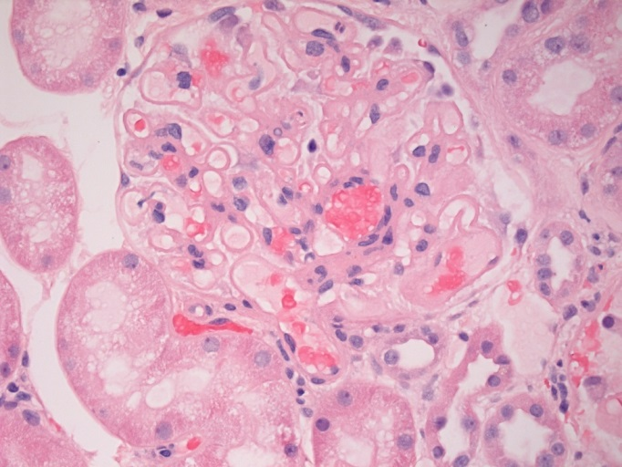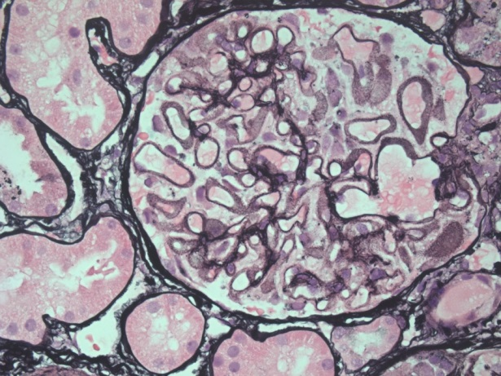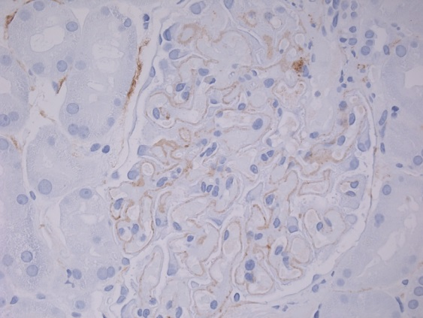

**Figure 1** Diffuse thickening of peripheral capillary loops (panel A) along with argyrophilic extensions of the glomerular basement membrane (spikes) and lucent areas representing the interposing immune deposits on the silver stain (panel B). Pale, peripheral granular C3d staining on immunohistochemistry (panel C).