Elevated blood (1-3)-B-D glucan causes apparent endotoxemia in dialysis patients and is associated with inflammation

**INTRODUCTION**: Elevated blood endotoxin levels are frequently reported in dialysis patients and implicated in the pathogenesis of systemic inflammation. Previous studies measured blood endotoxin using the Limulus Amoebocyte Lysate (LAL) assay which does not account for false positive activation by (1-3)-β-D glucan, a carbohydrate component of yeast and fungal cell walls. High blood levels of (1-3)-β-D glucan occur in dialysis patients but the significance of this is unknown. We aimed to determine the influence of blood (1-3)-β-D glucan levels on blood endotoxin read-out measurements using the LAL assay in dialysis patients and determine the association of (1-3)-β-D glucan with inflammation, clinical symptoms and adverse clinical outcomes.

**METHOD**: Blood was sampled from 20 healthy controls, 20 CKD 1-3 patients, 20 CKD 4-5 patients, 16 peritoneal dialysis patients, 30 haemodialysis (HD) patients without inflammation (based on CRP <5mg/L in the last month) and 30 HD patients with evidence of persistent inflammation (CRP >5mg/L in the last 3 months). Blood samples were measured for pro-inflammatory cytokines interleukin-6 (IL-6), tumour necrosis factor alfa (TNF-α) and high-sensitivity C reactive protein (CRP). Samples were measured for (1-3)-β-D glucan and endotoxin using the LAL assay – with and without a (1-3)-β-D glucan blocking agent to prevent false positive activation of the LAL assay. Kidney disease related symptoms, fatigue and depression were assessed using patient-reported questionnaires. The associations between endotoxin, (1-3)-β-D glucan, inflammation and symptoms were explored. Patients were followed-up for 18 months for severe infections requiring hospitalisation, adverse cardiovascular events and mortality.

**RESULTS**: Blood endotoxin measurements obtained using the LAL assay without (1-3)-β-D glucan blocking agent correlated highly with blood (1-3)-β-D glucan levels (r=0.545, p<0.001). Repeat measurement of the same samples for endotoxin using a (1-3)-β-D glucan blocking agent revealed a low level of prevalence of endotoxemia in this population with only 3/135 subjects testing positive for blood endotoxin. All three were HD patients (two in the inflamed group, one in the non-inflamed). Blood (1-3)-β-D glucan levels were the highest in HD patients, followed by peritoneal dialysis patients and CKD patients (see figure).

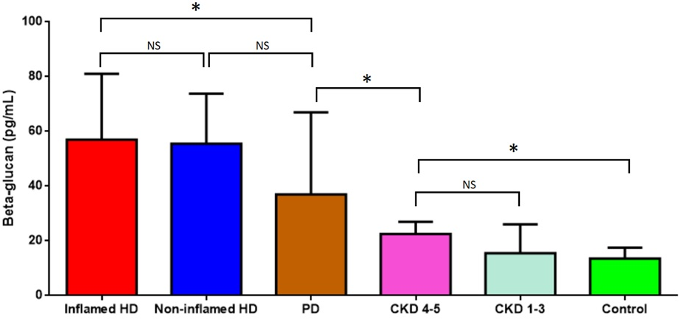

Blood (1-3)-β-D glucan levels correlated strongly with IL-6, TNF-α and CRP (r=0.64, 0.62 and 0.34 respectively, p<0.001). There was also a positive association between (1-3)-β-D glucan and fatigue, depression and uraemic symptom scores. High blood (1-3)-β-D glucan (>80pg/mL) was associated with increased risk of severe infection during the 18 month follow-up, but not with adverse cardiovascular events or death.

**CONCLUSION**: Blood levels of (1-3)-β-D glucan are high in HD patients and account for previous reports of blood testing positive for endotoxin in this population. (1-3)-β-D glucan is associated with inflammation and high levels are associated with increased risk of severe infections. The cause of raised (1-3)-β-D glucan levels is unclear since the reticulo-endothelial system is its primary route of removal not kidney function. The possible role of reticulo-endthelial dysfunction in advanced kidney disease requires further exploration.