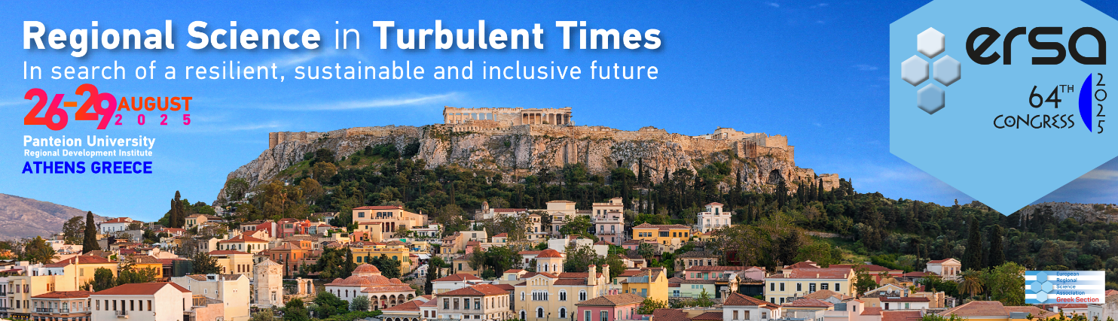

**FORM FOR SPECIAL SESSION PROPOSAL**

*\* Indicates required question*

**What is the title of the special session topic? \***

……….

**Is your special session proposal based on a research project?** (click on the box to tick) **\***

Yes. If yes, please specify……

No

**Who are the convener(s) of this topic?  (name, institution, email).** Please also specify who is the corresponding convener for the ERSA Congress Secretariat **\***

……….

**How many presentations do you foresee for your topic?** (a minimum of 4 presentations are required) *

……….

**Can you name at least four authors who will be directly invited by you to present in your special session?** (name and affiliation) **\***

……….

**Please provide a description of your special in the following page – this info will be posted on the Congress website.**



Special Session Proposal

**Special Session Title**

(Please list here the special session organizer(s) of this proposal including   
first name, last name, email and affiliation - and specify who is the corresponding convener for ERSA Congress Secretariat)

**Abstract**Please insert here a brief explanation of your special session topic – max one page