PDC2021
Vienna, Austria

Key International and Political Developments
Advancements and Progress in NEO Discovery
NEO Characterization Results
Deflection and Disruption Models & Testing
Mission & Campaign Designs
Impact Consequences
Disaster Response
Decision to Act
Public Education & Communication

Benchmarking the FLAG Hydrocode for Kinetic Impactor Deflection Simulations

Wendy K. Caldwell⁽¹⁾, Abigail Hunter⁽²⁾, and Catherine S. Plesko⁽³⁾
⁽¹⁾Los Alamos National Laboratory, P.O. Box 1663, MS B259, Los Alamos, NM 87545, (505) 551-4875, wkcaldwell@lanl.gov
⁽²⁾Los Alamos National Laboratory, P.O. Box 1663, MS F605, Los Alamos, NM 87545, (505) 606-0765, ahunter@lanl.gov
⁽³Los Alamos National Laboratory, P.O. Box 1663, MS A143, Los Alamos, NM 87545, (505) 667-2345, plesko@lanl.gov

Keywords: DART, impact modeling, deflection, kinetic impactor

ABSTRACT

In 2022, the National Aeronautics and Space Administration’s (NASA) Double Asteroid Redirection Test (DART) mission is scheduled to launch, becoming the first planetary defense mission to test a kinetic impactor for potentially hazardous object (PHO) mitigation. Prior to mission launch, impact modeling simulations are crucial for preparing for the eventual spacecraft impact and subsequent data analysis. In this work, we present simulation results in preparation of the DART mission. Our work uses the arbitrary Lagrangian–Eulerian (ALE) hydrocode FLAG, developed and maintained by Los Alamos National Laboratory, to simulate high velocity impacts into solid bodies.

To benchmark FLAG for the DART mission, we replicated simulations performed by the DART Impact Modelers Working Group. These simulations involved aluminum and basalt impactors and targets, testing a variety of strength, damage, and porosity models to understand those effects on crater formation and momentum enhancement (β), a crucial quantity in determining the effectiveness of kinetic impactor deflection. β measures the momentum of an asteroid post-deflection relative to the initial momentum of the kinetic impactor. We will discuss our simulations of the test cases selected for benchmarking codes for the DART mission. Cases 1a and 1b consist of strengthless aluminum and basalt, respectively. Case 1a’ consists of aluminum with Von Mises strength. Cases 2 considers basalt with strength and damage, and Cases 3 and 4 consist of basalt with strength, damage, and porosity, differing only in target geometry. Case 5 is a validation problem from a laboratory impact into basalt. Figure 1 shows benchmarking Case 1a, strengthless Al-6061 impacting strengthless Al-6061 at 5 km/s.

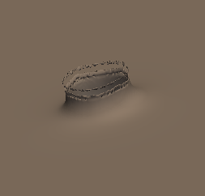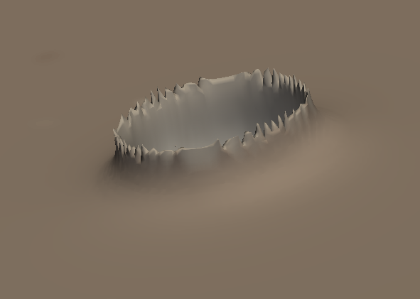
Figure 1: DART benchmarking Case 1a, strengthless Al-6061 impacting strengthless Al-6061, at initialization (left), about 25 μs after impact (center), and at the simulation stop time of 400 μs after impact.

All impacts tested in the study were normal impacts and were thus simulated in both 2D and 3D. Figure 2 shows the computational mesh of Case 1a at the simulation stopping time (400 μs). The impactor, in green, shatters and remains in the crater floor. The computational mesh as more finely resolved around the point of impact, with larger zone sizes used farther from the impact point.

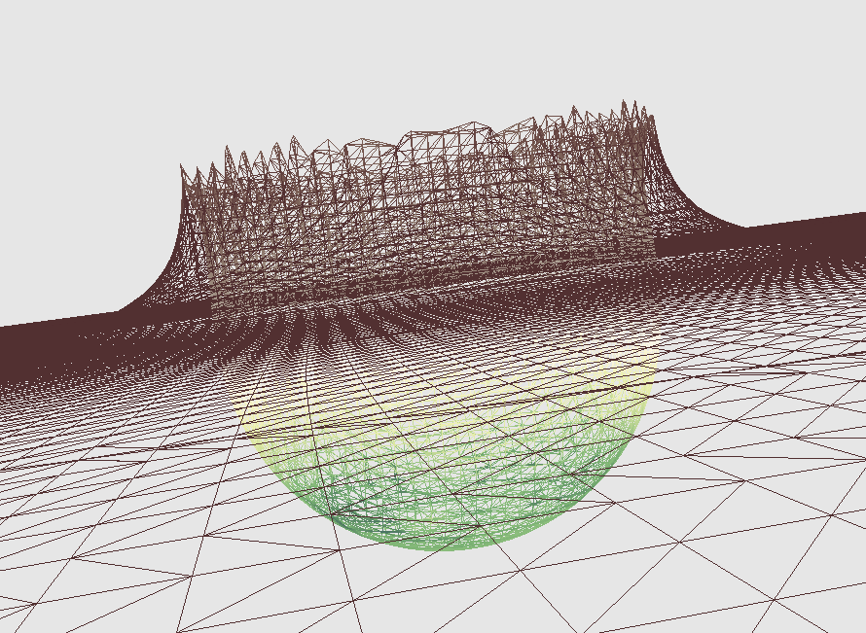
Figure 2: Case 1a 400 μs after impact. The impactor is shown in green, and the target is shown in brown. The computation mesh is more resolved around the impact point, and zone size increases farther from impact.

In addition to discussing our results, we will also discuss how our results compare to previously published results using these same test cases to benchmarking 5 hydrocodes. We will compare crater dimensions and momentum enhancement for these cases.

Comments:

Also matches Special Topics criteria (DART mission); oral presentation preferred

