**Collaborative System Manager (COSM 1.2) features and usage in railways and automotive sectors.**

A. Tosetto*1*;*

*1BLUE Engineering Srl, Turin, Italy, *Primary author contact details:* [*a.tosetto@blue-group.it*](mailto:a.tosetto@blue-group.it)

1. **Introduction**

Collaborative System Manager was originally developed by BLUE Engineering with the collaboration of ThalesAleniaSpace Turin. Since 2015 BLUE Engineering starts using COSM in its core business projects, in railway and automotive sectors. Several specific model and algorithms are implemented and used from early to detailed design phases.

* 1. **Improvements**

Version 1.2 of COSM includes a set of railways relevant algorithms, Electrical Vehicle automotive algorithms.

The Main Library (main COSM executable) includes a new View, like a bill of material for a specific option, and a new 3D viewer, able to load also CAD data.

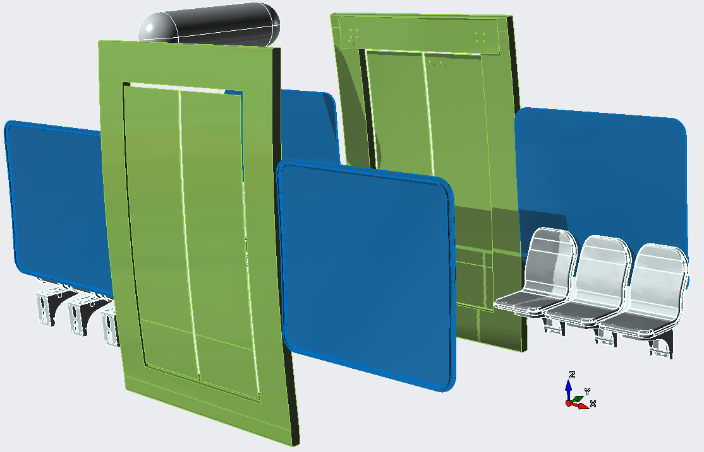

Figure 1: CAD import Example.

* 1. **Usages**

COSM is used in feasibility phase of both Automotive and Railways Sectors mas budgets and performances are evaluated and help to define specifications for trainset/automotive design.

The tool is used till the final design phase to perform mass balance validation based on final layout and suppliers equipment data.

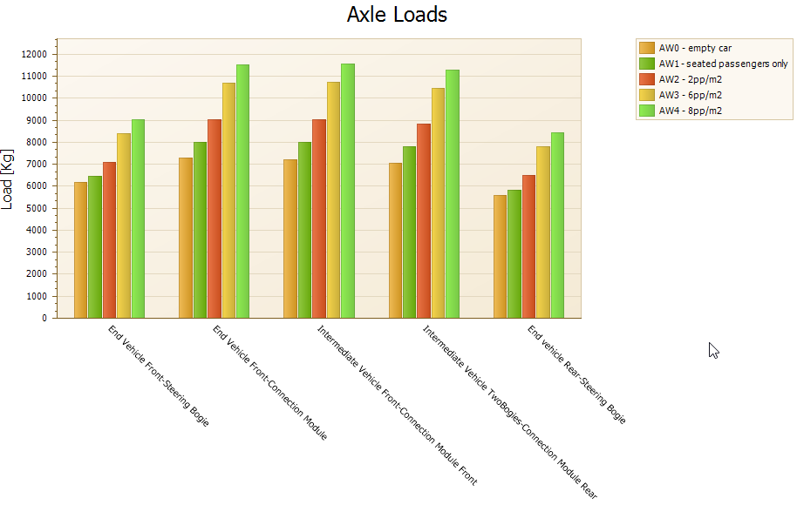

Figure 1: Trainset Axle Load Calculation Example.