Autonomous Star Tracker performance approaching Dimorphos Asteroid in DART Mission

**Mr. Franco Boldrini(1), Mr. Rossano Bettarini(2)), Mr. Dorico Procopio(3), Mr. Gianni Berrighi(4), Mr. Emil Superfin(5), Ms. Sarah Hefter(6), Mr. Daniel O'Shaughnessy (7)**

*(1) Leonardo S.p.A, franco.boldrini@leonardo.com, +390558050518*

*(2) Leonardo S.p.A, rossano.bettarini@leonardo.com, +390558050416*

*(3) Leonardo S.p.A, dorico.procopio@leonardo.com, +390558050416*

*(4) Leonardo S.p.A, gianni.berrighi@leonardo.com, +39 3351805278*

*(5) The Johns Hopkins University Applied Physics Laboratory, Emil.Superfin@jhuapl.edu*

*(6) The Johns Hopkins University Applied Physics Laboratory, Sarah.Hefter@jhuapl.edu*

*(7) The Johns Hopkins University Applied Physics Laboratory, Daniel.OShaughnessy@jhuapl.edu*

**ABSTRACT**

On DART Spacecraft, a NASA / Johns Hopkins University Applied Physics Laboratory Mission, the APS based Autonomous Star Tracker (AA-STR) developed by Leonardo S.p.A was selected as the only Star Tracker included in the Guidance Navigation and Control system.

After a 10 month journey, DART Spacecraft impacted Dimorphos Asteroid keeping AA-STR in attitude control loop until the impact.

A large amount of data was collected during cruise and the approach phases. The post processing of data shows that Star Tracker performance are in line with predictions and full performance was maintained until last telemetry was available (2.3s before the impact to Dimorphos).

AA-STR, which is flying since 2013 in many GEO, Earth Observation and Inter-planetary missions, confirmed the satisfactory performance of the previous flown units, being the first Star Tracker to touch an Asteroid in operative mode.

This paper analyses and presents the AA-STR performance.

# DART MISSION OVERVIEW

The NASA Double Asteroid Redirection Test (DART) is a technology demonstration mission that tested the kinetic deflection technique for asteroid hazard mitigation on Dimorphos, the secondary member of the Didymos binary asteroid system. The binary system was ideal, as the size of Dimorphos is representative of numerous potentially hazardous Near Earth Objects where a kinetic deflector is a useful mitigation, and the binary system offers a unique ability to accurately measure the deflection by observing the period change of Dimorphos with respect to Didymos. Launched aboard a SpaceX Falcon 9 on 24 November 2021, the DART spacecraft successfully intercepted Dimorphos on 26 September 2022. The impact occurred when the Earth-Dimorphos range was sufficiently small, thereby allowing observation by Earth-based optical and radio telescopes. The DART mission demonstrated that a direct collision with an asteroid is able to adjust an asteroid’s speed and path [2]. Ground- and space-based assets continued to observe the Didymos system following impact, helping to confirm the successful impact, verify the Dimorphos period change far exceeded the requirement (>30 minutes, versus the required 70 seconds), and showed an impressively long tail of dust and debris.

The DART guidance, navigation, and control (GNC) system provided three-axis attitude control of the spacecraft. Attitude estimation was accomplished through the use of a single AA-STR (APS Autonomous Star Tracker) from Leonardo S.p.A, which was in the attitude control loop until the impact.

DART was designed, built, and operated by a team led by the Johns Hopkins University Applied Physics Laboratory (JHU/APL), and included partnerships across the globe. NASA’s Planetary Defense Coordination Office is the lead for planetary defense activities and is sponsoring the DART mission.

# AA-STR DESCRIPTION

AA-STR is an APS based Autonomous Star Tracker manufactured by Leonardo S.p.A.

AA-STR was qualified on 2008 [5] replacing the former CCD Autonomous Star Tracker (A-STR). The first Flight Model was launched in AlphaSat mission on 2013 [2] and was flown as the first APS based Autonomous Star Tracker embedded in an attitude system control loop.

AA-STR has accumulated a very large flight heritage and was flown on many Interplanetary missions (Parker Solar Probe, Solar Orbiter, BepiColombo, EXOMARS 2016, Hayabusa-2), GEO (AlphaSat, SB4000, Meteosat Third Generation) and Earth Observation (Cosmo, PRISMA, SMAP)

Today more than 30 units are flying and more than 60 units have been manufactured and delivered.

AA-STR consists of a unique and compact assembly that includes the following modules:

* A sunshade providing protection against light from Sun, Earth or other bright objects outside the FOV or reflected by the S/C itself.
* An electro-optical module, including the optical system, which images a zone of the sky on the APS detector. The APS temperature is kept to its operative range by a thermo-electric-cooler.
* The electronics to control the APS detector, to process the pixel data and execute the SW program for pattern recognition and attitude estimation, data /command exchange (MIL 1553 or RS422).
* The power supply conditioning for interfacing the Primary Power bus ([24÷52V] or [70÷110V]).
* A main structure that supports the above listed modules.

The AA-STR Star Tracker configuration is shown in Figure 1, datasheet for AA-STR is reported in Table 1.

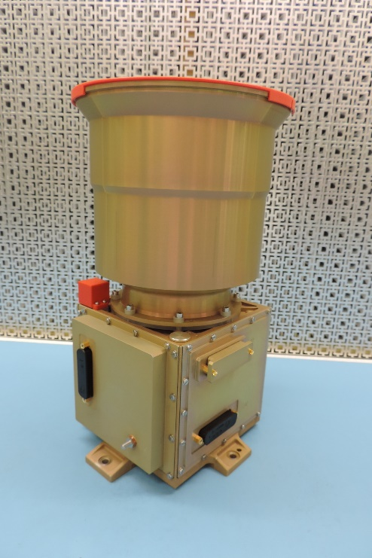

Figure 1 AA-STR picture

The “operational” modes (for attitude determination) in orbit are:

* The acquisition mode AAD (Autonomous Attitude Determination)
* The tracking mode NEAT (Nominal Environment Autonomous Tracking)

Once AAD success is achieved (a few seconds nominally), the STR switches autonomously to NEAT. INI (Initialization), STB (Stand-by), SWM (SoftWare) are used during start-up and unit configuration. CTM (Commanded Tracking) and FOTO are usually used on ground were not used S/C configuration.



Figure 2 AA-STR operative modes

Table 1

|  |  |  |
| --- | --- | --- |
| AA-STR datasheet | | |
| Mechanical Architecture | Mass (Kg) | 2.6 |
| Envelope (mm) | 156 x 164 x 283 |
| Random Vibration (grms) | 20 |
| Shock (g) | 2000 |
| Interfaces | Bus Voltage (V) | [24÷52V] (or [70-110V]) |
| Data I/F | RS442 (or 1553 I/F) |
| Frequency (Hz) | 10 |
| Power consumption (W) | ≤5.5 ≤12 (@ 60°C) |
| Performance | FOV (deg) | 20x20 |
| Number of Tracked Stars | Up to 15 |
| Sun Exclusion Angle (deg) | 26 |
| Earth exclusion Angle | 25 |
| Moon | Robust in FOV |
| Acquisition robustness (°/s) | Up to 1 |
| Tracking robustness (°/s) | Up to 2 |
| Boresight stability (arcsec/s) | ≤ 0.15 |
| Bias (arcesc) | <12 |
| FOV Error XY/Z (arcesc) | 2 / 5 |
| Random Error (arcesc) @0.5°/s | 7 / 60 |
| Environment | Operating temperature (°C) | [-30 ÷ 60] |
| Survival temperature (°C) | [-35 ÷ 65] |

# AA-STR PERFORMANCE IN-FLIGHT

The telemetry made available during attitude tracking has been post-processed.

Telemetry analysis has been focused on two different phases during:

* A quiet period of the cruise (June 11st -26th, 2022)
* The approach (August 26th -September 26th, 2022) which also includes data just before the impact

As deeply discussed in next subsections, the huge quantity of data allows characterizing the sensor performance in terms of tracking robustness and accuracy even when TM packets have not been completely acquired or data are down-sampled with respect to the 10Hz star tracker cycle.

## AA-STR performance in cruise phase

During the Cruise phase, the full Attitude & Measured stars TMs have been provided with a sampling time of 1600 s.

From the telemetry it was possible to reconstruct that the operating temperature of the APS and optics are -10°C and ~+1.9°C respectively. The S/C is in almost quasi stationary conditions (average measured angular rate ωx=4.1E-05 deg/s, ωy=-2.5E-05 deg/s ωz=-3.34E-05 deg/s).

Attitude Tracking (NEAT), together to the tracking windows, AA-STR SW addresses a small sweeping window that scans the whole detector. This window is used to provide the local background estimation (average signal inside tracking window) and the global background average over the whole detector. Looking at the background estimation available in TM, an indication of the straylight signal can be obtained. The provided background values (150÷160DN) is in agreement with the detector electronic offset, therefore it can be concluded that NEAT was performed with negligible straylight.

Over the period of observation, the NEAT mode addressed 56 different stars of the on board star catalogue. The tracked star positions over the APS reference frame are reported in Figure *3*. As it can be noticed, the addressed stars sampled a huge part of the Field Of View (FOV).

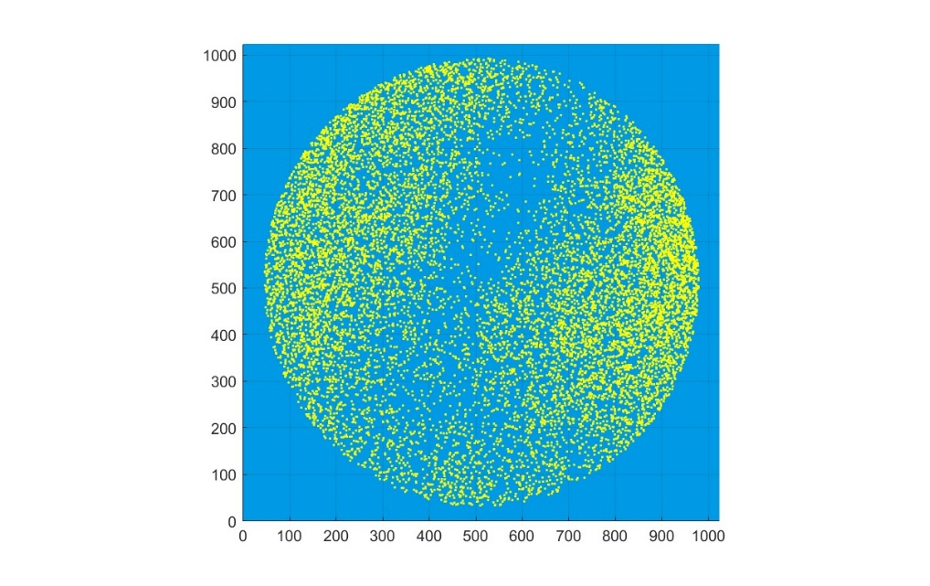

Figure 3 Star track on focal plane

The percentage of tracked stars was 99,98% so that a very good matching between stars expected in FOV and stars used for attitude quaternion computation is achieved (*Figure 4*).

Only two occurrences with missing stars were detected over the period of observation, and it was due to a magnitude mismatch as reported by telemetry.

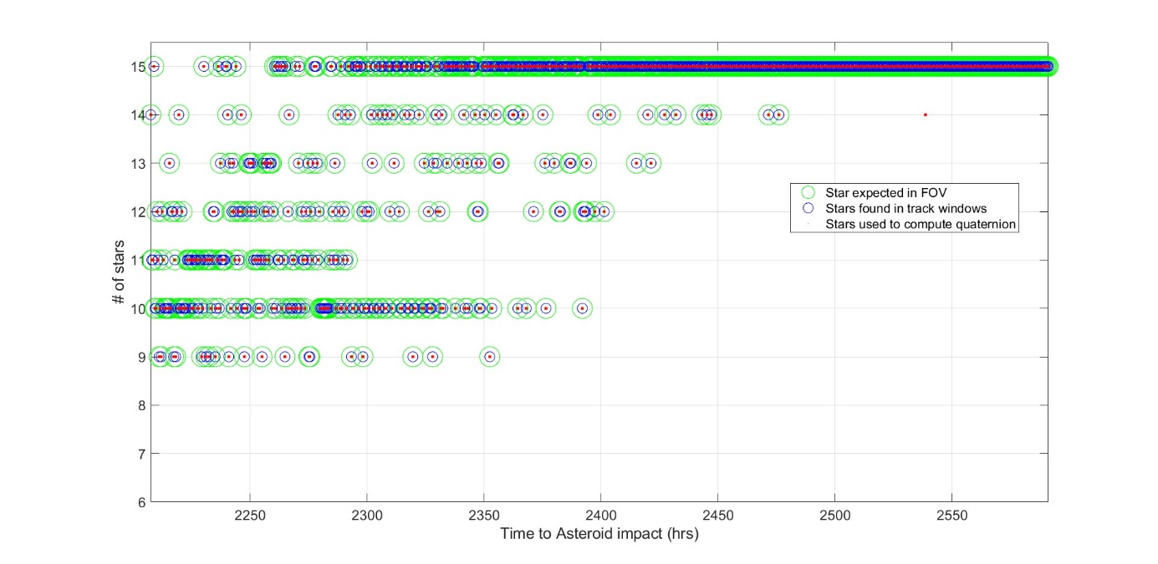

Figure 4 Number of expected stars (green circle) vs Number of stars for quaternion computation (red point)

Although it is not possible to evaluate the accuracy of the attitude measurement (absolute reference attitude is not available) and the very low sampling frequency does not allow to recover the residual error from the attitude best fit, an indirect accuracy estimation can be achieved looking at the Covariance Matrix. In fact, AA-STR together to the attitude quaternion, delivers in TM the square root of the terms of the Covariance Matrix's diagonal (P11, P22, P33) and the attitude Quality Index (IQ).

;; (1)

The diagonal terms of Covariance Matrix [3] give an estimation of the accuracy of the current attitude measurement, in practice it is a statistical attitude error estimation on transversal X/Y axes (Pitch/ Yaw) and boresight Z axis (Roll).

The Quality Index IQ is a parameter that, on the base of the covariance matrix information, produces in a synthetic way, by combining the error on 3 axes, an indicator of the accuracy of the current attitude measurement: IQ =1 means "full accuracy" (theoretically 0 arcsec error), IQ = 0 means "the worst accuracy" estimation.

The *COV_X, COV_Y* and *COV_Z* values are reported in *Figure 5*, while the delivered Quality index and its transfer functions (Quality index values vs measurement error estimation) are provided in *Figure 6*.

The plot of COV_X, COV_Y and COV_Z shows that the statistical estimation of the error is very low for all attitude quaternion measurements. Over the period of observation, the quality index is higher than ~0.9 and the average error estimations (1σ) is:

* COV_X=1.6 arcsec (1)
* COV_Y=1.6 arcsec
* COV_Z=14.2 arcsec

The error estimators show AA-STR is in full performance.

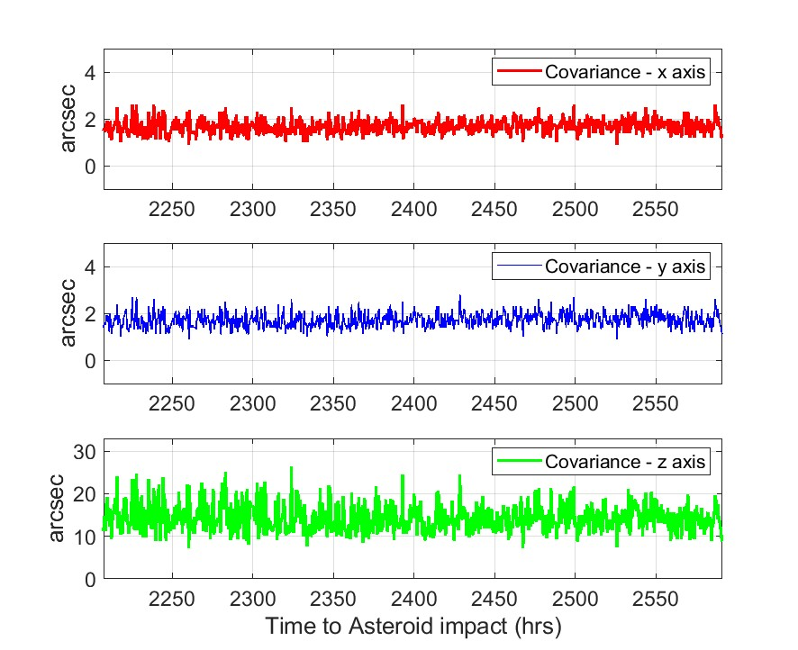

Figure 5 Covariance terms (X, Y and Z axes)

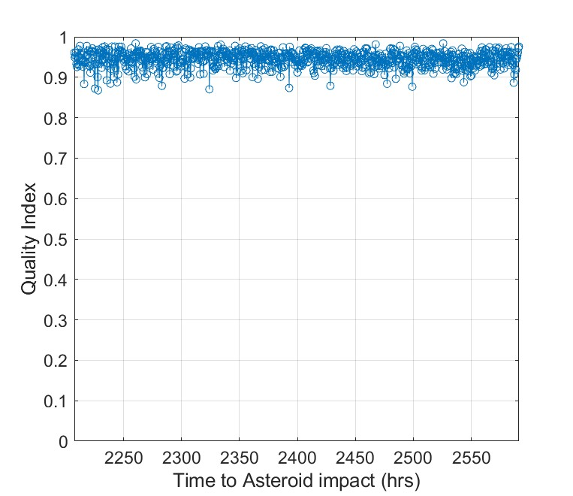

Figure 6 Quality Index (on the left) and its transfer function Iq vs measurement error (on the right)

## AA-STR performance during the approach phase

This analysis is focused on the asteroid approach phase (August 26th -September 26th, 2022) and it also includes data just before the impact.

During this period a large amount of data was available. Data was collected every Star Tracker cycle @10Hz within 6 intervals until 24h before the impact (Table 2), then data was collected at 1Hz during the last 23h.

Table 2

|  |  |  |
| --- | --- | --- |
| Interval ID | Start (hr before impact) | Duration (sec) |
| 1 | 460.00 | 3821.20 |
| 2 | 360.09 | 963.30 |
| 3 | 236.24 | 10812.10 |
| 4 | 172.09 | 4511.90 |
| 5 | 151.72 | 9532.70 |
| 6 | 24.99 | 3374.90 |

S/C dynamics, APS and Optics temperature HKs are similar to the values provided during the cruise phase: APS is -10°C, Optics is ~ -0°C. S/C is in almost quasi stationary conditions (average measured angular rate ωx=-1.6E-03 deg/s, ωy=1.0E-03 deg/s ωz=6.3E-04 deg/s).

The background estimation available in telemetry shows that no significant straylight signal is present on detector.

During the long period of observation, the number of stars in the on board star catalogue selected for tracking increases to 168 and a very significant part of APS was addressed by the tracked stars (*Figure 7*). The yellow zone of the plot highlights APS zones addressed by tracked stars, as it can be noticed the whole APS was almost sampled.

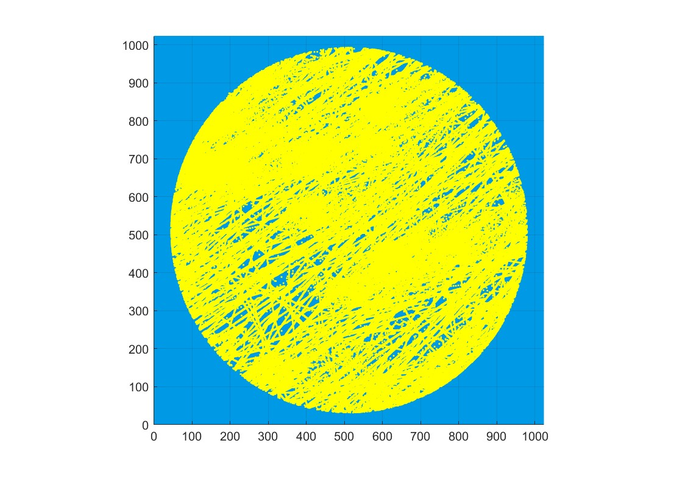

Figure 7 Star track on focal plane (yellow area)

As for the cruise phase, the very good matching between the number of expected stars and the number of stars used for attitude quaternion is confirmed: 99.98% of expected stars were used for attitude quaternion computing.

*Figure 8* provides the number of expected stars and the number of stars used for attitude quaternion computing during the whole approach phase.

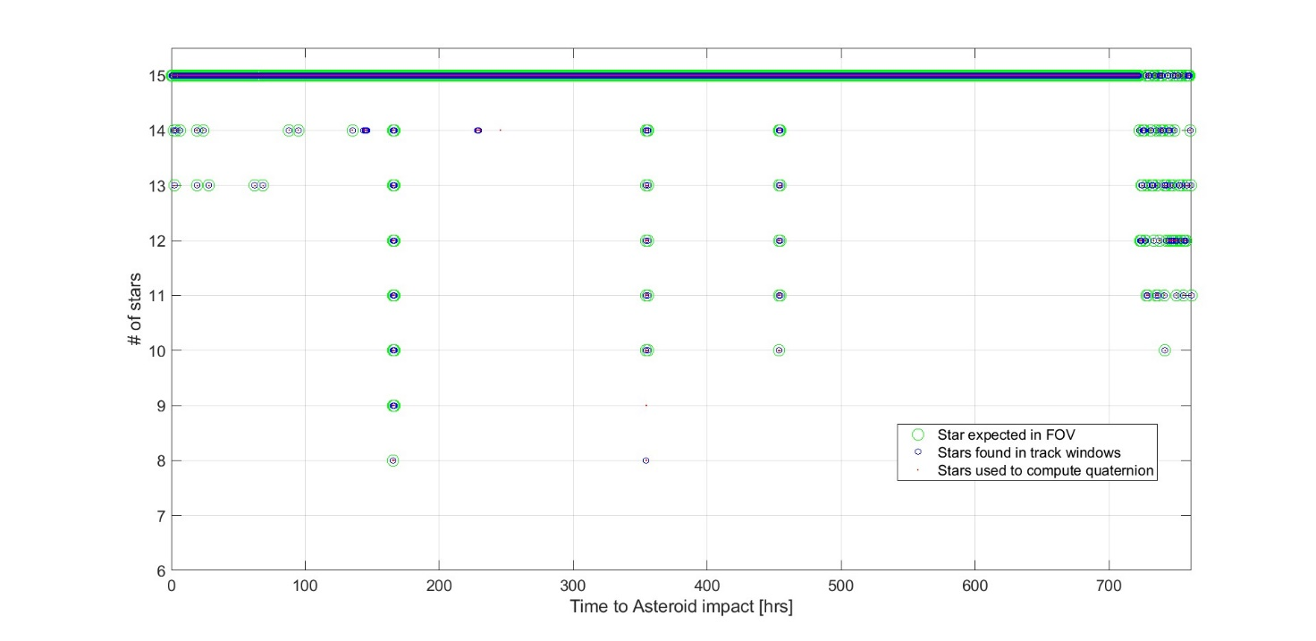

Figure 8 Number of Expected stars (green circles) vs Number stars for quaternion computing (red points)

The 10Hz sampling rate allows an estimation of pixel spatial error and temporal noise (high frequency measurement noise) and residual focal length error.

The high frequency measurement noise has been achieved by best fitting the Euler angles retrieved from the attitude quaternion and then computing the residual error over small intervals (10s). In this way S/C acceleration, jitter can be neglected while stars move about 1 ÷ 2 pixels over the focal plane.

As an example, Figure *9* reports the calculated Euler angles superimposed on the best fit for the interval#1. A zoom of 10s is also reported to appreciate the differences between measurements and relevant best fit. Figure *10* reports same information of Figure *9* for the interval#6.

Figure *11* reports the residual error for the two analyzed intervals.

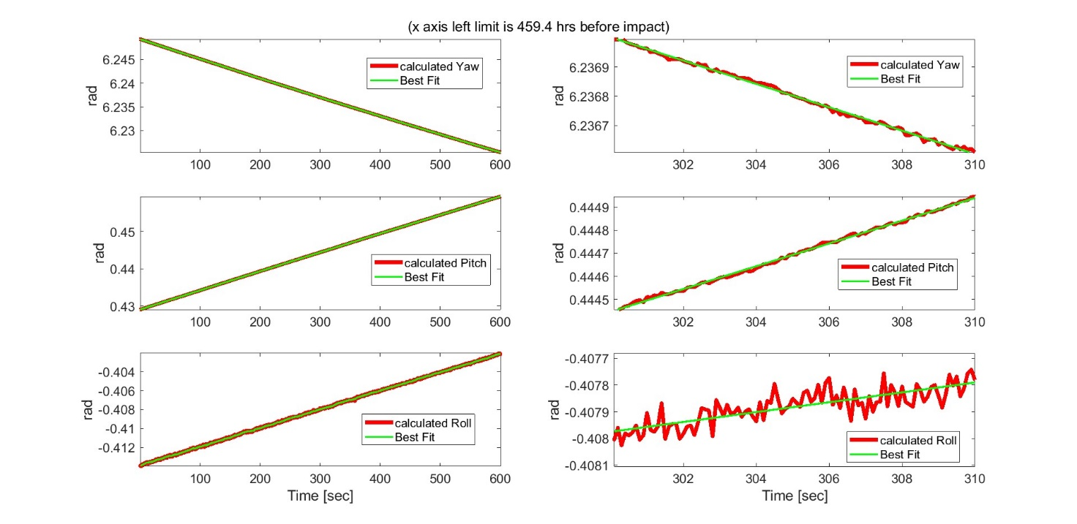

Figure 9 attitude best fit for interval#1 (left) and relevant zoom (right)

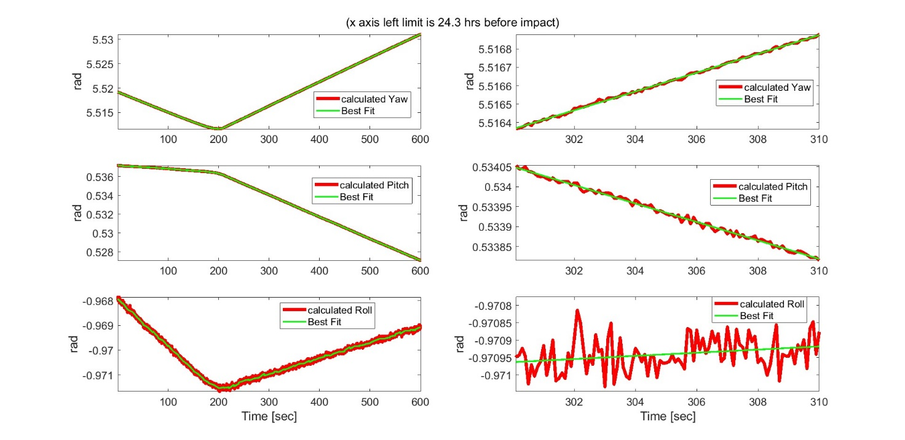

Figure 10 attitude best fit for interval#6 (left) and relevant zoom (right)

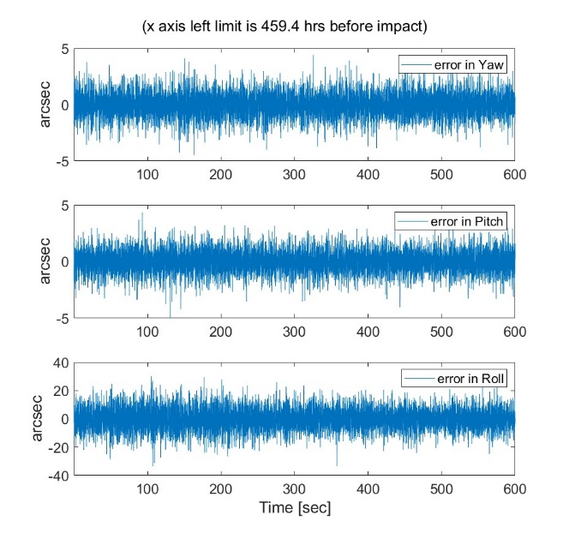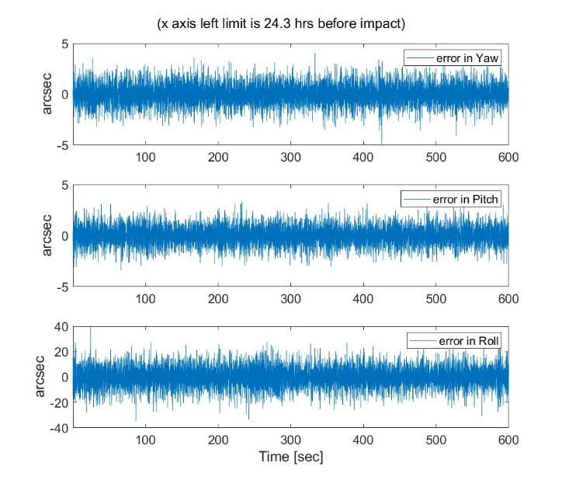

Figure 11 Residual error for yaw, pitch and roll for interval#1 (left) and interval#6 (right)

Considering the overall period of observation, the attitude error estimation (1σ) is

* Yaw < 1.2 arcsec (2)
* Pitch < 1.2 arcsec
* Roll <9.3 arcsec

As example, Figure *12* and Figure *13* report the statistical error estimation (*COV_X, COV_Y* and *COV_Z*) and Quality Index associated with the quaternion measurements provided in TM for the interval#1 and interval#6.

Looking at Figure *12*, the increase of error (mainly on Z-boresight axis) around time 500s can be related to a drop of the available stars in FOV that decrease from 15 to 10.

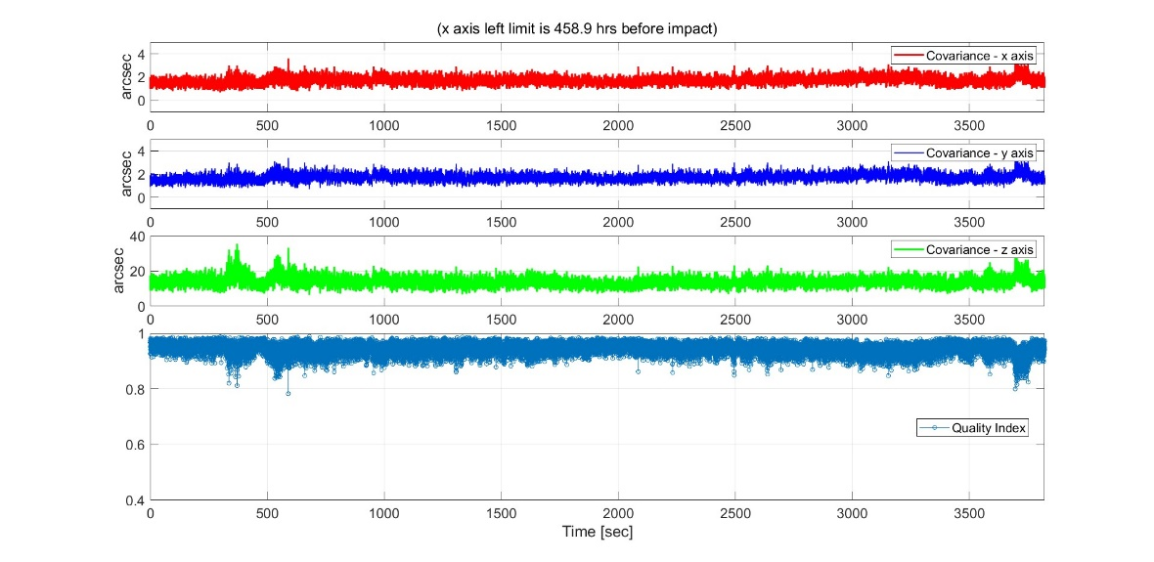

Figure 12 COV terms and quality index, interval#1

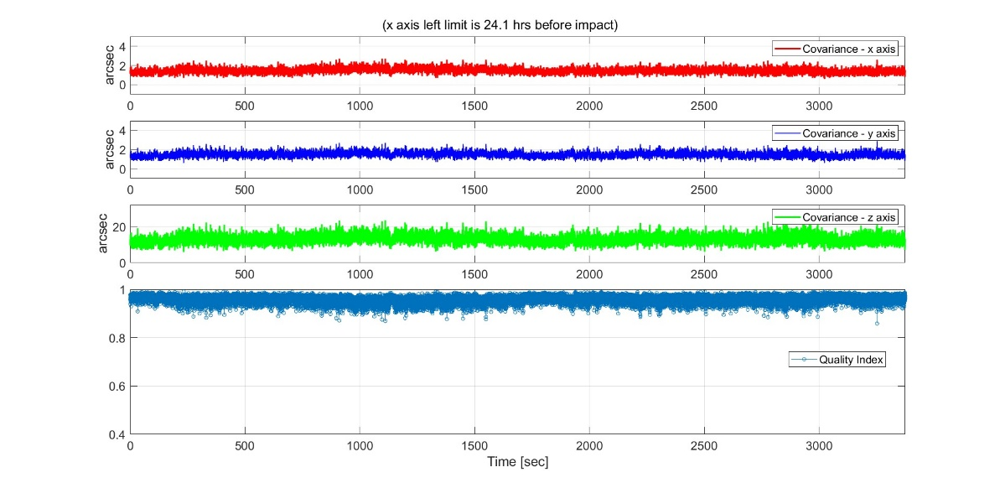

Figure 13 COV terms and quality index, interval#6

The average errors of COV_X, COV_Y and COV_Z over the whole period of observation, are:

* COV_X (1σ) < 1.5 arcsec (3)
* COV_Y (1σ) < 1.5 arcsec
* COV_Z (1σ) < 13.5 arcsec

The statistical error estimation confirms values detected in the cruise phase (Eq.1).

The attitude accuracy retrieved from the best fit (Eq.2) is consistent with the estimation provided by the Star Tracker itself (Eq.3). As expected COV_X, COV_Y, COV_Z (Eq.3) are slightly higher than accuracy estimation because they also include FOV error. In other words, COV_X, COV_Y, COV_Z and quality index can be considered reliable figures to estimate measurement errors during operations.

Finally, using star data measurements from different tracking sections, in which different stars in different FOV positions are present, it is possible to perform in-flight verification of the residual error in the focal length calibration.

The procedure has been also implemented in AA-STR SW, but it was not addressed during Flight operation.

Results are reported in *Figure 14* for interval#6 (no significant variation is obtained looking at other available intervals).

The error in the star pair measurements is measured as a function of the true star pair separation. In case no residual error in focal length is present, the error in the star pair separation is constant. On the contrary, if stars with larger separation present larger errors in star separation measurement, a residual error of focal length is still present. The line (in red in *Figure 14*) fitting the star separation errors presents a slope in the case of the processed data: the slope is equivalent to a residual error in focal length calibration of 3.8μm.

This leads to conclude:

* Residual error on focal length (< 4μm) is in line with the expectations. The AA-STR error budget includes 10 μm residual error in focal length calibration due to the on ground set up induced errors, ground to orbit shifts and uncertainty in focal length variation with respect to temperature (Topt is ~0°C during flight, while on ground calibration is performed at 20°C)
* If autonomous focal length calibration was enabled during flight, (~4μm) error would be recovered and the associated low frequency error would have been also improved

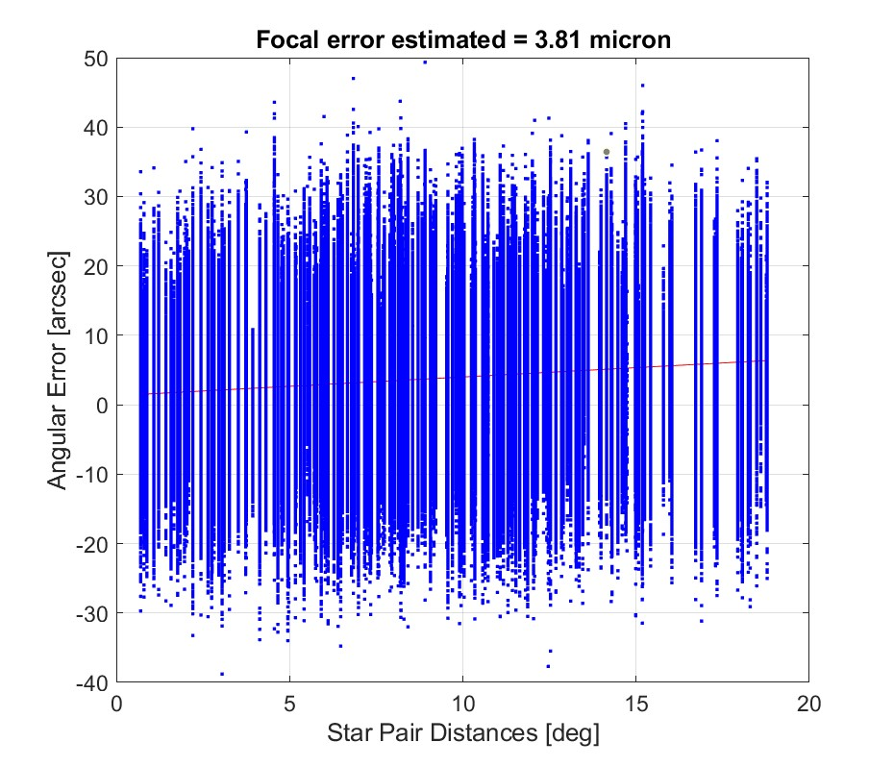

Figure 14: Angular separation error as a function of star pair distance (red line is the best fit).

## Last TMs before the impact

Finally, this section considers the last 23h before the impact to Dimorphos.

Starting 23h before impact, telemetries are sampled at 1Hz and only a subset of DWs is available: attitude quaternion and quality index, number of expected and tracked stars, global and local average estimation of background signal on APS.

Figure 15 reports the angle to the AA-STR boresight from Didymos and Dimorphos and the Asteroids Apparent Diameter. The plot is obtained using the asteroid positions estimated by the onboard SMARTNav system [2]. It assumes that the asteroids are both circular and that Didymos has a radius of 590 meters and Dimorphos has a radius of 80 meters. The angle to ST boresight is computed from the edge of each Asteroid.

Time-to-go (Tgo) is computed such that Tgo=0 corresponds to the ephemeris-based intercept point. The final 1Hz telemetry point was time tagged 2.34 sec prior to this time, when the S/C speed was 6.14 km/sec and distance was 15.89 km relative to Dimorphos [2]. As expected, both Asteroids were out of useful STR FOV (10 deg) but inside the free FOV angle.

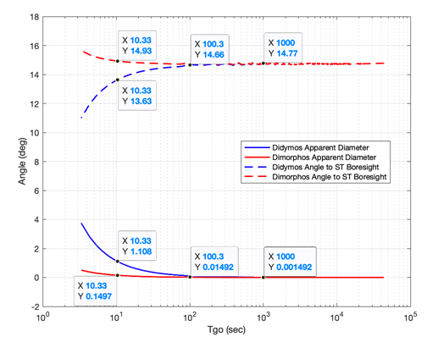

Figure 15

As discussed in the previous sections, the local and global average background values provide useful information about straylight signal on the detector.

*Figure 16* reports the values (DN) of the average global and local background. The value of ~ 150DN can be associated to the electronics offset. Considering the evolution of local and global background, no significant increase of signal is detected over the last 23h with the exception of the local background which increases at the very end cycle.

In the last TM, local BKG rises from 150DN to 240 DN, this means that 90DN can be associated to the straylight signal detected on the APS area addressed by the sweeping window. Considering the exposure time (100ms) and the DN to electron conversion factor, straylight signal is 16200 e-/s.

The increase of straylight, at least demonstrated in a partial APS area addressed by the local average background estimation, is not surprising considering the low angle between asteroids and Star Tracker boresight (Figure 15) and the large asteroid apparent diameter.

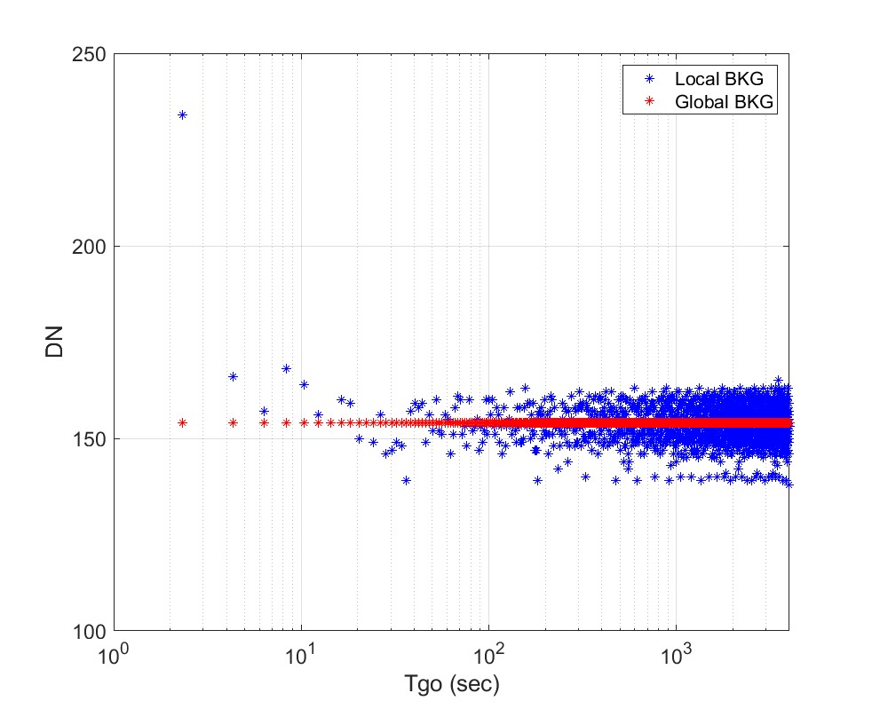

Figure 16 Local and Global average background estimation TM

During the approach, AA-STR was maintained in NEAT mode and the number of stars used to determine the attitude quaternion coincides with the number of expected stars in the FOV (15 stars) even in the last cycles before the impact where the straylight signal is increasing, confirming tracking robustness.

*Figure 17* reports the number of expected and stars used for attitude quaternion computation.

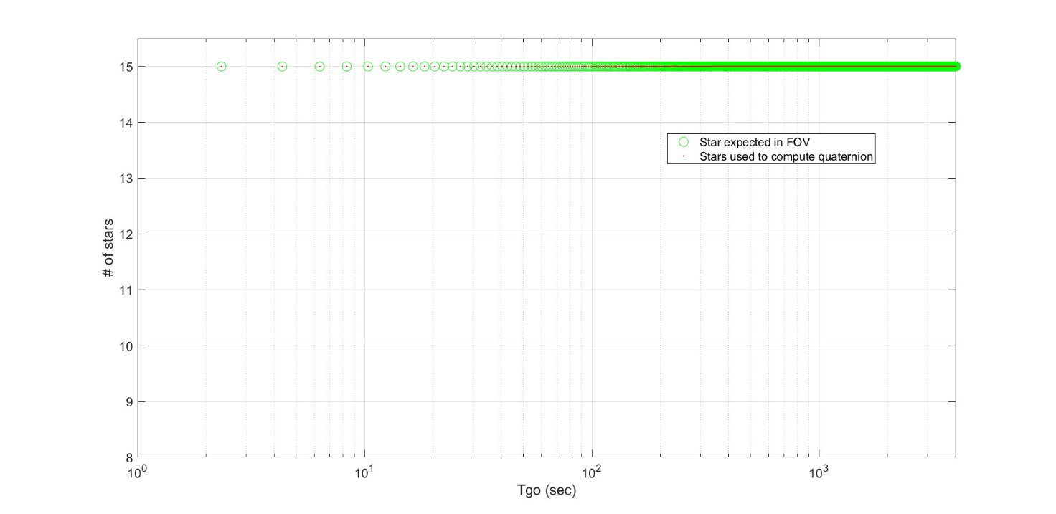

*Figure 17* Number of expected stars and tracked stars used for attitude quaternion computation

The low sampling frequency does not allow assessment of attitude error as performed in the previous section. However, considering the quality index measurements it is possible to retrieve the Star Tracker measurement accuracy.

The quality Index is reported in *Figure 18*.

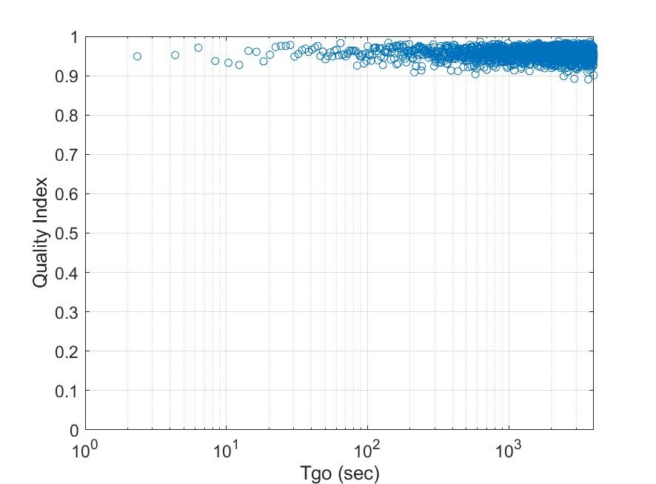

Figure 18 Quality Index

The quality index values are always higher than 0.9. Considering the good correlation between quality index and measurement accuracy (discussed in previous section), a measurement accuracy (1σ) better than ~1.5arcsec is expected on the transversal axes and better than ~14 arcsec on boresight.

The measurement error is fully in line with the cruise phase and it is also maintained for the very last TM, 2.3s before the impact, when straylight was also increasing because of the scattering effect of the approaching Asteroid.

# CONCLUSIONS

The APS Autonomous Star Tracker (AA-STR) was the only Star Tracker in the Guidance Navigation and Control system of the DART spacecraft and it was operative until the impact to Dimorphos.

This Paper has discussed Star Tracker performance through Cruise and the approach phases to the Asteroid.

AA-STR performance was in in line with previous flown units until the last available telemetry. Data processing shows that pixel spatial error and temporal noise (high frequency error) is

* Yaw (1σ) < 1.1 arcsec
* Pitch (1σ) < 1.1 arcsec
* Roll (1σ) < 8.6 arcsec

The residual focal length error, which has been computed with the same procedure implemented in Flight SW, is (4μm) and it is in line with the expectation (<10μm). This error could have been autonomously compensated if the procedure was activated by AOCS during flight.

Available data enabled correlation of the Quality Index and the Diagonal terms of the covariance matrix to the retrieved attitude accuracy. The good matching between the square root of the diagonal covariance matrix terms and the attitude error estimated by post processing allows to conclude AA-STR maintained full accuracy during the cruise and the Asteroid approach phase, preceding the Asteroid impact, when straylight was increasing.

The robustness of the AA-STR confirms the satisfactory capability of previously flown units, being that the AA-STR is the first Star Tracker to touch an Asteroid while tracking 15 stars just 2s before the impact.

**ACKNOWLEDGMENTS**

The authors wish to thank all the colleagues that have contributed to the development of the AA-STR. Among the others, we wish to thank Carmen Capitani who managed AA-STR for DART acceptance test campaign & delivery and Andrea Sica who performed a large amount of flight data processing.

Leonardo thanks Johns Hopkins University Applied Physics Laboratory for the large amount of data made available.

# REFERENCES

[1] Alvarado M., Massier S. , Brouillard E. Bettarini R, *Alphasat the first In-Flight In-Orbit Experience of the New European Large Platform Alphabus*, GNC 2014 9yh International ESA Confenerence on Guide Navigation & Control Systems.

[2] Daly, R.T., Ernst, C.M., Barnouin, O.S. et al. *Successful kinetic impact into an asteroid for planetary defence*. Nature 616, 443–447 (2023). https://doi.org/10.1038/s41586-023-05810-5.

[3] D. Shuster, *A Survey of Attitude Representations*, Journal of the Astronautical Sciences, Vol. 41, No. 4, 1993 pp. 439-517.

[4] E. Superfin, D. O’Shaughnessy, D. Mages, M. A. Jensenius, S. Miller, M. Pittelkau, *Line of Sight Error characterization and mitigations on the DART Mission*, 45th Annual AAS Guidance, Navigation and Control Conference, paper AAS-23-96, Breckenridge, CO, 2023.

[5] R. Bettarini, F. Boldrini, D. Procopio, S. D’Halewyn , D. Temperanza, *On Ground and In-Flight qualification of the AlphaBus Platform APS based Star Tracker*, AAS 10-046.