PDC2021
Vienna, Austria

Key International and Political Developments
Advancements and Progress in NEO Discovery
NEO Characterization Results
Deflection and Disruption Models & Testing
Mission & Campaign Designs
Impact Consequences
Disaster Response
Decision to Act
Public Education & Communication

Accelerated Root Finding for the DART Inverse Test Using Machine Learning Decision Trees

Cody Raskin⁽¹⁾, Tane Remington⁽¹⁾, and Mike Owen⁽¹⁾
⁽¹⁾Lawrence Livermore National Laboratories, postal address

Keywords: DART, Inverse Test, Machine Learning

ABSTRACT

In September 2020, the DART working group conducted an “inverse test” of the various teams’ capabilities at determining Dimorphos’ material properties given a standard set of post-impact observables. These observables included the volume of Dimorphos, the impact velocity and mass of the DART spacecraft, and the resultant change in momentum of Dimorphos derived from a prior calculation by the “red team”. The purpose was to gauge the efficacy of each approach at reproducing the input parameters of the red team simulation used to generate the test data.
Given no other data than what can be observed in the real event of the DART impact, the available parameter space for Dimorphos properties that reproduce the observed momentum enhancement factor (β) can be quite large. This makes converging onto the correct combination of material properties a potentially cumbersome and time-consuming task if done by traditional, brute force modeling techniques.

At LLNL, we adapted a machine learning (ML) decision tree algorithm to the task of choosing our simulation parameters (in this case density and yield strength) for a series of Smoothed Particle Hydrodynamics (SPH) simulations. The algorithm chose a number of initial combinations of parameters to build out its decision tree. After only one iteration, our ML algorithm settled on a combination of strength and density parameters that exactly matched the desired β measurement. For completeness, we deliberately chose a new β that was not coincidentally in the set of initial parameters and the decision tree settled onto a new set of parameters that reproduced that result as well.

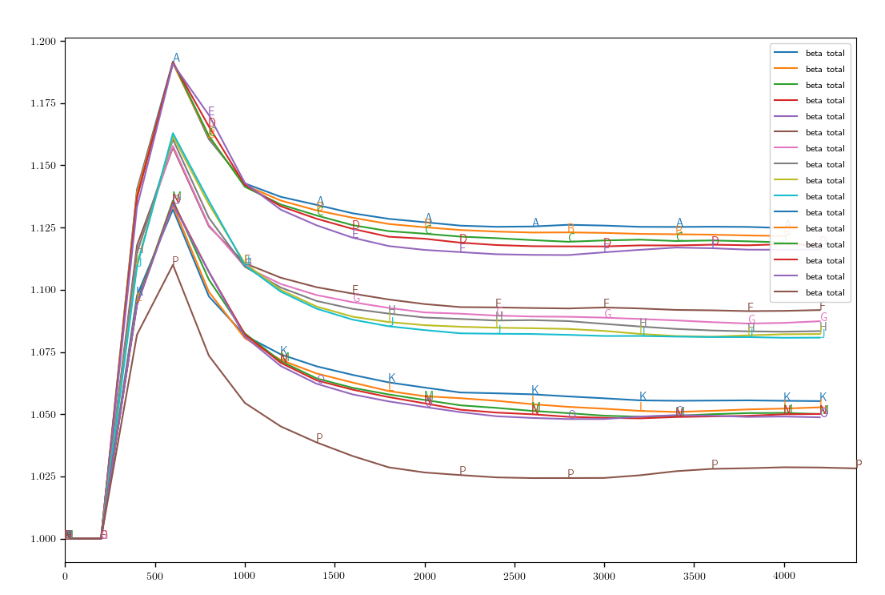
A plot of compute cycles (time) vs. β for simulations that vary density and yield strength independently. Different choices for yield strength from 1.5 GPa to 3.0 GPa have the greatest effect on β, resulting in “families” of solutions with minor differences amongst each other due to density.

The swiftness with which the ML algorithm found a solution in this test owes primarily to the fact that β scales linearly by the available parameters, and in a more formal test with several more parameters (e.g. porosity and inhomogeneity), the algorithm may not find a solution quite so quickly. Nevertheless, this approach bears promise even under those circumstances for greatly reducing the number of simulations required to converge to a solution.

Comments:

Oral Presentation

This work was performed under the auspices of the U.S. Department of Energy by Lawrence Livermore National Laboratory under Contract DE-AC52-07NA27344.

