PDC2021
Vienna, Austria

Please submit your abstract at https://atpi.eventsair.com/7th-iaa-planetary-defense-conference-2021/abstractsubmission

You may visit https://iaaspace.org/pdc

(please choose one box to be checked)
(you may also add a general comment - see end of the page)

Key International and Political Developments
Advancements and Progress in NEO Discovery
NEO Characterization Results
Deflection and Disruption Models & Testing
Mission & Campaign Designs
Impact Consequences
Disaster Response
Decision to Act
Public Education & Communication

Spacecraft Geometry Effects on Cratering and Deflection in the DART Mission

J. Michael Owen⁽¹⁾, Mallory DeCoster⁽²⁾, and Dawn Graninger⁽³⁾
⁽¹⁾Lawrence Livermore National Laboratory, PO Box 808, M/S L-38, Livermore, CA USA 94550, mikeowen@llnl.gov
^{(2,3)}The Johns Hopkins University Applied Physics Laboratory, Laurel, MD USA

Keywords: DART, Kinetic Impactors, Crater modeling

ABSTRACT

In the 2019 PDC we presented preliminary modeling examining the effects of different spacecraft geometry on the outcome of the DART kinetic impactor experiment. In that study we considered only full-density solid impactors (i.e., with no open spaces or density variations), and found a variance in the measured β of around 10% (comparing a solid sphere to a solid rendering of the DAWN spacecraft shape). In this talk we compare results using a high-fidelity rendering of the DART spacecraft based on CAD descriptions of the components, including void spaces and different materials for the components. This requires high-resolution calculations, which we carry out with the Spheral ASPH code and the Eulerian CTH code. We describe the impact of this geometry on the distribution of ejecta, crater morphology, and final β determination. We find in the early phases the crater formed by a compact solid impactor (such as a sphere) is qualitatively different than the more complex crater formed by the realistic DART CAD geometry. Similarly, the early histories of the ejecta mass and resulting β are different, though there is evidence they converge more closely as the models evolve. In this talk we discuss the consequences of these geometry effects on the major characteristics we wish to measure with DART: the β factor and ejecta characterization. We also consider the effect on the crater morphology, which will be significant for the HERA mission.

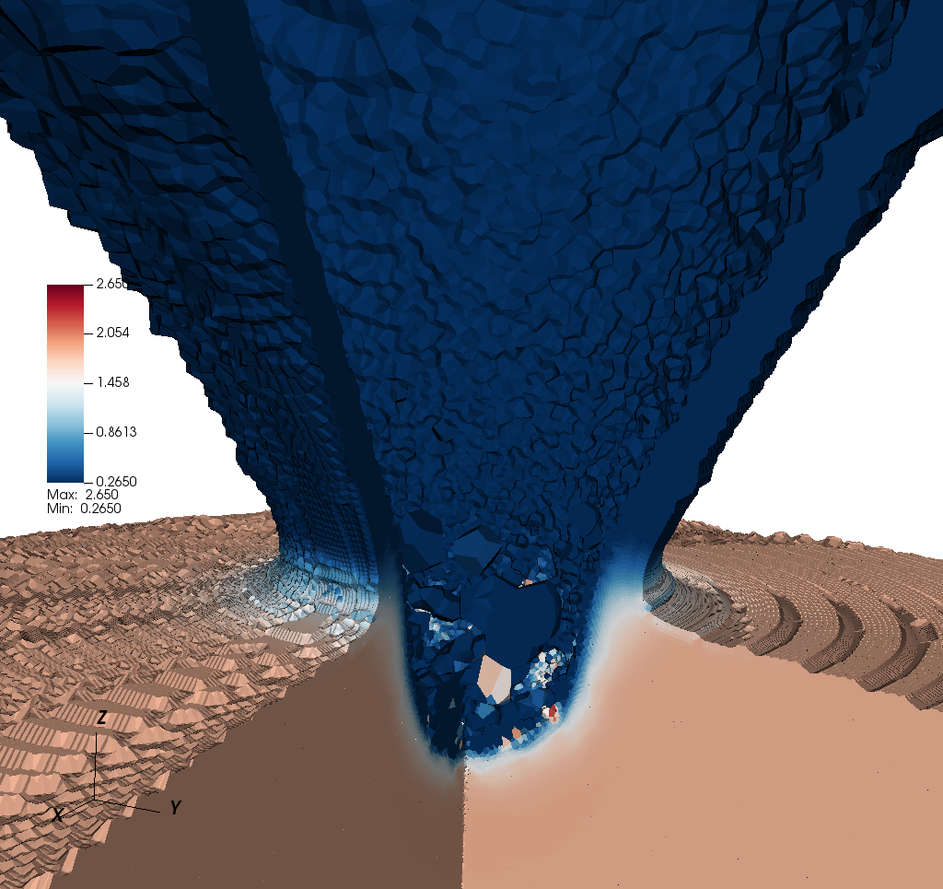
Figure 1 The mass density following the impact of a spherical solid spacecraft. In this image we can see the transient crafter and ejecta curtain.

This work was performed under the auspices of the U.S. Department of Energy by Lawrence Livermore National Laboratory under Contract DE-AC52-07NA27344. LLNL-ABS-XXXXXX

**************************************

Comments:

Preferred Oral session.

