**Deflection and Disruption Models & Testing**

**HYPERVELOCITY CRATERS ON IRON-NICKEL ALLOYS: CTH COMPUTATIONS USING DATA FROM HIGH STRAIN-RATE MECHANICAL TESTS**

Sidney Chocron (1), James Walker (1), Amanda Alexander (2), Simone Marchi (2)

(1) *Southwest Research Institute, 6220 Culebra Rd., San Antonio, TX 78238, USA*

[sidney.chocron@swri.org](mailto:sidney.chocron@swri.org) , [james.walker@swri.org](mailto:james.walker@swri.org)

(2) *Southwest Research Institute, 1050 Walnut St, Boulder, Colorado 80302, USA*

[alexander@boulder.swri.edu](mailto:alexander@boulder.swri.edu), [marchi@boulder.swri.edu](mailto:marchi@boulder.swri.edu)

**Abstract**

Asteroid 16 Psyche is one the most massive in the asteroid belt (~200 km diameter) and is believed to be the exposed iron-nickel core of a planetesimal. The NASA mission, *Psyche,* led by Arizona State University is planned to launch in 2022 with arrival to the asteroid in 2026. Southwest Research Institute has started an internal research effort to better understand how impact craters on these metallic bodies are formed.

When performing hydrocode impact computations of crater formation, some of the most critical inputs are the material properties. These usually require three pieces of information which can be determined through mechanical tests: equation of state, strength model, and failure model. Additionally, these material properties may depend, for example, on temperature, pressure, and strain-rate.

During this research project, two alloys relevant for the Psyche Mission (Fe90%-Ni10% and Fe94%-Ni6%) were mechanically tested in the laboratory at low and high strain-rates (for room and liquid nitrogen temperatures). From these tests, we determined the necessary input parameters for the Johnson-Cook strength and failure models that were subsequently used in CTH impact computations. It is shown that when a material is well characterized, computations can reliably predict the crater depths and diameters measured in the hypervelocity impact tests published previously by one of the coauthors. (Marchi, S. *et al.* (2020), *J. Geophys. Res.: Planets*, 125(2), pp. 1–19).

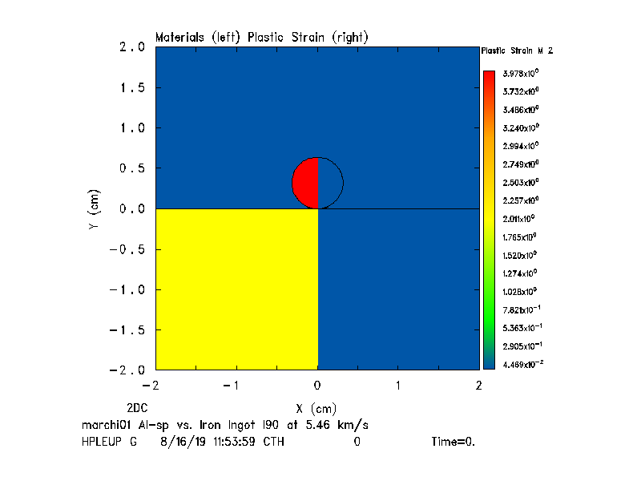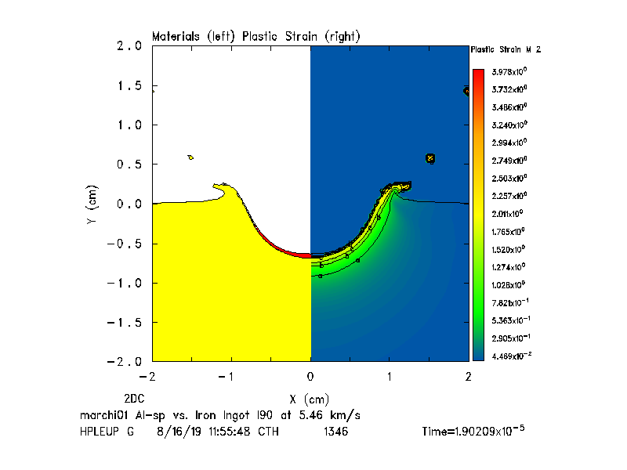

**Figure 1**. CTH computation a) Initial impact geometry, 2) Final crater formed

The figure shows the initial and final geometry for an aluminum sphere impacting an iron-nickel target at a speed of 5.46 km/s. These computations were performed with CTH, a hydrocode developed and maintained by Sandia National Laboratories. The presentation will go over some details on the material models and properties and will compare the code predictions with impacts performed at different speeds, temperatures, and angles.

**************************************

***Comments:***

*Alternative session: NEO Characterization Results*

*Preference for Oral Presentation*