PDC2021
Vienna, Austria

Please submit your abstract at https://atpi.eventsair.com/7th-iaa-planetary-defense-conference-2021/abstractsubmission

You may visit https://iaaspace.org/pdc

(please choose one box to be checked)
(you may also add a general comment - see end of the page)

Key International and Political Developments
Advancements and Progress in NEO Discovery
X NEO Characterization Results
Deflection and Disruption Models & Testing
Mission & Campaign Designs
Impact Consequences
Disaster Response
Decision to Act
Public Education & Communication

Monitoring Near Earth Objects colors in the frame of NEORocks program

M. Birlan^{(1,3)}, A. Barucci⁽²⁾, T. Hromakina⁽²⁾, M. Fulchignoni⁽²⁾,
F. Colas⁽¹⁾, A. Sonka⁽³⁾, E. Petrescu⁽⁴⁾, E. Dotto⁽⁵⁾, S. Fornasier⁽²⁾,and F. Merlin⁽²⁾
⁽¹⁾IMCCE, Observatoire de Paris, CNRS UMR8028, 77 ave Denfert Rochereau, 75014 Paris Cedex, France, email : Mirel.Birlan@obspm.fr
⁽²⁾LESIA, Observatoire de Paris-Meudon, 5 place Jules Janssen, 92190 Meudon Cedex, France
⁽³⁾Astronomical Institute of the Romanian Academy, 5 Cutitul de Argint, 040557, sector 4, Bucharest, Romania
⁽⁴⁾Vasile Urseanu Astronomical Observatory, bd. Lascar Catargiu 21,010661, Bucharest, Romania.
⁽⁵⁾INAF – Osservatorio Astronomico di Roma, Viale del Parco Mellini, 84, 00136, Roma, Italy.

Keywords: Near-Earth Asteroids, colors, telescope, physical characterization

ABSTRACT

This work was done in the framework of European Community programme called NEORocks. During 2020 several observational runs were performed at the Observatoire de Haute Provence and Observatoire de Pic du Midi, in France, for colors of Near Earth Objects (NEOs).

The goal of NEORocks programme is to improve the knowledge on the physical properties of the NEOs population, the implications for their origin and evolution, and the topics related to planetary defense. This goal is achieved by linking up the expertise in performing small body astronomical observations and the related modelling needed to derive their dynamical and physical properties to the pragmatic approach of planetary defense, which aims to provide operational loops and information systems to protect the citizens and the ground infrastructures from potential threats.

NEOs targets covered mostly the Potential Hazardous Asteroids (PHAs). When possible, colors, astrometry, and lightcurves were recorded for the newly discovered objects. Johnson B and V, Cousins R and Gunn I filters were used in determining colors of 31 NEOs. Color-color diagrams (Figure 1) show 11 PHAs of our sample in the context of major taxonomic classes. As a first attempt, in our sample we conclude that: i) there are no fraction of C-type asteroids; ii) the major part of our sample exhibits similarities with S and Q type taxons, and iii) two objects are outliers of major taxons.

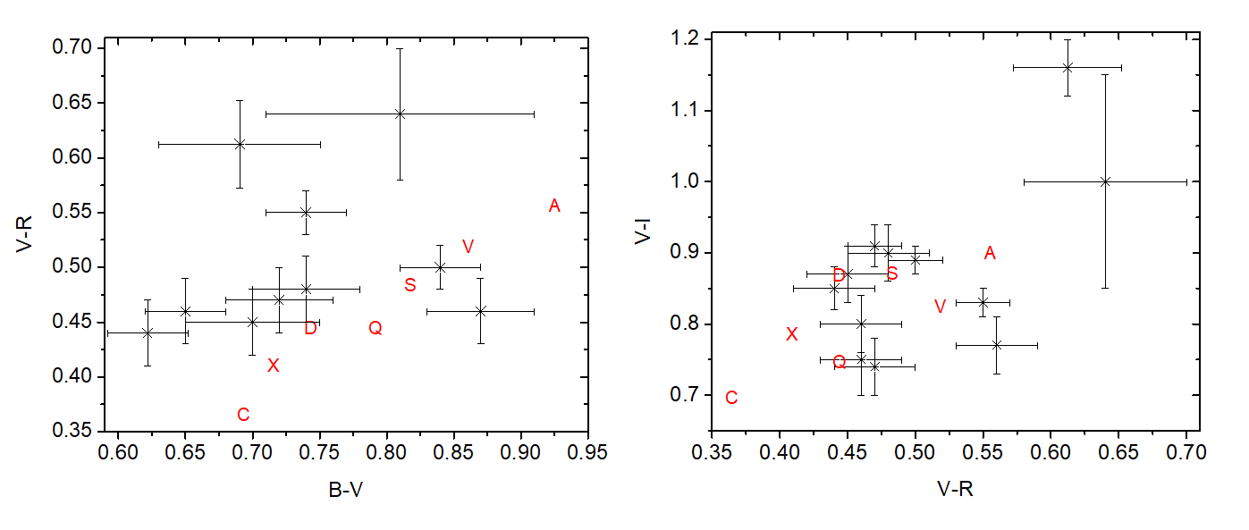
Figure 1. Digrams of PHAs observed during 2020 in the frame of NEORocks programme.

Comments: Poster

