TITLE

**Principal author name (1), Co-author name (1), co-author name (2)**

*(1) Affiliation, complete mailing address, phone, email*

*(2) Affiliation, complete mailing address, phone, email*

**PAPER**

This document gives the guidelines to write the paper for the 4S Symposium 2024, it has been formatted accordingly and can be used as an example.

Please, provide an informative abstract of no more than 200 words. The abstract should stand alone as a summary of the paper, not as an introduction (i.e., no numerical references).

# SUBMISSION PROCEDURE

Please note that the 4S Symposium adopts the policy ‘no paper – no podium’. The paper shall not contain any sort of advertisement with reference to a commercial activity (detailed guidelines for the paper can be found on the Abstract Submission page of the 4S website). The paper shall be uploaded through the paper submission link by **15th of April 2024**. The paper upload link and the login details have been provided in the notification e-mail.

Submissions received after this date will have the corresponding presentation withdrawn from the programme.

The papers shall be delivered in PDF format only. The file shall be named as follows:

PaperNumber_LastName-FirstName_Paper.pdf (example: 975_Rocket-Alex_Paper.pdf)

The Proceedings will be published on a digital support. The following are some guidelines for preparing the article in accordance with the standards for conference proceedings.

# GENERAL SPECIFICATIONS

All papers shall be in English. The number of pages should not exceed 15.

# PAGE LAYOUT

* Paper format: standard A4
* Fully justified
* Margins (left, right, top and bottom): 2 cm - 0.79 inches

**Font:**

Text: Times New Roman

Variable: Times New Roman italic

Symbol: True Type Symbol font

**(Type 1 font only)**

**Type size:**

Paper title: 12 pt bold (**TITLE**)

Author(s): 12 pt bold (**Author**)

Affiliation(s): 12 pt italic (*Affiliation*)

Text: 12 pt (regular text)

Text in tables: 10 pt

Symbols: 12 pt (≅ Ω π)

# TITLE and AUTHOR AFFILIATION

The paper’s title, author(s) name(s), affiliation(s), complete mailing address and e-mail should be centred at the top of the first page using the fonts and type sizes indicated above. If there are several authors, the complete affiliations should be given for each of them using superscripts (1) in the authors (2) list (3) to refer to them.

# HEADINGS

This sheet has been typeset in accordance with the style to be followed for the headings.

Main Headings: Font Times New Roman, 12, bold, UPPER CASE with conjunctions and prepositions in lower case. Use the decimal system in Arabic figures for the numbering. The main headings shall be preceded by two empty lines and followed by one empty line, as in Heading 1 of this template.

## Heading 2

Subheadings (heading 2): Font Times New Roman, 11, bold, Title Case.

# EQUATIONS

Equations are to be numbered consecutively throughout the paper. Each equation number must be unique (do not use “Equation 2bis” or “4”,…). Equations should be centred, with the equation number in parentheses.

Leave a double line space before and after equations. Always refer to equations by number, as Eq. 1 or Eqs. 3–6, not as “above” or “below”.

(1)



# FIGURES AND TABLES

Responsibility for the inclusion of good quality figures/illustrations (black and white or colour) resides with the author(s).

Figure captions shall be below the figures; table captions shall be above the tables.

All figures and tables shall be referenced in the text.

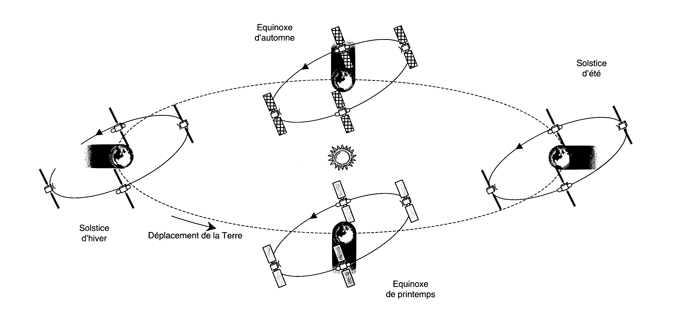

Figure 1. Title

# REFERENCES

Number citations consecutively in square brackets [1]. Refer simply to the reference number, as in [3]. Do not use “Ref. [3]” or “reference [3]” except at the beginning of a sentence: “Reference [3] was the first…” The title of the book or of the journal shall be in italic script.

Sample reference

[1] Johnson N.L. and McKnight D.S., *Artificial Space Debris*, Orbit Book Company, Malabar, Florida, 1991.

[2] Grün E., et al. *Collisional Balance of the Meteoritic Complex*, ICARUS, Vol. 62, 244 – 272, 1985.