PDC2021
Vienna, Austria

Please submit your abstract at https://atpi.eventsair.com/7th-iaa-planetary-defense-conference-2021/abstractsubmission

You may visit https://iaaspace.org/pdc

(please choose one box to be checked)
(you may also add a general comment - see end of the page)

Key International and Political Developments
Advancements and Progress in NEO Discovery
NEO Characterization Results
Deflection and Disruption Models & Testing
Mission & Campaign Designs
Impact Consequences
Disaster Response
Decision to Act
Public Education & Communication

Rotational periods of small NEAs with close approaches

Sonka Adrian Bruno ⁽¹⁾, Mirel Birlan ^{(2,1)}, Alin Nedelcu ^{(1,2)}, Vlad Turcu ⁽³⁾, Dan Moldovan ⁽³⁾, Andreea I. Henriksen ⁽⁴⁾, Simon Anghel ^{(1,5)},
⁽¹⁾ Astronomical Institute of the Romanian Academy, 5 Cuţitul de Argint, 040557 Bucharest, ROMANIA, +0741072239, sonka@astro.ro
⁽²⁾ IMCCE, Observatoire de Paris77 av Denfert Rochereau, 75014 Paris cedex, France,
⁽³⁾ Romanian Academy Cluj-Napoca Branch, Astronomical Observatory Cluj-Napoca, 19 Cireșilor, 400487 Cluj-Napoca, Romania,
⁽⁴⁾ Technical University of Denmark, Kongens Lyngby, Denmark,
⁽⁵⁾ Bucharest University, Faculty of Physics, Magurele, Romania

Keywords: asteroids, photometry, rotational period

ABSTRACT

We present first lightcurves of six fast-rotators Near Earth Asteroids (NEAs). Few of them are in a non-principal-axis rotational state.
During an observational campaign, established to confirm new discovered NEAs, we monitored them for brightness changes. The program used telescopes in the range of 0.4-0.6 m in diameter located in Romania, as follow:
i) from Bucharest Observatory (MPC code 073) we observed the asteroid 2018 GE3;
ii) from Cluj-Napoca Observatory we observed 2020 UA;
iii) form Berthelot Observatory (MPC code L54) we observed 2019 GT3, 2020 GA2, 2020 FG2, 2020 UA and 2021 AU.

Our targets span the absolute magnitudes between 21-28.4. We found very fast rotational periods and tumbling states for 2020 GF2 and 2020 UA (0.019 and 0.044 h respectively). For 2018 GE3 and 2019 GT3 we found small rotational periods (0.304 and 0.3547 h respectively) and large amplitudes. Plotted on a frequency vs. diameter diagram (Figure 1) all the asteroids observed reveal their monolithic structure. Four asteroids show amplitudes larger than 0.6 magnitude, which implies a large axis ratio and elongated shapes. The observed asteroids fill some points in the low diameter (uncharted territory) part of the Frequency-Period Diagram for asteroids.

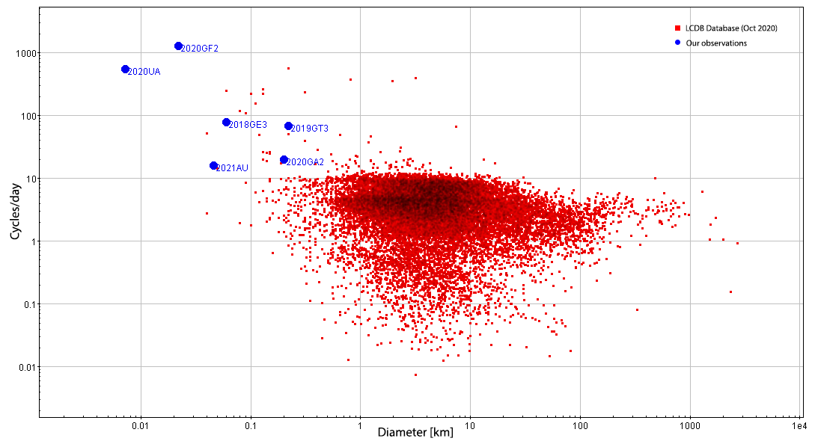
Figure 1. Frequency-diameter diagram with LCDB Database and our observations

**************************************

Comments:

(Alternative session, Time slot, Oral or Poster, Etc…)

