Artificial Intelligence for Early Design of Space Missions in support of Concurrent Engineering sessions

F. Murdaca^{1*}, A. Berquand¹, A. Riccardi¹, T. Soares², S. Gerené³, N. Brauer⁴

¹University of Strathclyde, Glasgow, UK,
²ESA, Noordwijk, Netherlands
³RHEA group, Leiden, Netherlands
⁴AIRBUS, Bremen, Germany
*Primary author contact details: francesco.murdaca@strath.ac.uk

- Introduction
Pre-feasibility and feasibility studies outputs are the first steps of a space mission development. This is the step when experts are encouraged to consider several design options with a certain creativity margin, select input parameters, balance trade-offs and eventually take decisions that will impact the whole design of the mission. At the era of Big Data analytics space mission design could benefit from computational intelligent methods to capitalise on previous, present and future studies and lessons learned to support experts in this design process.

This paper describes the early stages of the development of an ontology based Cognitive Assistant (CA), also called Design Engineering Assistant (DEA) for the preliminary design of space missions in support of concurrent engineering sessions. Figure 1 displays the preliminary architecture of the tool. CAs, decision support tools based on computational intelligence methods and extensive knowledge bases (i.e. formal ontologies), have the potential to enhance the productivity of human experts by providing new insights on large amount of data accumulated in their field. CAs are already successfully being used in the aeronautical, automobile, agricultural, legal and medical fields. However, in the space field few or only incomplete ontologies have been manually developed so far.

In the frame of this study automatic or semi-automatic ontology learning techniques are applied to build a complete space mission ontology taking advantage of accumulated unstructured and structured data from the space domain. The primary targeted users are space systems and subsystems experts taking part into concurrent engineering studies. The DEA will interact with the users via a natural language interface and use machine learning methods to improve its answers to the users’ queries.
This paper presents how a cognitive assistant could support space systems experts, whether by relieving their workload, by allowing them to capitalise on pasts designs and lessons learned or by providing hints of alternative design. The DEA will help the experts to not only rely on their own knowledge but also beneficiate from all the accumulated expertise from the space mission design field. This intelligent agent is not intended to substitute the human but rather to enhance her/his perception of different design alternatives and past decisions outcomes. Beyond the technical challenges the DEA must also prove its reliability and trustworthiness to the experts. The intelligent agent has to find its place into the experts’ work habits.

- Figure
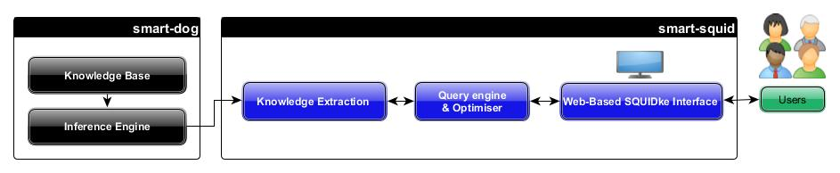
Figure 1: DEA Preliminary Architecture

