PDC2021
Vienna, Austria

Key International and Political Developments
Advancements and Progress in NEO Discovery
NEO Characterization Results
Deflection and Disruption Models & Testing
Mission & Campaign Designs
Impact Consequences
Disaster Response
Decision to Act
Public Education & Communication

X-RAYS, NEUTRONS, GAMMAS, OH MY: WHY SIMULATING ASTERIOD DEFLECTION USING A NUCLEAR DEVICE IS HARD

Kirsten M. Howley⁽¹⁾, Mary T. Burkey⁽¹⁾, Nicholas A. Gentile⁽¹⁾, and
Robert A. Managan⁽¹⁾
⁽¹⁾Lawrence Livermore National Laboratory, 7000 East Ave, Livermore, CA 94550, corresponding email: burkey1@llnl.gov

Keywords: Nuclear Deflection/Disruption, X-ray Deposition, Neutron Deposition, Gamma Deposition, Numerical Modeling

ABSTRACT
For asteroid deflection using a nuclear device, simulating the energy deposition into an asteroid and the subsequent response poses notable modeling challenges. Energy is deposited into the asteroid is in the form of thermal x-rays characterized by short mean-free paths, with lesser contributions from neutrons and gamma-rays characterized by longer mean-free paths. The partitioning of these energies and their detailed spectra depend on the specifics of the device used, but it is sufficient to say that the output is dominated by soft thermal x-rays. This poses a challenge in asteroid deflection simulations that must resolve orders of magnitude in length scales ranging from micrometers (soft x-rays) to kilometers (asteroid) to accurately model the physics. To complicate matters further, deposition of soft thermal x-ray energy is concentrated in the asteroid surface, and a significant amount of the deposited energy (up to 90%) is immediately lost to blackbody radiation before material can respond hydrodynamically.
In this paper we discuss the relative challenges, effectiveness and idiosyncrasies in modeling asteroid deflection using x-rays, neutrons and gamma rays. We find that soft thermal x-rays are the most abundant energy source in nuclear detonations and discuss challenges in numerical modeling of these deflection scenarios.
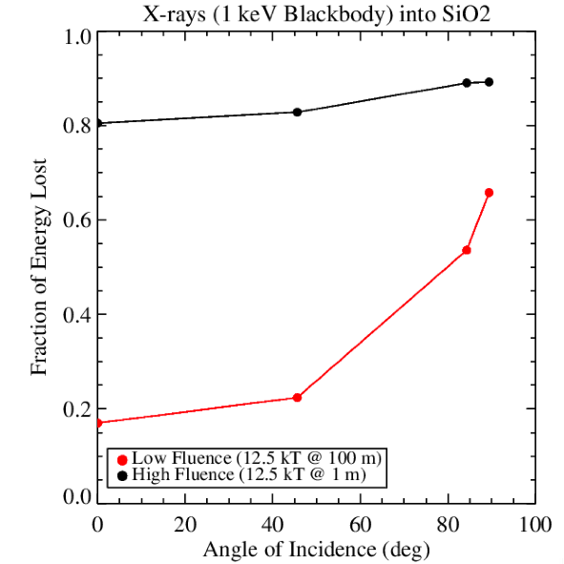
Fig 1. Image shows fraction of energy lost for a 1 keV blackbody X-ray source deposited into an asteroid-like material (SiO₂) as a function of surface fluence (an example of a device yield at two stand-off distances is used) and angle of incidence for the incoming energy (where 0° is normal to the surface). For high fluence cases, a large fraction of energy (up to 90%). X-rays deposited at increasing angles of incidence result in more energy lost. Simulations are performed using the hydrocode Kull.
This work was performed under the auspices of the U.S. Department of Energy by Lawrence Livermore National Laboratory under Contract DE-AC52-07NA27344. LLNL-ABS-818442

**************************************

Comments: An oral presentation is preferred.

