PDC2021
Vienna, Austria

Key International and Political Developments
Advancements and Progress in NEO Discovery
NEO Characterization Results
Deflection and Disruption Models & Testing
Mission & Campaign Designs
Impact Consequences
Disaster Response
Decision to Act
Public Education & Communication

FITS IMAGE ARCHIVE AT ESA’S NEO COORDINATION CENTRE

Regina Rudawska^{(1,5)}, Angelo Foglietta^{(1,7)}, Detlef Koschny^{(1,2,9)}, Juan L. Cano^{(1,8)}, Luca Conversi^{(1,3)}, Marco Micheli ^{(1,6)}, Pablo Ramirez Moreta^{(1,10)}, Gianpiero Di Girolamo⁽⁴⁾, Johannes Klug⁽⁴⁾
⁽¹⁾ESA NEO Coordination Centre, Via Galileo Galilei, 00044 Frascati (RM), Italy, neocc@ssa.esa.int
⁽²⁾ESA ESTEC, Keplerlaan 1, 2201 AZ Noordwijk, The Netherlands
⁽³⁾ESA ESRIN, Largo Galileo Galilei, 1, 00044 Frascati (RM), Italy
⁽⁴⁾ESA ESOC Space Safety Service Centre, Robert-Bosch-Straße 5, 64293 Darmstadt, Germany
⁽⁵⁾RHEA Systems, Jonckerweg 18, 2201 DZ Noordwijk, The Netherlands
⁽⁶⁾RHEA Systems, Via di Grotte Portella, 6/8, 00044 Frascati (RM), Italy
⁽⁷⁾Alia Space Systems, Via Lunati, 10, 00044 Frascati (RM), Italy
⁽⁸⁾Elecnor Deimos, Via Giuseppe Verdi, 6, 28060 San Pietro Mosezzo (NO), Italy
⁽⁹⁾LRT / TU Munich, Boltzmannstraße 15, Garching bei München 85748, Germany
⁽¹⁰⁾ GMV, Isaac Newton 11, Tres Cantos, 28760 Madrid, Spain

Keywords: databases, information provision, astrometry

ABSTRACT

To assess the threat level of a Near-Earth Asteroid (NEA) the discovery alone is not enough. It is crucial to compute reliable orbits based on accurate astrometric positions that would cover an arc as long as possible. We can accomplish this by performing follow-up observations or mining astronomical archives for information proceeding the discovery itself.

To fulfil those goals, ESA’s NEO Coordination Centre (NEOCC) hosts the FITS Image archive which is a searchable catalogue of astronomical images dedicated to small bodies observation campaigns provided by ESA's telescopes (or telescopes under agreement with the Agency). Moreover, the NEOCC coordinates, collects and analyse telescopic observations of NEOs (Conversi et al., 2021; Micheli et al., 2021).
Currently, there are over 460 thousand images in our database. The archive includes images from telescopes such as: Optical Ground Station (J04), La Sagra Sky Survey (J75), Klet Observatory (246), Karl Schwarzschild Observatory (033), Calar Alto-Schmidt (Z84), and soon from other observatories cooperating with ESA. Figure 1 shows the area of the sky covered by the NEOCC image database. All of the available images in the archive have already been analysed to discover or follow-up already known asteroids, and their astrometric measurements have been submitted to the Minor Planet Center. Moreover, the NEOCC image database is planned to be linked into the Solar System Object Image Search (SSOIS) system developed by the Canadian Astronomy Data Centre (CADC; Gwyn, Hill, Kavelaars, 2012). Therefore, the database will be extremely useful in order to allow further inspections of the images and to possibly find unidentified detections of NEOs or other moving objects.

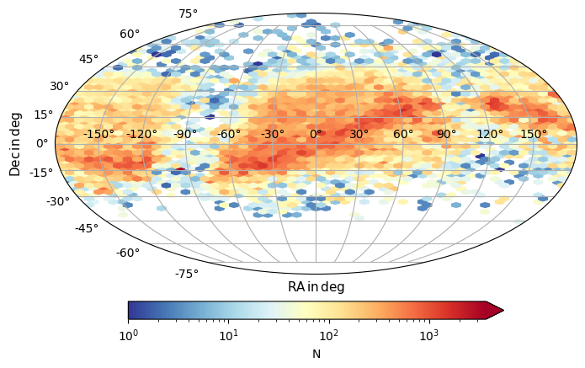
Figure 1: The sky covered by NEOCC image database.

References:
Conversi, L. et al. (2021): ESA’s NEOCC observational network. This conference.
Gwyn, S.D., Hill, N. and Kavelaars, J.J. (2012): Ssos: a moving-object image search tool for asteroid precovery. Publications of the Astronomical Society of the Pacific, 124, 579.
Micheli, M. et al. (2021): Recent observational highlights from ESA’s NEO Coordination Centre. This conference.

**************************************

