PDC2021
Vienna, Austria

Key International and Political Developments
Advancements and Progress in NEO Discovery
NEO Characterization Results
Deflection and Disruption Models & Testing
Mission & Campaign Designs
Impact Consequences
Disaster Response
Decision to Act
Public Education & Communication

Meerkat Asteroid Guard imminent impactor warning service of the European Space Agency

Michael Frühauf⁽¹⁾, Marco Micheli^{(2,3)}, Dario Oliviero^{(2,4)}, Detlef Koschny^{(2,5,1)}
⁽¹⁾LRT / TU Munich, Boltzmannstraße 15, Garching bei München 85748, Germany, m.fruehauf@tum.de
⁽²⁾ESA NEO Coordination Centre, Via Galileo Galilei, 00044 Frascati (RM), Italy, neocc@ssa.esa.int
⁽³⁾RHEA Systems, Via di Grotte Portella, 6/8, 00044 Frascati (RM), Italy
⁽⁴⁾Elecnor Deimos, Via Giuseppe Verdi, 6, 28060 San Pietro Mosezzo (NO), Italy
⁽⁵⁾ESA ESTEC, Keplerlaan 1, 2201 AZ Noordwijk, The Netherlands

Keywords: orbit determination, data visualization, warning service, impactor, follow-up

ABSTRACT

Telescopes all over the world are continuously scanning the night sky for undiscovered asteroids and comets. New detections have to be immediately analyzed for their orbit and impact scores to schedule follow-up observations in case of potential hazards or to start mitigation actions. Until today, only 4 asteroids have been observed before their impact, all of them discovered within less then 24 hours before their impact [1][2][3][4]. This underlines the need for a rapid orbit determination and threat assessment. Besides impactors, artificial objects and other interesting natural objects are regularly discovered, which need to be identified among conventional near-Earth objects (NEOs) and followed-up, before their ephemerides get too uncertain and they get lost.

The European Space Agency has developed the so-called Meerkat Asteroid Guard (short Meerkat) imminent impactor warning service. It is a fully automated system running 24/7, taking observational data of newly discovered NEOs from the Minor Planet Center’s NEO Confirmation Page and computing preliminary orbits by the Systematic Ranging orbit determination technique [5][6][7]. Besides identifying potential impactors, Meerkat is looking for close approaching objects, interior-Earth objects and potential interstellar objects. The data is accessible via a web interface. Meerkat provides an ephemeris service with the option of only considering impacting solutions. In particular this option is useful when the over-all detection chance is low but an impact should be ruled out by negative observations, as it was done for 2006 QV89 [8]. We also introduced several new plots to help users evaluate the threat of an object and to speed up the observatory selection process for follow-ups.

The ’Dashboard’ plot (Figure 1) gives a clear overview for threat assessment by visualizing the relevant information as pie charts. Among others, an impact score and an impact time estimate is shown. Another feature is the orbital class dependent size estimate. This distinction is important, since impacting solutions of the Systematic Ranging tend to have larger absolute magnitudes and hence smaller object sizes. Without this classification, mitigation and follow-up actions might be based on too large impactor size estimates.

The ’Station Selection’ plot (Figure 2) helps picking the right observatory for follow-up observations. It shows a time and field-of-view (FoV) dependent detection score contour. A number of selected observatories, displayed as lines with fixed FoV values and a line length depending on the ephemeris visibility, are plotted above the contour. The observatory lines are colored in a scheme indicating the visibility by the visual magnitude, depending on the stations’ limiting magnitudes. Hence, the user can immediately see, which of the stations can observe the object in terms of visual magnitude and ephemeris and which stations have high chances of detecting the object.

Meerkat is currently not publicly available.

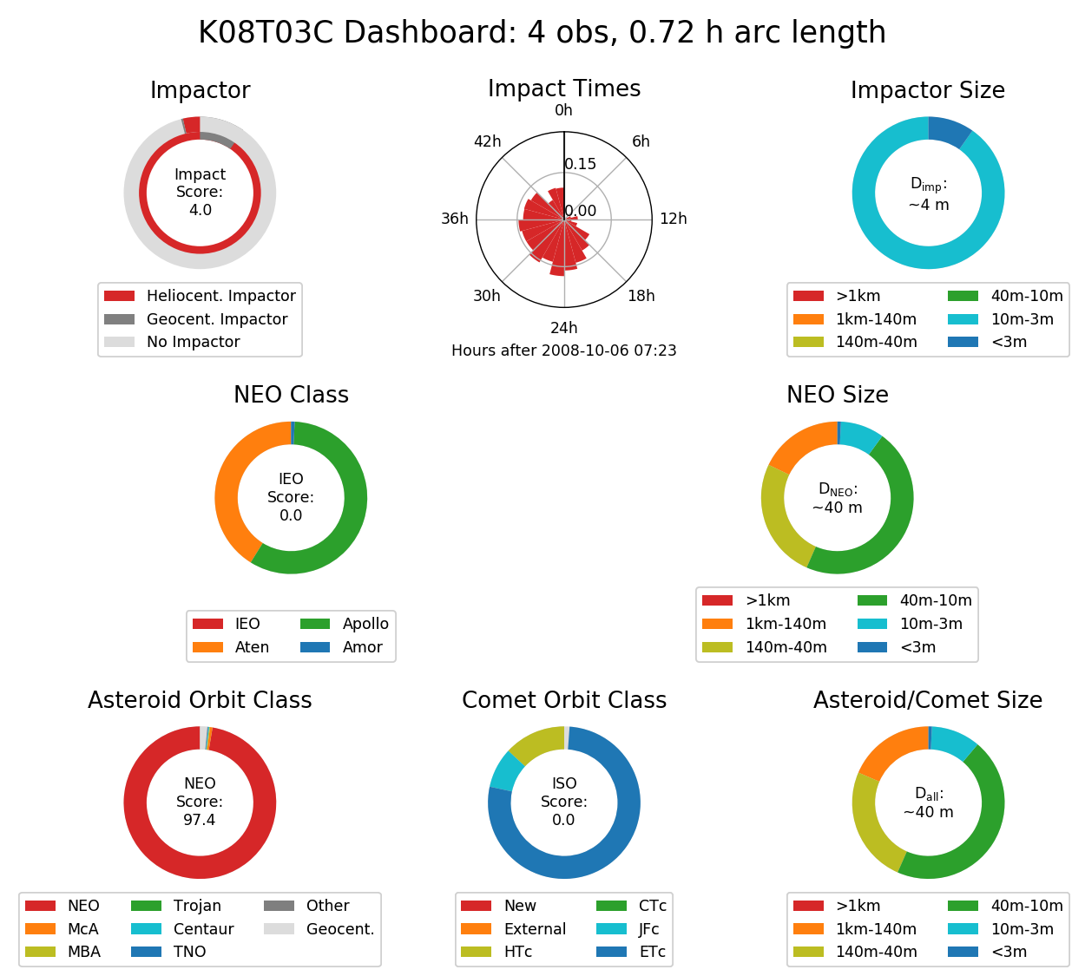Figure 1: The ’Dashboard’ plot (of K08T03C) shows a number of important object and orbit properties.
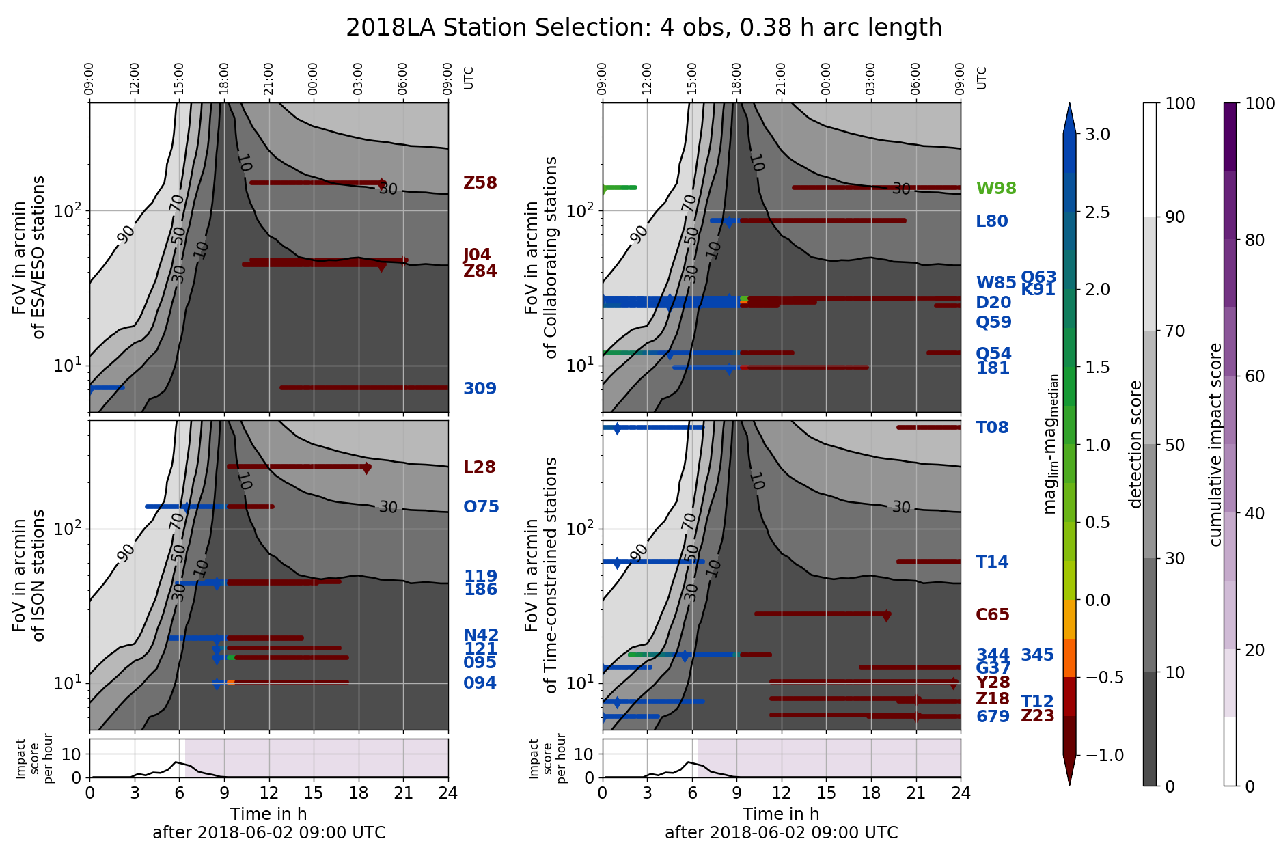Figure 2: The ’Station Selection’ plot (of 2018 LA) shows the detection score contour against the field-of-view (FoV) and time. The lines and their color indicate the station-dependent visibility of the object.
References
[1] Minor Planet Center, MPEC 2008-T50 : 2008 TC3, https://minorplanetcenter.net/mpec/K08/K08T50.html, 2008. [Online; accessed 10-December-2020]
[2] Minor Planet Center, MPEC 2014-A02 : 2014 AA, https://minorplanetcenter.net/mpec/K14/K14A02.html, 2014. [Online; accessed 10-December-2020]
[3] Minor Planet Center, MPEC 2018-L04 : 2018 LA, https://minorplanetcenter.net/mpec/K18/K18L04.html, 2018. [Online; accessed 10-December-2020]
[4] Minor Planet Center, MPEC 2019-M72 : 2019 MO, https://minorplanetcenter.net/mpec/K19/K19M72.html, 2019. [Online; accessed 10-December-2020]
[5] M. Frühauf, M. Micheli, T. Santana-Ros, R. Jehn, D. Koschny, O. Ramirez Torralba, A systematic ranging technique for follow-ups of NEOs detected with the Flyeye telescope, in: T. Flohrer, R. Jehn, F. Schmitz (Eds.), 1st NEO and Debris Detection Conference, ESA Space Safety Programme Office, 2019
[6] D. Farnocchia, S. R. Chesley, M. Micheli, Systematic ranging and late warning asteroid impacts, Icarus 258 (2015) 18-27
[7] S. R. Chesley, Very short arc orbit determination: The case of asteroid 2004 FU 162, in: Z. Knezevic, A. Milani (Eds.), Dynamics of Populations of Planetary Systems, Proceedings of IAU Colloquium 197, Cambridge University Press, 2004, pp. 255-258
[8] ESA's NEO Coordination Centre, Newsletter September 2019, http://neo.ssa.esa.int/NewsLettersArchive-portlet/DownloadFileServlet?newsLetterName=ESA-SSA-NEO-LE-0054_1_0_SSA-NEO_Newsletter_2019-09-06.pdf, 2019. [Online; accessed 10-December-2020]

**************************************

Comments:

Poster preferred, participating in student competition

