PDC2021
Vienna, Austria

Key International and Political Developments
Advancements and Progress in NEO Discovery
NEO Characterization Results
Deflection and Disruption Models & Testing
Mission & Campaign Designs
Impact Consequences
Disaster Response
Decision to Act
Public Education & Communication

DEFLECTION OF NEAR-EARTH ASTEROIDS BY ALTERING THE SURFACE ALBEDO AND INCREASING THE NET SURFACE RADIATION TO INTENSIFY THE YARKOVSKY EFFECT IN SPACE

Rishin Aggarwal⁽¹⁾, Devashish Bhalla⁽²⁾, Dhruva Anantha Datta⁽³⁾, Anshoo Mehra⁽⁴⁾, Manuel Ntumba⁽⁵⁾

⁽¹⁾⁽²⁾⁽³⁾⁽⁴⁾⁽⁵⁾Division of Space Applications, Tod’Aérs, Lomé, Région Maritime 141, Togo, +91 85809 87940, todaers.research@gmail.com,manuel.ntumba189@gmail.com
⁽¹⁾Department of Aerospace Engineering, Indian Institute of Space Science and Technology, India, 695547, +91 82880 12380, rishin.chd@gmail.com
⁽²⁾Department of Aerospace Engineering, Indian Institute of Space Science and Technology, India, 695547, +91 98705 85876, bhalladev36@gmail.com
⁽³⁾Department of ECE (Avionics), Indian Institute of Space Science and Technology, India, 695547, +91 87128 30996, ananthadattad@gmail.com
⁽⁴⁾Department of Automotive and Aerospace Engineering, M.S.Ramaiah University of Applied Sciences, India, 560058, +91 77603 69590, anshoo.mehra.9@gmail.com

Keywords: Yarkovsky thrust, Apophis, surface albedo, electrostatic adhesion.

ABSTRACT

The Yarkovsky effect describes a differential thermal momentum transfer that affects the orbital trajectories of small asteroids and meteoroids. It differs from solar radiation pressure in the sense that it is caused by the temperature difference generated on the asteroid surface due to solar radiation. The magnitude of the Yarkovsky effect is a function of the mass and thermal characteristics such as absorptivity and emissivity of the asteroid surface. We have focused our research on the artificial enhancement of Yarkovsky thrust for the asteroid Apophis because it concerns the possibility of impacting Earth by 2029, to deflect it from its base trajectory, as the Yarkovsky effect is driven by a temperature gradient on the asteroid surface that creates differential thermal radiation. This differential radiation can be enhanced by employing a spacecraft with a targeted electrostatic spraying mechanism, coupled with a UV radiator that can create a positively charged layer on the target locations of the asteroid surface. Each target location can then act as an electrostatic adhesive for the sprayed nanoparticles (induced with negative charge) such that they stick and alter the surface albedo (refer Figure 1). To further enhance the Yarkovsky effect, UV radiation can be focused on the sprayed target locations as long as the spacecraft is in orbit. Apophis belongs to the class of Chondrite meteors and is in a retrograde orbit around the Sun. Consequently, the enhanced Yarkovsky thrust will alter the orbit trajectory in a controlled manner such that Apophis will steer clear of the Earth. A similar technique may be utilised for other killer asteroids if orbit trajectories are known well in advance. The proposed method is expected to deflect the asteroid from its base trajectory within the stipulated timeframe. The proposed spraying mechanism will enable electrostatic adhesion such that the spray-coated locations will be able to absorb and radiate as per the spin-rate of the asteroid to alter the surface albedo to induce significant changes in its trajectory. The onboard UV radiator will further increase the net radiation being absorbed and radiated by the asteroid surface, hence intensifying the Yarkovsky thrust in the desired direction (refer Figure 2). The paper, in part, discusses how effective thrust enhancement can deflect Apophis such that it misses its approach trajectory towards Earth.

Figure 1:

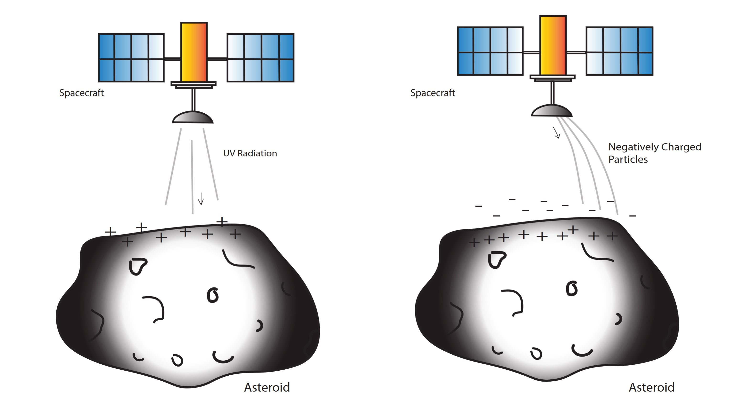

Figure 2:





