INFANTE: Technology demonstration of small missions using time space partitioning to manage multiple payloads

D. Silveira^{1*}; L. Murta², J. Ferreira³

¹GMV, Lisbon, Portugal, *Primary author contact details: dtms@gmv.com
²GMV, Lisbon, Portugal, luis.murta@gmv.com
³TEKEVER, Lisbon, Portugal, jose.ferreira@tekever.com

- Introduction
The INFANTE satellite is a R&D project for the development of a technology demonstrator, precursor of a NewSpace micro-satellite constellation for Earth Observation. In addition to its main purpose of demonstrating the capability to detect fast-developing events in a small platform, it also features a Payload Bay that holds experiments from various companies and research institutes. Due to the experimental and varied nature of the different applications running at the satellite, a Time and Space Partitioning (TSP) hypervisor is a valuable asset to run as a secure layer between the Payload Computer and the experiments. AIR [1] is an open source TSP hypervisor funded by ESA and GMV and is responsible for ensuring the correct execution and fault-handling of the Payload Bay subsystem. It will also manage the communication to each experiment and main Platform Computer, including the handling of TM/TC.
This work presents how distributed teams of the INFANTE consortium ensure the correct interoperability between all elements required by the payloads through IO and schedulability analysis. It also presents the capability of migrating AIR from ESA mission requirements to low-cost design re-use in small missions.
- INFANTE
The INFANTE project arises from the emergence of commercial opportunities in NewSpace, exploiting the know-how of established Portuguese companies and R&D institutes with the goal of deploying a microsatellite for Earth Observation (EO) with innovative solutions. INFANTE will demonstrate technologies for small missions such as increase the situational awareness on forest fires, agricultural management, maritime surveillance and meteorological events monitoring [2]. To do so, INFANTE will deploy an innovative suite of both optical and radar sensors, exploring different imaging possibilities across several bandwidths using satellite borne cameras and a Synthetic Aperture Radar (SAR).
Payload Bay Analysis
In tandem, INFANTE includes an adaptive payload bay with dedicated control electronics capable of hosting different experimental payloads. These payloads impose a wide and varying range of requirements handled by a Payload Computer and associated data buses. These requirements can be summarized into: Timing requirements; Computation requirements; Memory requirements and Communication requirements. Leading to a study analysis in terms of IO and schedulability.
The schedulability analysis resulted in scenarios per payload taking in consideration each experiment required timing constraints, such as duration and minimum inter-arrival time between messages, as well as power availability. The IO analysis defined the IO behaviour considering bandwidth requirements, handling data bursts of experiments, memory constraints, synchronization and latency.
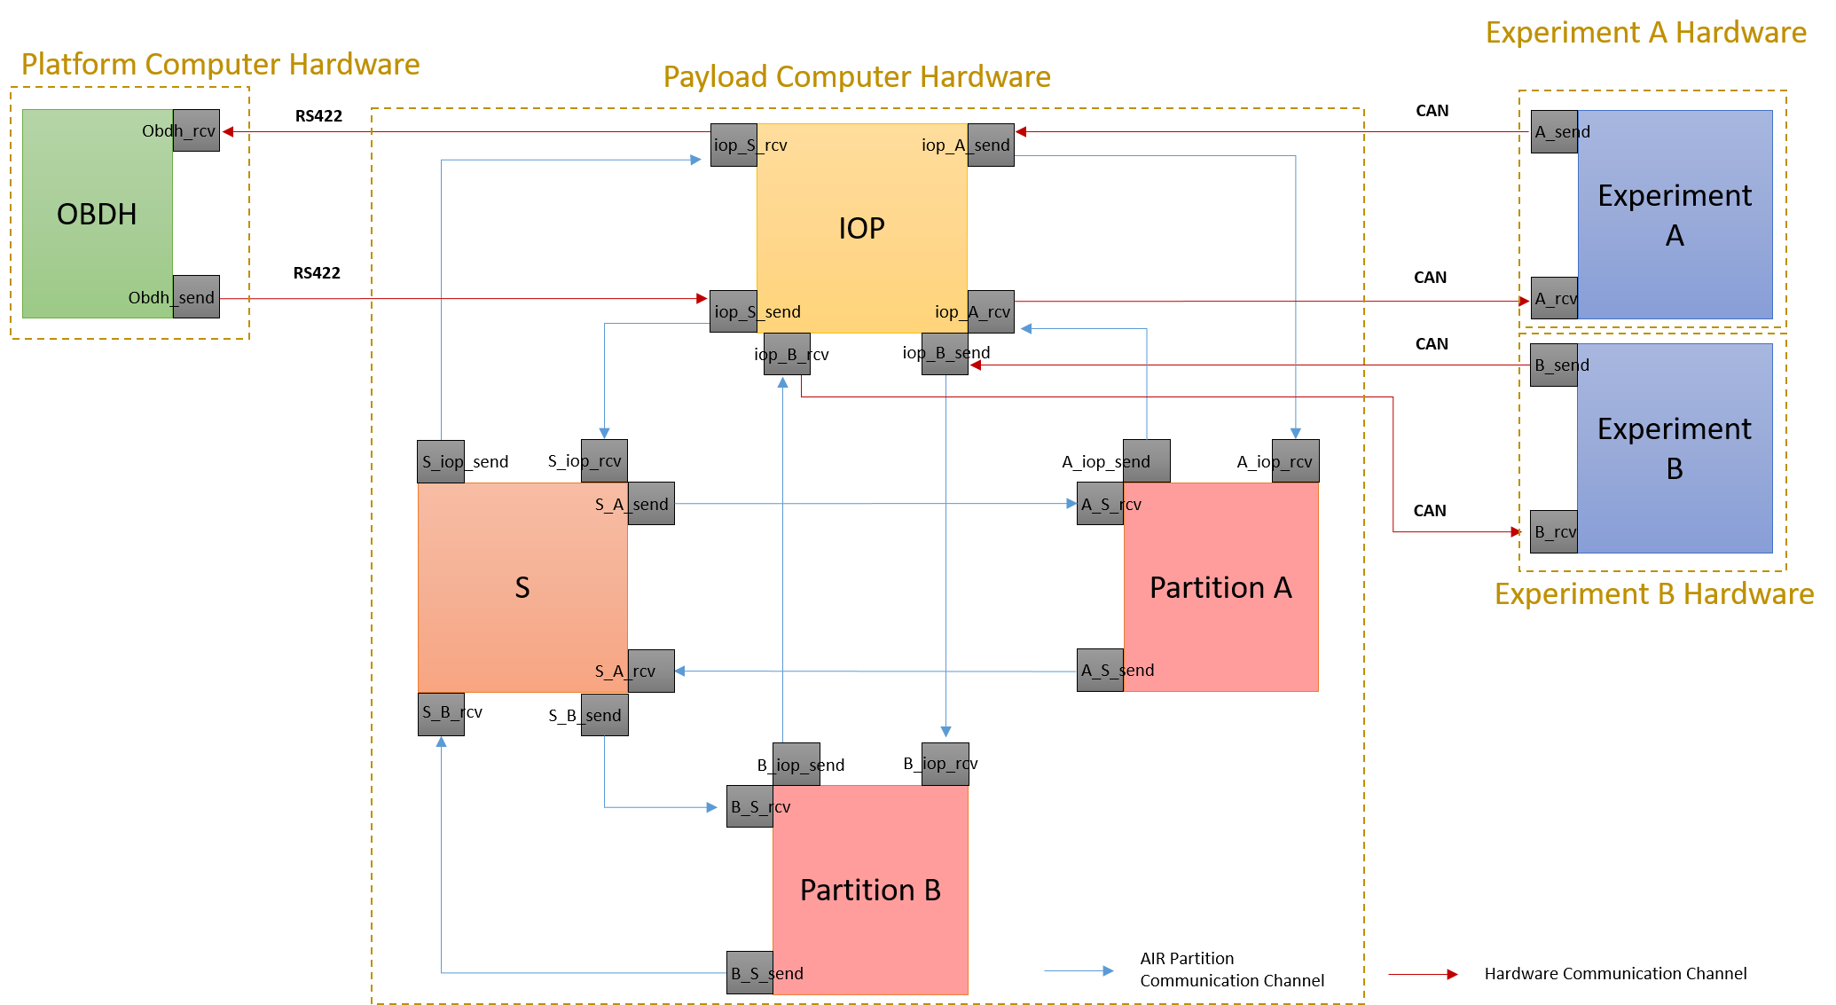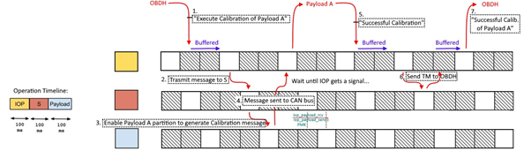
Figure 1: Illustration of IO (left) and Schedulability (right) results
- References
[1] Rufino, J., Craveiro, J., Schoofs, T., Tatibana, C., Windsor, J.: AIR technology: a step towards ARINC 653 in space. In Proceedings of Aerospace Conference DASIA (2009).
[2] F. V. Cunha et al., “Towards an Early Warning Service for Fast-Developing Events based on a SAR-enabled Microsatellite Constellation”, in Proc. 68th Int. Astronautical Congress, Australia, 2017.

