Preparation of the Electronic Paper for the Proceedings of the 42nd Esa antenna workshop
Principal Author Name⁽¹⁾, Co-Author Name⁽¹⁾, Co-Author Name⁽²⁾

⁽¹⁾Affiliation
City, Country
Email:

⁽²⁾Affiliation
City, Country
Email:

Abstract – Insert the abstract of your paper here.

Introduction
The proceedings of the 42nd ESA Antenna Workshop will be available to all participants at the workshop. The following instructions provide guidelines for preparing the required electronic format. Each submission should resemble these instruction sheets in format and style when completed. Please read all instructions thoroughly to avoid errors that could result in your paper(s) being omitted from publication.

Submission requirements
Publication of a paper in the proceedings of 41st ESA Antenna Workshop is contingent upon the receipt of the electronic version of the paper in PDF format by 20th of September 2024. Late papers may be omitted from the Proceedings.
The final version of the paper should be submitted via the available online submission tool.

Paper preparation
Each paper is limited to a minimum of 3 (three) and a maximum of 6 (six) single-sided pages. Prepare your paper using the following guidelines:

Margins: please adjust your word processor to the following margins shown in Table 1.

Text: the text shall be organized in double column, left and right justified.

Font: the text shall be in Times New Roman MT Std, the variables in Times New Roman italic, symbols in True Type Symbol font.

Header/footer: The use of header/footer or footnotes is not recommended.

Title and Author Affiliation
The paper title, author(s) name(s), affiliation, city, country and email should be centred at the top of the
Table 1. Recommended margins for the paper

Paper format: | A4
Unit: | inch | cm
Margin LEFT | 0.79 | 2.00
Margin RIGHT | 0.79 | 2.00
Margin TOP | 0.98 | 2.5
Margin BOTTOM | 1.38 | 3.5

first page using the font as indicated above. If there are several authors, the complete affiliation should be given for each of them using superscript⁽¹⁾ in the authors⁽²⁾ list⁽³⁾ to refer to them.

Equations
Should be centred and number equations consecutively with equation numbers in parentheses flush with the right margin. To make your equations more compact, you may use the solidus (/), the exp function, or appropriate exponents. Italicise Roman and Greek symbols for quantities and variables. Use a long dash rather than a hyphen for a minus sign. Use parentheses to avoid ambiguities in denominators. Punctuate equations with commas or periods when they are part of a sentence. Be sure that the symbols in your equation have been defined before the equation appears or immediately following. Use “(1)” not “Eq. (1)” nor “equation (1)” except at the beginning of a sentence, then use “Equation (1) is....”.

$D\left(θ,ϕ\right)=\frac{4πU\left(θ,ϕ\right)}{P_{rad}}$ (1)

Figures and Tables
Position figures and tables at the top and bottom of pages. Figure captions should be below the figures; table captions should be above the tables. Avoid placing figures and tables before first mentioned in the text. Use the abbreviation “Fig.1,” even at the beginning of a sentence. All images must be embedded into your document. The type of graphics you include will affect the quality and size of your electronic paper.

An example for an image embedded in the document is given in Fig. 1.

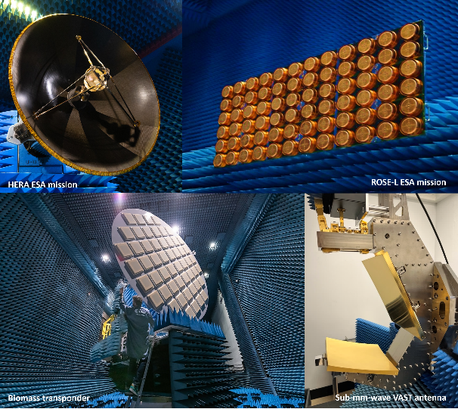
Fig. 1. 42nd ESA Antenna Workshop logo.

Abbreviations and Acronyms

Define abbreviations and acronyms the first time they are used in text, even after they have been defined in the abstract. Do not use abbreviations in the title unless they are unavoidable.

Page Numbering
Do not number the electronic paper.

PDF Pprerations
In order to allow reasonable quality printing, please avoid excessive compression when making your PDF file. Generally, image resolutions should be 600 dpi for monochrome, 300 dpi for greyscale and colour.

Important: embed all fonts and ensure that the PDF’s security setting is on “no security”.

References
Number citations consecutively in square brackets [1]. The sentence punctuation follows the brackets [2]. Refer simply to the reference number, as in [3]. Do not use “Ref.[3]” or “reference [3]” except at the beginning of a sentence: “Reference [3] was the first....” The title of the book or the name of the journal shall be typed in italic. Give all authors’ names; do not use “et al”.

Examples:

[1] G. Eason, B. Noble, and I.N. Sneddon, “On certain integrals of Lipschitz-Hankel type involving products of Bessel functions,” Phil. Trans.. Roy. Soc. London, vol. A247, pp. 529-551, April 1955.
[2] J. Clerk Maxwell, A Treatise on Electricity and Magnetism, 3rd ed., vol. 2. Oxford: Clarendon, pp. 68-73, 1892.
[3] I.S. Jacobs and C.P. Bean, “Fine Particles, Thin Films and Exchange Anisotropy,” in Magnetism, vol. III. G.T. Rado and H. Suhl, Eds. New York: Academic, pp. 271-350, 1963.
[4] Y. Yorozu, M. Hirano, K. Oka, and Y. Tagawa, “Electron spectroscopy studies on magneto-optical media and plastic substrate interface,” IEEE Transl. J. Magn. Japan, vol. 2, pp. 740-741, August 1987.

